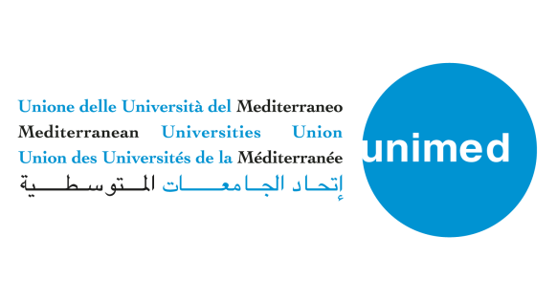
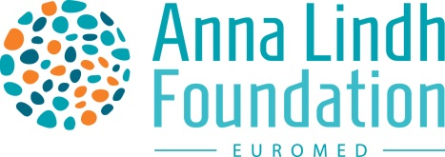

Beyond painting pictures and cultivating stereotypes: media narratives and foreign reporting for dialogue in the EuroMed - 8th july 2020
On the 8th of July, from 11:30-13:30 CET, the Anna Lindh Foundation organized together with the Mediterranean Universities Union (UNIMED) the second virtual Intercultural Trends and Media platform entitled “Beyond painting pictures and cultivating stereotypes: media narratives and foreign reporting for dialogue in the EuroMed”.
The meeting was organized as a space for a facilitated debate between journalists, academia and civil society to exchange reflections on the way media productions, cross-cultural reporting and mutual perceptions are changing as a result of the current crisis in the Euro-Mediterranean region and to share ideas on what could be done to minimize the negative consequences of the current crisis on intercultural exchanges and dialogue.
During the opening of the meeting, Eleonora Insalaco, Head of Operations and Intercultural Research at the Anna Lindh Foundation, acknowledged the effect that the public debate has on mutual perceptions in the Euro-Mediterranean by underlining that “we are living in a war of words, so we need to find ways to bring nuance to the public debate and highlight positive stories from the Euro-Mediterranean region".
In his opening remarks, Marcello Scalisi, Director of UNIMED underlined the importance of cooperation between academic institutions and media outlets: “Due to the situation, we have one common interest and same concerns. Joining efforts, pushing for more cooperation between the media and universities is essential to spread knowledge from academics to the general public. There are a lot of awareness raising issues in this period and this is something we shall build upon ”, concluded Dr. Marcello Scalisi.
During the meeting the reflections developed around how Covid-19 had affected media narratives and cross-cultural reporting in the region. For example, localism within the parameters of global challenges is on the rise again. This in turn opens up the opportunity to make smaller-scale media productions telling stories with an international impact.
Participants also acknowledged that the health crisis presented itself as an opportunity to promote environmentally sustainable working methods as it had put a temporary break on global CO2 emissions due to the shutdown of air traffic. Participants also underlined the need for environmental awareness actions to support and build on the environmental gains that the international community is witnessing.
Participants considered that the pandemic had brought about new possibilities within the parameters of online learning and virtual exchanges, cultural online activities and free access to online materials. These activities had in turn permitted reaching broader target groups.
Strengthening cooperation between civil society, media and academia was elevated by the participants as an essential mechanism to enhance and initiate measures promoting diversity and fostering intercultural dialogue. One step in achieving this goal could be to make successful experiences of civil society and practices strengthening resilience more visible and accessible. Along the same lines, participants acknowledged the need to make academic work in the area of intercultural dialogue more visible and accessible as well.
In addition to stimulating a discussion on the topics of the meeting, the aim was to establish a network of professionals within civil society, academia and journalists in the Euro-Mediterranean region. Participants to the second virtual meeting of the Intercultural Trends and Media Platform included: Nada Abdelsamad, the BBC, Lebanon; Ioannis Grigoriadis, the Hellenic Foundation for European and Foreign Policy, Greece; Nadia Motii, Université Mohammed V de Rabat, Morocco; Mònica Rius Piniés, University of Barcelona, Spain and Iason Athanasiadis, Freelance Journalist, Greece.

