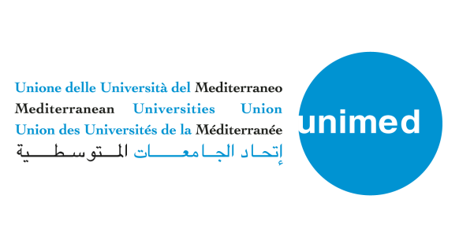
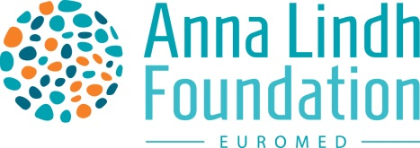

Feeling connected during the crisis – media narratives of the Euro-Mediterranean - 9 June 2020

On the 9th of June, from 11:30-13:00 CET, the Anna Lindh Foundation organized together with the Mediterranean Universities Union (UNIMED) the first virtual Intercultural Trends and Media platform entitled “Feeling connected during the crisis – media narratives of the Euro-Mediterranean”.
The meeting was organized as a space for a facilitated debate between journalists, academia and civil society to exchange reflections on the way media productions, cross-cultural reporting and mutual perceptions are changing as a result of the current crisis in the Euro-Mediterranean region and to share ideas on what could be done to minimize the negative consequences of the current crisis on intercultural exchanges and dialogue
During the opening of the meeting, Dr Nabil-Al Sharif, Executive Director of the Anna Lindh Foundation underlined that the Foundation strongly believes “in the importance of the media to reach large groups of society” while also underlining that “too many stereotypes are perpetrated via the media which hamper positive cross-cultural relations”.

In his opening remarks, Marcello Scalisi Director of UNIMED underlined the importance of virtual but also face-to-face academic mobility and that new methods are being looked into, in order to guarantee exchanges for students: “we have to contribute to creating a young Mediterranean generation that will get to know each other”, concluded Dr Marcello Scalisi.
During the meeting the reflections developed around how Covid-19 had affected media narratives and cross-cultural reporting in the region. For example, national TV-stations experienced a renaissance and a regained trust among the public. Concerns were also raised about the rise of hate speech as a result of the global pandemic, fake news, the fact that migrants are less present in the news and digital inequalities.
Present in the discussions were also some observations highlighting positive initiatives that had emerged from the current crisis. These include communal efforts promoting solidarity and cooperation among youth and women and an increased demand for good journalistic practices.
Lastly participants in the session called for increased media literacy, training for journalists, more nuanced coverage including stories on individual and community-led efforts.

To enrich the debate with the public opinion Eleonora Insalaco, Head of Operations and Intercultural Research at the Anna Lindh Foundation, underlined that “At the end of 2020 the ALF will share new scientific data from a regional public opinion poll that will shed light on how the current pandemic is impacting on mutual perceptions and intercultural relations in the Euro-Mediterranean region and will gather people’s opinions on the measures that could reduce negative stereotypes and hate speech”. With regards to the upcoming fourth edition of the Intercultural Trends report.
In addition to stimulating a discussion on the topics of the meeting, the aim was to establish a network of professionals within civil society, academia and journalists in the Euro-Mediterranean region. Invited participants to the first virtual meeting of the Intercultural Trends and Media Platform included: Alicia Arbid, Arab Women's Solidarity Association, Belgium; Miriam Diez Bosch, Ramon Llul University in Barcelona, Spain; Asiem El Difraoui, Institute of Media and Communications Policy, Germany; Hamida El Bour, IPSI - Institut de Presse et de sciences de l’Information, Tunisia; Shadi Ayash - Al Quds University, Leila Ghandi – The Monaco Women’s Impact summit, Monaco; Anna-Carin Hall, Kvinna till Kvinna, Sweden; Aygül Kabaca The Multicultural Centre, Sweden; Marlene Loureiro, University of Trás-os-montes e Alto Duoro, Portugal; Xavier Marquet, TV5 Monde, France; Fabian Pianka, Deutche Welle, Germany; Al Massae, Morocco; Bayan Tal, Jordan Media Institute, Jordan; Ugo Thamballi, Il Sole 24 Ore, Italy.

Ms Leila Ghandi ensured the moderation of the meeting. To see Ms Ghandi’s greetings to participants please this short video.
