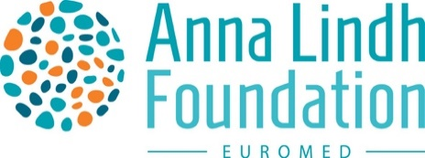

Open Call

The world we knew stopped a year ago. From one day to the other, our lives changed drastically. The Number 1 topic since then: Corona. In the turmoil of the pandemic, other crucial topics that affect society had to take a back seat.
We want to focus on issues that have been neglected over the past year. The_Gap intends to highlight what else is important, apart from the pandemic. The_Gap, an empty space and a place that is kept free for the issues not mentioned - a space for diversity.
Which issues did society forget about due to the pandemic? What gaps have emerged? We want to emphasise an intercultural dialogue on the topics that have become invisible in this period. Which story burns under your nails that people in other places need to know about? Which topics do people from different backgrounds than your own need to be discussed? We want to understand the issues that young people from the Euro-Mediterranean region conceive as problems of our time. What is the_Gap that we need to shed light on?

We collect contributions from the fields of art, culture, politics and society. Send us your photos, drawings, texts, poems, videos and other creative works... This is the stage for your contribution.

Every contribution published on the ALF Austria website in the virtual exhibition space will receive a compensation of € 100,00.

Send us your submission (in English or German) including the entry form:

- Text (max. 3600 characters)
- Picture (300dpi)
- Sound recording (max. 5 minutes, MP3)
- Video (max. 8 minutes, uploaded on Vimeo or YouTube)

Prerequisites:

- You are between 14 and 32 years.
- You live in one of the 42 countries of the Euro-Mediterranean region.
- You enjoy expressing yourself artistically in texts, pictures, sound recordings or videos.
- You want to participate as a group with your friends or as an individual.
- You have an exciting idea that can be implemented artistically and that supports intercultural dialogue.
- An international audience can easily understand your project and your contribution represents the values represented by Anna Lindh Foundation.
Please send your submissions via email to Anna.LindhFoundation@oiip.ac.at
Deadline: 12 June 2021
Publication: summer 2021

The ALF and its national networks promote intercultural dialogue and focus on civil society exchange.

This event is part of the ALF Virtual Marathon for Dialogue which gives civil society - and especially young people from the Euro-Med region - the opportunity to discuss current issues. The online exhibition “The_Gap” thus creates a place and a platform for intercultural exchange and dialogue.
Please do not hesitate to ask your questions about the Open Call to Anna.LindhFoundation@oiip.ac.at
#AnnaLindh #ALFAustria #The_Gap

For the editorial team: Carina Radler, Christina Riegler, Magdalena Übleis-Lang

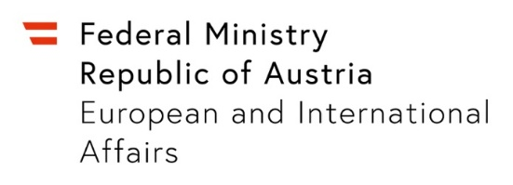

Open Call: The_Gap

Your contribution:
Title: __________________________________________________________________________
Description: ______________________________________________________________________________________________________________________________________________________________________________________________________________________________________________________________________________________________________________________________________________________________________________________________________________________________________________________________________________________________________________________________________
Details about the Artist:
First Name: _________________________ Last Name: _____________________________
Phone number: ______________________ E-mail address: _________________________
Additional Contributors: ______________________________________________________
__________________________________________________________________________
Short biography: ____________________________________________________________ ________________________________________________________________________________________________________________________________________________________________________________________________________________________________________________________________________________________________________
How did you learn about the Open Call?
_________________________________________

Declaration of Consent for Data Processing/Publication

- I agree that my personal data, including contact details and information about my contribution, are saved and processed for the purpose of the Call.

- In case my contribution is selected for publication, I hereby agree that my contribution will be published on the website of Anna Lindh Foundation Austria in the context of the online exhibition “The_Gap”.

Signature Place, date

__________________________________________________________________________

This Declaration of Consent can always be modified or withdrawn via email without giving reasons. In case of publication all other rights remain with the creator.

Declaration of Consent by Legal Guardian for participants under 18:
I, _______________________, hereby agree that Anna Lindh Foundation Austria publishes my daughter's/son’s _____________________ submission on the Anna Lindh Foundation Austria website in the context of the online exhibition “The_Gap”.

Signature Place, Date

__________________________________________________________________________

