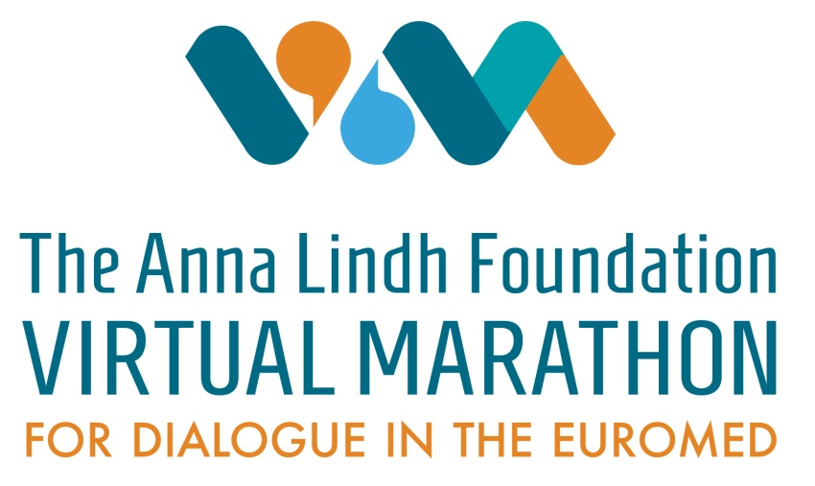

1st. INTERNATIONAL ONLINE PIANO COMPETITION SERGEI RACHMANINOFF

The competition is a public music-pedagogical event in which regular and part-time students of primary, secondary schools or related music institutions participate.
The competition is held online between june 5th. To 7th. 2021.

Deadline for the applications and submission of video compositions is till 30.may 2021.

You can find an application form at: www.https://pianobih.com

The competition is divided into piano solo and piano duo (four-handed)

The competition is organized by prof.mr. Monika Tadić and prof. Dzan Dervisević, within ALF B&H and within the Anna Lindh virtual marathon for dialogue in EuroMEd

Compensation for all categories (piano solo and piano duo) is 20 €

Categories:

Piano solo
Program: two or more compositions of your choice.
- Baby cat - 2012 i and younger (5')
- Cat A - 2011 (6')
- Cat B - 2010 (7')
- Cat C - 2009 (8')
- Cat D - 2008 (9')
- Cat E - 2007 (10')
- Cat F - 2006 (11')
- Cat G - 2004 - 2005 (13')
- Cat H - 2002 - 2003 (15')

Piano duo
Program: 2 compositions of your choice (free time)
- Cat A - 2010 -2011 OMŠ
- Cat B - 2008 -2009
- Cat C - 2006 - 2007
- Cat D - 2004 - 2005 SMŠ
- Cat E - 2002 - 2003
Youtube videos can be as a whole or individually. Each recording must show the instrument as well as the whole body.

1.
First prize
(90 – 100 points)

2.
Second prize
(80 – 89,99 points)

3.
Third prize
(70 – 79,99 price)

4.
Fourth prize
(60- 69,99 points)

The winner of the “Laureate” of each category, in addition to the diploma, also received a gold medal.

Special cash prize for Sergei Rachmaninoff play in the Baby category from A to F (primary school) and in the G and H category (secondary school).

All participants and their professors receive diplomas in electronic form.

Candidates from abroad – pay a compensation to:
ACCOUNT NAME – Youth Resource Center Tuzla;
BANK NAME – UniCredit bank;
CITY / COUNTRY: Tuzla, Bosnia and Herzegovina;
ACCOUNT NUMBER – 25005565101;
IBAN BA – 393383004890309533;
SWIFT CODE – UNCRBA22.
Purpose of the payement: a compensation for piano competition
Candidates from Bosnia and Herzegovina – pay a compensation to:
-UniCredit bank Tuzla;
-Youth Youth Resource Center Tuzla;
-Transcription account number: 3383 0022 6176 8516 with the indication for “FESTIVAL”.

The donation can also be paid through Wester Union, for more information contact the organizer, Professor Džan Dervišević, by e-mail: dzan.dervisevic1@gmail.com

The Jury:

István I Székeli
Professor at the Superior Conservatory Katarina Gurska in Madrid and the Franz Liszt Center for Special Talents in La Nucia (Spain). István is a concert pianist and internationally recognized teacher. (Full profile…)

Marija Maksimova
Marija Maksimova is a pianist and a renowned pedagogue of piano and chamber music who has received more than 300 international and national awards with her students. (Full profile).

Margarita Vujović
Margarita Vujović was born in Daugavpils (Latvia). At the age of five, she went to music school (piano department) in her hometown, where she spent the next twelve years in the class of prof. Aivars Broks continues her studies… (Full profile)

