MEETING AROUND THE INTERCULTURAL TRENDS REPORT
Presentation and debate on key findings from the 2021 Anna Lindh Report on Intercultural Trends and Social Change in the Euro-Mediterranean Region
Thursday 23th September 2021
3pm-5pm CEST

15:00-15:45 | Welcome and opening remarks
Marcello Scalisi, UNIMED Director
Eleonora Insalaco, Head of Operations and Intercultural Research, Anna Lindh Foundation

15:45-16:00 | Enhancing Euro-Mediterranean Cultural Relations
 | Stephen C. Calleya, Professor of International Relations and Director of the Mediterranean Academy of Diplomatic Studies, University of Malta
16:00-16:15 | Living together in multicultural environments
 | Necdet Saglam, Professor of Business Administration at Anadolu University in Turkey
16:15-16:30 | Cultural diplomacy at the service of dialogue in the Mediterranean
 | Antonio Chaves Rendòn, Head of Strategic Planning and Programming, The Three cultures of the Mediterranean Foundation
16:30 – 17:00 | Debate and closing remarks
Organised in the framework of:
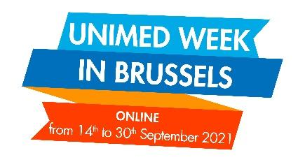

Working language: English and French (with interpretation service)

