Fifth Intercultural Morning Coffee
Tuesday 8th of June, 09:30 am to 10:15 am CET Time

Attendees:

Participants: Piaras Mac Éinrí, lecturer in Geography at University College Cork (Ireland), Renee Hattar, Head of International Studies, Programs and Projects at the Royal Institute for Inter-Faith Studies (RIIFS) (Jordan), Nahia Kanj student at the American University of Beirut (Lebanon).

ALF Representatives
Chair of the meeting: Eleonora Insalaco - Head of Operations and Intercultural Research
Facilitator and rapporteur: Johannes Jauhiainen – Social Media Executive
Co-rapporteur: Racha Omeyri - Intercultural Research Officer

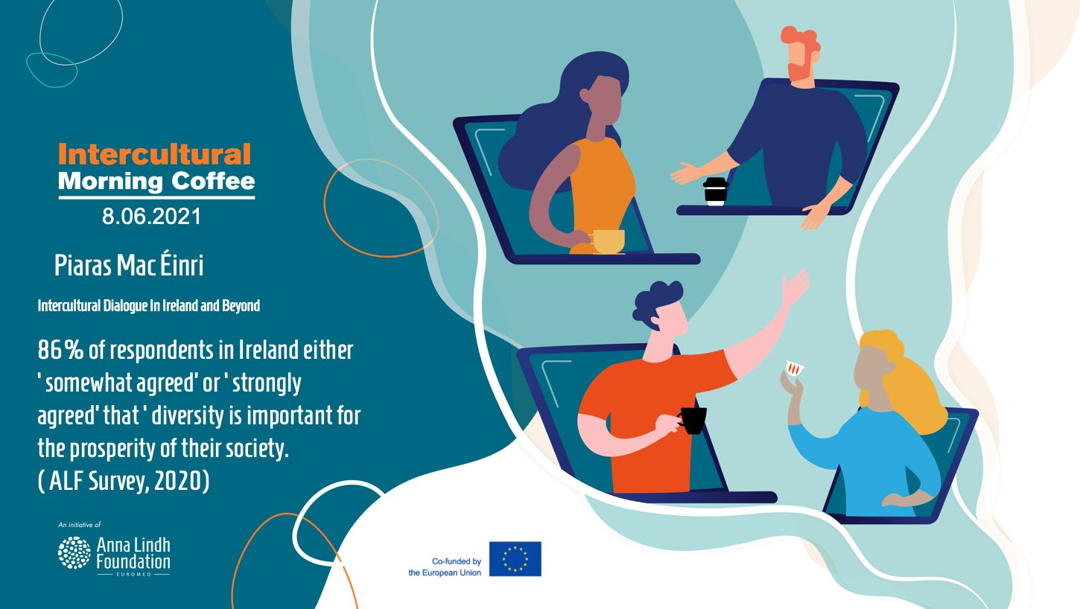

Background of the meeting

In the last 20 years, Ireland has gone through a significant transformation. According to Piaras Mac Éinrí, Lecturer in Geography and European Studies at the Department of Geography in University College Cork, Ireland has high rates of return migration as well as immigration. Moreover, it has an international outlook, with a strong record in foreign aid and NGO participation.

The 2020 Anna Lindh Survey reveals that Ireland is ranked at the more tolerant end of the spectrum when people were asked about how they would feel about persons from different cultural backgrounds being work colleagues, neighbors, attending the same school, and marrying a close relative.

Considering these observations and the media coverage Ireland has received in the last years, one may ask what civil society in other parts of the Euro-Mediterranean could do, in order to encourage a similar kind of positive transformation with regards to tolerance, mutual respect, and views towards living together in multicultural communities. Another question concerns cross-cultural and foreign reporting, which seems to have undermined these social changes in Ireland while reporting on political issues.

These questions and observations were explored during the Intercultural Morning Coffee on the 8th of June, with a brief presentation by Piaras Mac Éinrí who is an author of the upcoming fourth edition of the Anna Lindh Intercultural Trends Report.

Summary of key challenges and recommendations

The meeting started with a short introduction Piaras Mac Éinrí, Lecturer in Geography and European Studies at the Department of Geography in University College Cork, who noted that according to the Anna Lindh Survey of 2020, Ireland ranked at the more tolerant end of the spectrum when people were asked how they would feel about persons from different cultural backgrounds being work colleagues, neighbours, attending the same school and marrying a close relative.

According to Mac Éinrí, the reasons for these apparent changes are probably multi-factorial. Women have driven the campaign for a more open and equal society, notably in calling for reform of legislation in such areas as abortion rights. Investment in education since the 1970s and a recovery to relative prosperity have also made a difference. Ireland is now a porous society, with high rates of return migration as well as immigration.

Finally, Mac Éinrí, also shed light on how respondents in Ireland had answered the question: ‘If you could start a new life, in which country of the world would you start it?’. According to Mac Éinrí, the historical default position of substantial numbers of young Irish people, faced with a crisis in jobs and economic opportunity, has been to leave. The evidence from the ALF survey suggests such thinking is still present, with a staggering 82% - far above any other surveyed country – saying they would start over somewhere else. So though an expressed intent may never be acted upon, Ireland is still living in the shadow of the recent 2008 crash, and it should thus serve as a wake-up call to policymakers with regards to building a society in which all are able to build a prosperous and inclusive future.

During the roundtable of the meeting the role of religion was discussed at length with light shed on different practices and customs that enable members of all faiths and particularly to safeguard and cherish their identity whilst also being a part of their local and regional communities.

The role of women was also discussed and reflected upon, noting for example the increased role that women have gained in Ireland from the viewpoint of participation in the labour market, perceived gender roles but also from a legislative point of view. In Ireland, it was also proposed that the proactive and lively debate about the place of women in our societies might have been a significant driver of the above mentioned development.

Recommendations

- Dialogue and cohesion can be promoted when members of the community accept and embrace each other for who they are, noting that diversity is an asset and not a threat.
- Civil society actors, North and South of the Mediterranean should make use of the findings of the survey to enact positive social change in their regional and local communities.

Annex II Post-event press release

The Morning Coffee meetings are conceived as space for alumni of the Intercultural Trends and Media Platform to discuss informally up-to-date affairs with regards to dialogue and cross-cultural reporting in the media in the Euro-Mediterranean region.

The Morning Coffee on the 8th of June il was arranged to shed light on an upcoming article on intercultural dialogue and relations in Ireland, in the fourth edition of the Anna Lindh Intercultural Trends Report, written by Piaras Mac Éinrí, lecturer in Geography at University College Cork (Ireland).

Prof. Piaras Mac Éinrí, noted while providing an overview of the Intercultural Trends Survey 2020 data related to Ireland that according to the Anna Lindh Survey of 2020, Ireland ranked at the more tolerant end of the spectrum when people were asked how they would feel about persons from different cultural backgrounds being work colleagues, neighbours, attending the same school and marrying a close relative.

Among the points discussed: Dialogue and cohesion can be promoted when members of the community accept and embrace each other for who they are, noting that diversity is an asset and not a threat: and Civil society actors, North and South of the Mediterranean should make use of the findings of the survey to enact positive social change in their regional and local communities.

“With these Morning Coffees, we want to make it easy for academics, journalists and civil society members, North and South of the Mediterranean, to call each other, or send an email, for any pending questions they might have in relation to their work. We need more cooperation and discussions”, underlined Eleonora Insalaco, Head of Operations and Intercultural Research at the Anna Lindh Foundation, during the meeting on the 21st of April”.

About the Intercultural Trends and Media Platform & The Intercultural Morning Coffee
The Intercultural Trends and Media Platform & the Intercultural Morning coffees are organised by the Anna Lindh Foundation and the Mediterranean Universities Union (UNIMED) bringing together media, academia and civil society to create a network and to discuss how perceptions between Europeans and Southern and Eastern Mediterranean people have evolved in recent years as a result of the growing migratory and refugee movements, the rise of populist’s discourses and phenomena of violent extremism.
If you are a journalist, member of civil society or academic who would like to participate in a future edition of the Intercultural Trends and Media Platform, please do not hesitate to contact us (Johannes.Jauhiainen@annalindhfoundation.org - Intercultural Research Social Media Executive).
For more information on the Intercultural Trends and Media work at the Anna Lindh Foundation you can contact: Eleonora.Insalaco@annalindhfoundation.org - Head of Operations and Intercultural Research.
