Seventh Intercultural Morning Coffee
Wednesday 8th of September, 09:30 am to 10:30 am CET Time

Attendees:

Participants: Dr. Fares Braizat, author of an article in the upcoming fourth edition of the Anna Lindh Intercultural Trends Report & Chairman of Nama Strategic Intelligence Solutions; Nicole Hamouche, freelance journalist and social entrepreneur; Benoite Martin, civil society representative and PhD researcher at Ulster University analyzing educational policies is North East Syria.

ALF Representatives
Chair of the meeting: Eleonora Insalaco - Head of Operations and Intercultural Research
Facilitator and rapporteur: Johannes Jauhiainen – Social Media Executive
Co-rapporteur: Racha Omeyri - Intercultural Research Officer

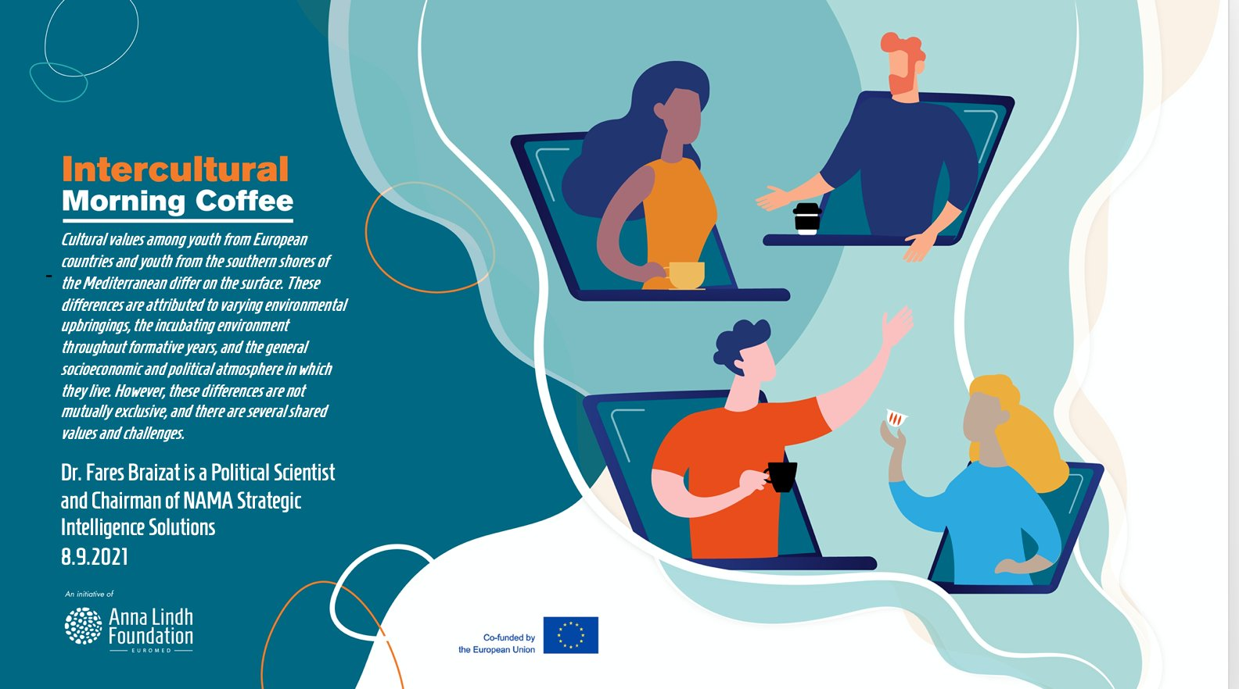

Background of the meeting 2
Summary of key challenges and recommendation 2
Annex II Post-event press release 5

Background of the meeting

The Anna Lindh Foundation organized the Intercultural Morning Coffee as part of a series of meetings, which bring together researchers, journalists, and civil society to discuss up-to-date issues over a cup of coffee in the morning and strengthen the network established with the Intercultural Trends Media Platform..

The role of youth is often instrumentalised particularly in areas burdened by polarization, hate speech and violence. Yet, the 2020 Anna Lindh Foundation Intercultural Trends Survey reveals that respondents in all four corners of the Euro-Mediterranean believe that youth can play a central role in leading dialogue initiatives, preventing and tackling hate speech and cultural divides in society.
. Yet, the Anna Lindh Foundation’s Intercultural Trends Survey of 2020 also reveals that respondents in all four corners of the Euro-Mediterranean believe that youth can play an instrumental role in leading dialogue initiatives and promoting cohesion.

For example, the Anna Lindh Intercultural Trends Survey, polled in 2020, reveals that 88% of respondents in the polled Southern Mediterranean countries (Algeria, Jordan, Lebanon, Mauritania, and Morocco) consider exchange programmes involving people across the region as an effective means of preventing and dealing with hate speech and polarization. This sentiment is also echoed in Europe, where 87% of respondents agree with their peers in the Southern Mediterranean.

Based on these findings youth exchange programmes could be developed to enhance tolerance and acceptance. These programmes could focus on topics of shared interest such as the natural environment and the impact of climate change, which 89% of respondents in European countries and 76% of respondents in SEM countries said they were either ‘very interested’ or ‘somewhat interested’ in hearing about in relation to the other country group.

Summary of key challenges and recommendation

The meeting started with a short introduction Dr. Fares Braizat, author of the Anna Lindh Intercultural Trends Report & Chairman of Nama Strategic Intelligence Solutions.

In his keynote observation, Dr. Braizat underlined that young people are more connected now than in previous generations, perhaps in part due to the pressing political constraints and economic pressures they face. Youth have also been hit hardest economically by the ongoing pandemic, more than one in six young men and women have lost their jobs.

In the Arab world a third of the population have declared an interest in migrating to other countries, whilst the number for youth is even higher amounting to around half of the respondents. The concentration of those are also found among the highly educated and males in particular, according to Dr. Fares Braizat’s reading of the Anna Lindh Intercultural Trends Survey.

The economic growth in the Southern Mediterranean is also not strong enough to generate the jobs required to integrate youth into the job market, according to Braizat. Instead millions more are needed, which would require an economic growth above seven percent. Unfortunately, that will most probably not be possible, as the pandemic has taken a toll on the economy and in addition, the Jordanian labour market, among others, has seen an influx of a new unemployed workforce consisting mainly of around 200 000 Syrian migrants and refugees.

When speaking on the solutions to these above-mentioned challenges Dr. Braizat pointed to data from the ALF Intercultural Trends Survey, which reveals that most respondents in the Arab SEM nations (Algeria, Jordan, Lebanon, Mauritania, and Morocco) see exchange programmes involving people across the region as an effective means of preventing and dealing with these challenges.

On average, 50% of respondents from these countries indicated that exchange programmes are ‘very effective’ and an average of 37% stated that they are ‘somewhat effective’ in preventing and dealing with challenges such as hate speech and polarisation. The results were also very similar among respondents in European countries, which illustrates that the attitudinal environment is conducive to a more constructive engagement with youth exchange programmes.

Lastly, Braizat also underlined that there are many opportunities with regards to shared interests and possible business opportunities for both shores of the Mediterranean. One of these is ecotourism, which would echo a sentiment polled for the Anna Lindh Foundation’s Intercultural Trends Survey, namely that 76 - 88% of respondents, South and North of the Mediterranean reported to be interested in news on climate change and the natural environment from the other shore of the Mediterranean.

The roundtable discussion then started with a brief discussion on some best practices with regards to promoting intercultural dialogue and youth participation in Lebanon, especially against the backdrop of the Beirut blast on the fourth of August 2022.
Participants of the meeting were also called on to carefully assess the needs of local communities before going into action by implementing projects that would promote youth employment and entrepreneurship. One reason for this was that there are already a number of startup incubators and social entrepreneurship hubs. And the aim should, after all, not be to create overlap.
The importance of volunteer programs was also recognized as they give especially youth the possibility to participate in their local communities with peers from all walks of life.
With regards to engaging youth in cross-cultural exchange programmes, it was noted that it remains a challenge to find and engage people that would not already have an invested interest and existing knowledge about the other region. Hence a challenge that remains is how to design exchange programmes that would reach also those who normally do not apply for such opportunities.

Recommendations
- More needs to be done in order to engage youth in intercultural exchanges that are normally not offered the chance.
- Youth entrepreneurship needs to be encouraged in order to contribute to economic growth, which in turn would facilitate more youth entering the job market.
- The mutual interest on both shores of the Mediterranean, could be deepened within the parameters of ecotourism, which would also facilitate cross-cultural encounters.

Annex II Post-event press release

The Morning Coffee meetings are conceived as space for alumni of the Intercultural Trends and Media Platform to discuss informally up-to-date affairs with regards to dialogue and cross-cultural reporting in the media in the Euro-Mediterranean region.

The Morning Coffee on the 8th of September, was arranged to shed light on an upcoming article on youth in the Euro-Mediterranean, in the fourth edition of the Anna Lindh Intercultural Trends Report, written by Dr. Fares Braizat, Chairman of Nama Strategic Intelligence Solutions.

In his keynote observation, Dr. Braizat underlined that young people are more connected now than in previous generations, perhaps in part due to the pressing political constraints and economic pressures they face. Youth have also been hit hardest economically by the ongoing pandemic, more than one in six young men and women have lost their jobs.

When speaking on the solutions to these above-mentioned challenges Dr. Braizat pointed to data from the ALF Intercultural Trends Survey, which reveals that most respondents in the Arab SEM nations (Algeria, Jordan, Lebanon, Mauritania, and Morocco) see exchange programmes involving people across the region as an effective means of preventing and dealing with these challenges.

Lastly, Braizat also underlined that there are many opportunities with regards to shared interests and possible business opportunities for both shores of the Mediterranean. One of these is ecotourism, which would echo a sentiment polled for the Anna Lindh Foundation’s Intercultural Trends Survey, namely that 76 - 88% of respondents, South and North of the Mediterranean reported to be interested in news on climate change and the natural environment from the other shore of the Mediterranean.

“With these Morning Coffees, we want to make it easy for academics, journalists and civil society members, North and South of the Mediterranean, to call each other, or send an email, for any pending questions they might have in relation to their work. We need more cooperation and discussions”, underlined Eleonora Insalaco, Head of Operations and Intercultural Research at the Anna Lindh Foundation, during the meeting on the 8th of September.

Lastly, Insalaco also noted based on the recommendations presented during the morning coffee that the Foundation and other relevant actors promoting intercultural exchanges for youth and explore projects highlighting mutual interests such as the interest in the environment on both shores of the Mediterranean.

About the Intercultural Trends and Media Platform & The Intercultural Morning Coffee
The Intercultural Trends and Media Platform & the Intercultural Morning coffees are organised by the Anna Lindh Foundation and the Mediterranean Universities Union (UNIMED) bringing together media, academia and civil society to create a network and to discuss how perceptions between Europeans and Southern and Eastern Mediterranean people have evolved in recent years as a result of the growing migratory and refugee movements, the rise of populist’s discourses and phenomena of violent extremism.
If you are a journalist, member of civil society or academic who would like to participate in a future edition of the Intercultural Trends and Media Platform, please do not hesitate to contact us (Johannes.Jauhiainen@annalindhfoundation.org - Intercultural Research Social Media Executive).
For more information on the Intercultural Trends and Media work at the Anna Lindh Foundation you can contact: Eleonora.Insalaco@annalindhfoundation.org - Head of Operations and Intercultural Research.
