25th of May
11:00-12:30 CET

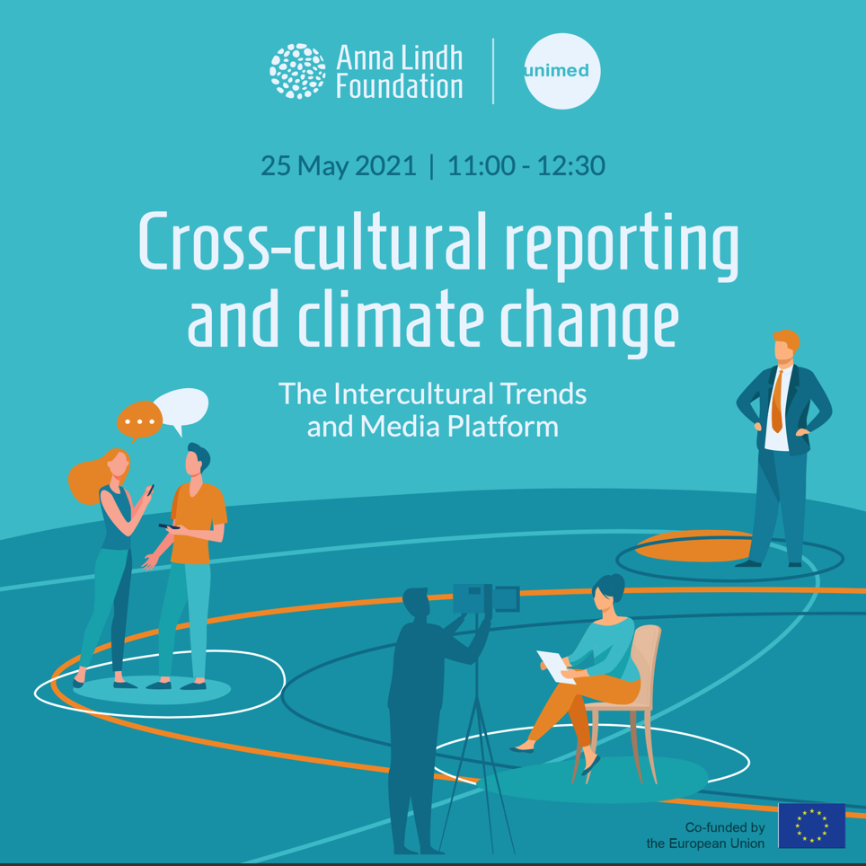

List of participants:

Participants from civil society, academia and the press in the Euro-Mediterranean region

Emma Hakala, Senior Research Fellow at the Finnish Institute of International Affairs, Finland; Giorgos Lialios, Journalist at Kathimerini newspaper, Greece; Adil Salhi, Professor at Abdelsmalek Essaidi University, Morocco; Mariam Chazalnoel Traore, International expert in climate migration at the International Organization for Migration (IOM), Oussama Abaouss, Science and environmental journalist specialized in the wildlife of Morocco, lecturer at the Institute for Leadership and Communication Studies in Rabat, Morocco; Josep Vila Subiros, Professor at the University of Girona; Matteo Lupetti, journalist and author, Italy, Wolfgang Cramer, Professor of Global Ecology at the Mediterranean Institute for marine and terrestrial biodiversity and ecology (IMBE),Aix Marseille Université, CNRS, IRD and Avignon Université, France; Carmit Lubanov, Executive Director of the AEJI-Association of environmental justice in Israel, Israel.

Anna Lindh Foundation:

Eleonora Insalaco, Head of Operations and Intercultural Research; Racha Omeyri, Intercultural Research Officer - Co-rapporteur of the meeting; Johannes Jauhiainen, Intercultural Research Social Media Executive- Co-rapporteur and technical moderator of the meeting;
The Mediterranean Universities Union:

Marcello Scalisi, Director; Nathalie Clauter, Project Manager; Camille Limon, Communications Officer.

The Meeting 4
Summary of key challenges and recommendations 4
Annex 1: Press Release 6
Annex 2 Post-event Press Release 7
AnnexIV Post-Exchange Questionnaire 8

About the Meeting

Climate change is one of the most pressing challenges of our time and according to the Anna Lindh Intercultural Trends Survey over 85% of respondents in both Europe and the Southern and Eastern Mediterranean, reported being interested in news and information on climate change and issues linked to the environment from the other shore of the Mediterranean. This common ground and mutual interest paves the way for dialogue on these issues.
That is why the Anna Lindh Foundation dedicated the next edition of the Intercultural Trends and Media Platform on the 25th of May to cross-cultural reporting on climate change in the Euro-Mediterranean.
The platform started with a brief introduction by Mariam Traore Chazalnoel, who is a Thematic Specialist on Migration, Environment, and Climate Change at the International Organization for Migration (IOM). Traore is also a contributor to the upcoming fourth edition of the Anna Lindh Intercultural Trends Report.
Among the questions for debate during the platform were:
- Since the outburst of the pandemic in which way has the media covered environmental issues and cultural diverse communities within your country?
- Which good and bad practices could you share in relation to climate change and measures to promote respect for the environment within the current context?
- The findings of the ALF Intercultural Trends Survey 2020 reveal a high level of common interest in climate and environmental issues by people in the EuroMed region, what kind of media coverage could satisfy this information appetite?
- Many studies have highlighted the importance of nature and climate action for migrant integration and inclusion. How can this action be enhanced via the media? What role could the media play to promote migrant integration and inclusion in host communities?

Summary of key challenges and recommendations

The meeting started with a brief introduction by Eleonora Insalaco, Head of Operations and Intercultural Research at the Anna Lindh Foundation, who underlined that over 80% of respondents to the Anna Lindh Survey think Euro-Mediterranean cooperation can contribute to addressing climate change. This in turn underscores the appetite among media consumers in the Euro-Mediterranean for cross-cultural reporting on climate change and environmental issues.

In her introduction, Mariam Chazalnoel Traore noted that in many cases, environmental migration is multi-causal, since climate and environmental issues intersect with economic, demographic and security factors, which shape the decision to migrate. This is of relevance to the Euro-Mediterranean region as many people moving across borders are perceived as “economic” migrants. Yet, the negative impacts of climate change on livelihoods and economic survival often play a significant role in the decision to migrate, which is something that the media overlooks.

Thinking about the reasons for this mutual interest in news on the environment and climate change, Chazalnoel Traore suggested that it might be linked to people observing and directly experiencing the impacts of climate and environmental degradation on their daily lives. Especially since some countries in the Southern Mediterranean, like Mauritania and Morocco, are particularly vulnerable to climate impacts. However, speaking of the inclination to migrate in the Euro-Mediterranean, Chazalnoel Traore underscored that the Anna Lindh Survey also reveals that only 20% of Southern and Eastern Mediterranean respondents want to move to Europe. The Anna Lindh Survey can hence be a leverage to advocate for policy changes, which is something that the International Organization for Migration will do, concluded Chazalnoel Traore.

During the roundtable, it was highlighted that the media often drew parallels between issues relating to the environment and issues relating to security that framed the debate especially in Europe. This in turn has encouraged a public debate on how to reassess threats to security but it has not been directly linked with the issue of migration, at least in Northern Europe.

It was also acknowledged that media narratives covering the pandemic have often focused on either global or local perspectives, but with less of an emphasis on migration. However, as sanitation has become a more widely covered subject due to the pandemic, questions regarding the environment and climate also became more of a priority in the media discourses.

The changes that the pandemic might have on consumer habits were also discussed and it was argued that these may in turn prove effective for tackling climate change.

Light was also shed on challenges relating to access of data concerning climate change, for which there is more data available in the Northern shore of the Mediterranean than the Southern shore. Furthermore, the lack of data has made it more difficult for experts to analyze the migratory and humanitarian situation in the Mediterranean from an environmental perspective.

The possibility of a Mediterranean Green Deal was discussed briefly even though it was also highlighted that it will require much effort for the countries to sign something with legally binding implications.

It was also acknowledged that journalists writing specifically about climate change and the environment are getting fewer due to new priorities in editorial rooms and economic challenges. Furthermore, the public debates are not always very favorable to transmitting information on climate change as one good article can be overshadowed by five commercials for cars.

Recommendations

- Public policies should be developed to ensure that people can live productive and dignified lives and that the worst of climate impacts are avoided. This can be supported by EU investments in sustainable development programmes, The EU Green Deal and the Neighbourhood, Development and International Cooperation Instrument.

- Due to the complexity of climate change as a topic, journalists would benefit from cooperation with academics and members of civil society working in the field with questions relating to the environment. Journalists need help from academics and experts, in order to bring nuance to the public debate.

- When covering environmental issues the media should consider it as a transversal subject affecting all of humanity and multiple aspects of life.

- Climate change should also be recognized as an opportunity, particularly for employment through new emerging industries and markets.

Annex 1: Press Release

Climate change and cross-cultural reporting on the agenda of the sixth Intercultural Trends and Media Platform
Climate change is one of the most pressing challenges of our time and according to the Anna Lindh Intercultural Trends Survey over 85% of respondents in both Europe and the Southern and Eastern Mediterranean, reported being interested in news and information on climate change and issues linked to the environment from the other shore of the Mediterranean. This common ground and mutual interest paves the way for dialogue on these issues.
That is why the Anna Lindh Foundation is happy to dedicate the next edition of the Intercultural Trends and Media Platform on the 25th of May to cross-cultural reporting on climate change in the Euro-Mediterranean.
“With these virtual exchanges, the Foundation aims to encourage a facilitated debate on what could be done to improve cross-cultural reporting and by working on areas of mutual interest”, underlines Eleonora Insalaco, Head of Operations and Intercultural Research at the Anna Lindh Foundation.
The platform will start with a brief introduction by Mariam Traore Chazalnoel, who is a Thematic Specialist on Migration, Environment, and Climate Change at the International Organization for Migration (IOM). Ms. Traore is also a contributor to the upcoming fourth edition of the Anna Lindh Intercultural Trends Report.
About the Intercultural Trends and Media Platform
The Intercultural Trends and Media Platform is organised by the Anna Lindh Foundation and the Mediterranean Universities Union (UNIMED) bringing together media, academia, and civil society to create a network and to discuss how perceptions between Europeans and Southern and Eastern Mediterranean people have evolved in recent years as a result of the growing migratory and refugee movements, the rise of populist’s discourses and phenomena of violent extremism.
If you are a journalist, member of civil society or academic who would like to participate in a future edition of the Intercultural Trends and Media Platform, please do not hesitate to contact us (Johannes.Jauhiainen@annalindhfoundation.org - Intercultural Research Social Media Executive).
For more information on the Intercultural Trends and Media work at the Anna Lindh Foundation you can contact: Eleonora.Insalaco@annalindhfoundation.org - Head of Operations and Intercultural Research

.

Annex 2 Post-event Press Release

Tackling climate change is a shared interest and responsibility for all of the Euro-Mediterranenan area
Climate change is one of the most pressing challenges of our time and according to the Anna Lindh Intercultural Trends Survey over 85% of respondents in both Europe and the Southern and Eastern Mediterranean, reported being interested in news and information on climate change and issues linked to the environment from the other shore of the Mediterranean. This common ground and mutual interest paves the way for dialogue on these issues.
With this in mind the Anna Lindh Foundation and the Mediterranean Universities Union were eager to dedicate a virtual exchange among journalists, academics and civil society to this timely topic of high interest.

“We will continue to advocate for Euro-Mediterranean cooperation and solutions with regards to pressing questions such as climate change, as this is something that our public opinion poll shows support for”, stated Eleonora Insalaco, who underlined during the meeting that the Anna Lindh Intercultural Trends Survey of 2020 reveals that over 80% of people, North and South of the Mediterranean considered Euro-Mediterranean cooperation offer tools to tackle climate change.

Thinking about the reasons for the high level of mutual interest in news on the environment and climate change, Chazalnoel Traore, international expert on climate migration at IOM, suggested that it might be linked to people observing and directly experiencing the impacts of climate and environmental degradation on their daily lives. However, speaking of the inclination to migrate in the Euro-Mediterranean, Chazalnoel Traore underscored that the Anna Lindh Survey also reveals that only 20% of Southern and Eastern Mediterranean respondents want to move to Europe. The Anna Lindh Survey can hence be a leverage to advocate for policy changes, which is something that the International Organization for Migration will do, concluded Chazalnoel Traore.

Participants proposed a number of recommendations including the following:

Public policies should be developed to ensure that people can live productive and dignified lives and that the worst of climate impacts are avoided. This can be supported by EU investments in sustainable development programmes, The EU Green Deal and the Neighbourhood, Development and International Cooperation Instrument.

Due to the complexity of climate change as a topic, journalists would benefit from cooperation with academics and members of civil society working in the field with questions relating to the environment. Journalists need help from academics and experts, in order to bring nuance to the public debate.

When covering environmental issues the media should consider it as a transversal subject affecting all of humanity and multiple aspects of life.

Climate change should also be recognized as an opportunity, particularly for employment through new emerging industries and markets.

About the Intercultural Trends and Media Platform
The Intercultural Trends and Media Platform is organised by the Anna Lindh Foundation and the Mediterranean Universities Union (UNIMED) bringing together media, academia, and civil society to create a network and to discuss how perceptions between Europeans and Southern and Eastern Mediterranean people have evolved in recent years as a result of the growing migratory and refugee movements, the rise of populist’s discourses and phenomena of violent extremism.
If you are a journalist, member of civil society or academic who would like to participate in a future edition of the Intercultural Trends and Media Platform, please do not hesitate to contact us (Johannes.Jauhiainen@annalindhfoundation.org - Intercultural Research Social Media Executive).
For more information on the Intercultural Trends and Media work at the Anna Lindh Foundation you can contact: Eleonora.Insalaco@annalindhfoundation.org - Head of Operations and Intercultural Research.

Annex IV Post-Exchange Questionnaire

Fourth Virtual Intercultural Trends & Media Platform meeting (December 15, 2020 – 11:00-12:30 CET)
Post-Exchange Questionnaire
*Required

Thank you for your participation in the Fourth Intercultural Trends & Media platform Virtual Exchange organised by the ALF and UNIMED

1_Participant name (optional)

2_What best describes you *

Media professional (e.g. journalist, blogger, opinion maker, editor …)

Academic (e.g. university professor, researcher …)

Civil society activist (e.g. youth worker, social activist …)

3_How would you rate your satisfaction with the Fourth Virtual Intercultural Trends & Media Platform (15 December session)? *

Very Low
1.
2
3
4
5
Very High

4_How would you rate the following statements? *

Strongly disagree
Disagree
Undecided
Agree
Strongly agree

The online event met my expectations

The addressed topic is relevant to my work/professional life

This virtual exchange encouraged meaningful discussion amongst the participants

This virtual exchange facilitates building positive relationships with participants from different sectors

The online event met my expectations

The addressed topic is relevant to my work/professional life

This virtual exchange encouraged meaningful discussion amongst the participants

This virtual exchange facilitates building positive relationships with participants from different sectors

5_How can Virtual Exchange help sustaining the work of intercultural trends & media platforms across the region? *

6_Since the outburst of the pandemic, in which way the media have covered migration issues and cultural diverse communities within your country? *

7_Which good and bad practices could you share in relation to the portrayal of migrants and refugees within the current context? *

8_What measures to promote diversity and dialogue via the media? *

9_What role could migrants and refugees and the media play for intercultural dialogue in the EuroMed region? *

10_What suggestions do you have to the ALF to support intercultural dialogue and cross-cultural reporting during the current situation? *

11_What aspects did you appreciate about this Virtual Exchange?

12_What aspects would you improve for a potential future Virtual Exchange?

13_In what ways (if any) was this Virtual Exchange different from other communications you have online or offline?

14_Are you interested in having further Virtual Exchange sessions? *
Yes
No

15_Which topics would you like to be discussed in potential future Virtual Exchanges? *

