8th of April 2021
11:00-12:30 CET

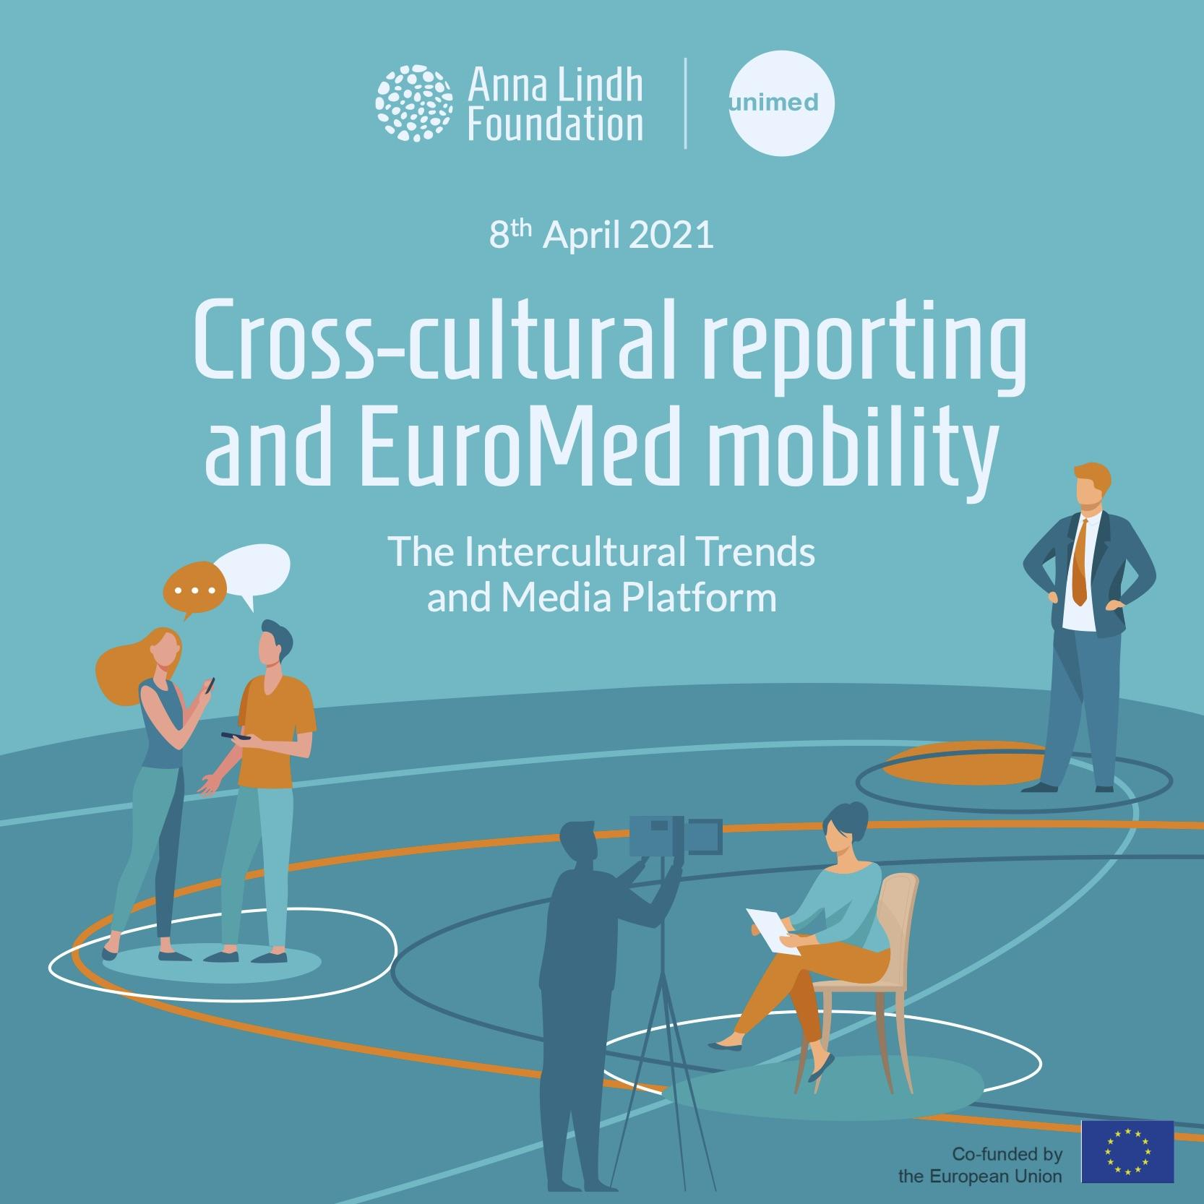

List of participants:

Participants from civil society, academia and the press in the Euro-Mediterranean region

Sara Ahmed, Managing Editor, Egyptian Streets, Egypt; Daham Alsasaad, Freelancejournalist and Filmmaker, Denmark; Anna Alboth, Media Programmes Coordinator, Minority Rights Group, The United Kingdom; Erik Halkjaer, Editor in Chief at OmVärlden & President of the Swedish Branch of Reporters Without Borders, Samira Mechri, Professor at University Tunis El Manar, Sweden; Denise Mellion, coordinator at River of Light, Sweden, Bilal Almobarak, Member of the Support Group Network in Sweden, Noora Kotilainen, Post-Doctoral Researcher at the National Defence University of Finland, Finland; Ahmed El Jechtimi, journalist writing for Thomson Reuters in Morocco, Yamina El Kirat El Allame Morocco, Ayman Mhanna, Executive Director of the Samir Kassir Foundation; Mayssa Rekhis Co-Founder and secretary general of the young republic, Sweden.

Anna Lindh Foundation:

Eleonora Insalaco, Head of Operations and Intercultural Research; Racha Omeyri, Intercultural Research Officer co-rapporteur of the meeting; Johannes Jauhiainen, Intercultural Research Social Media Executive, co-rapporteur of the meeting.

The Mediterranean Universities Union

Marcello Scalisi, Director; Nathalie Clauter, Project Manager; Camille Limon, Communications Officer.
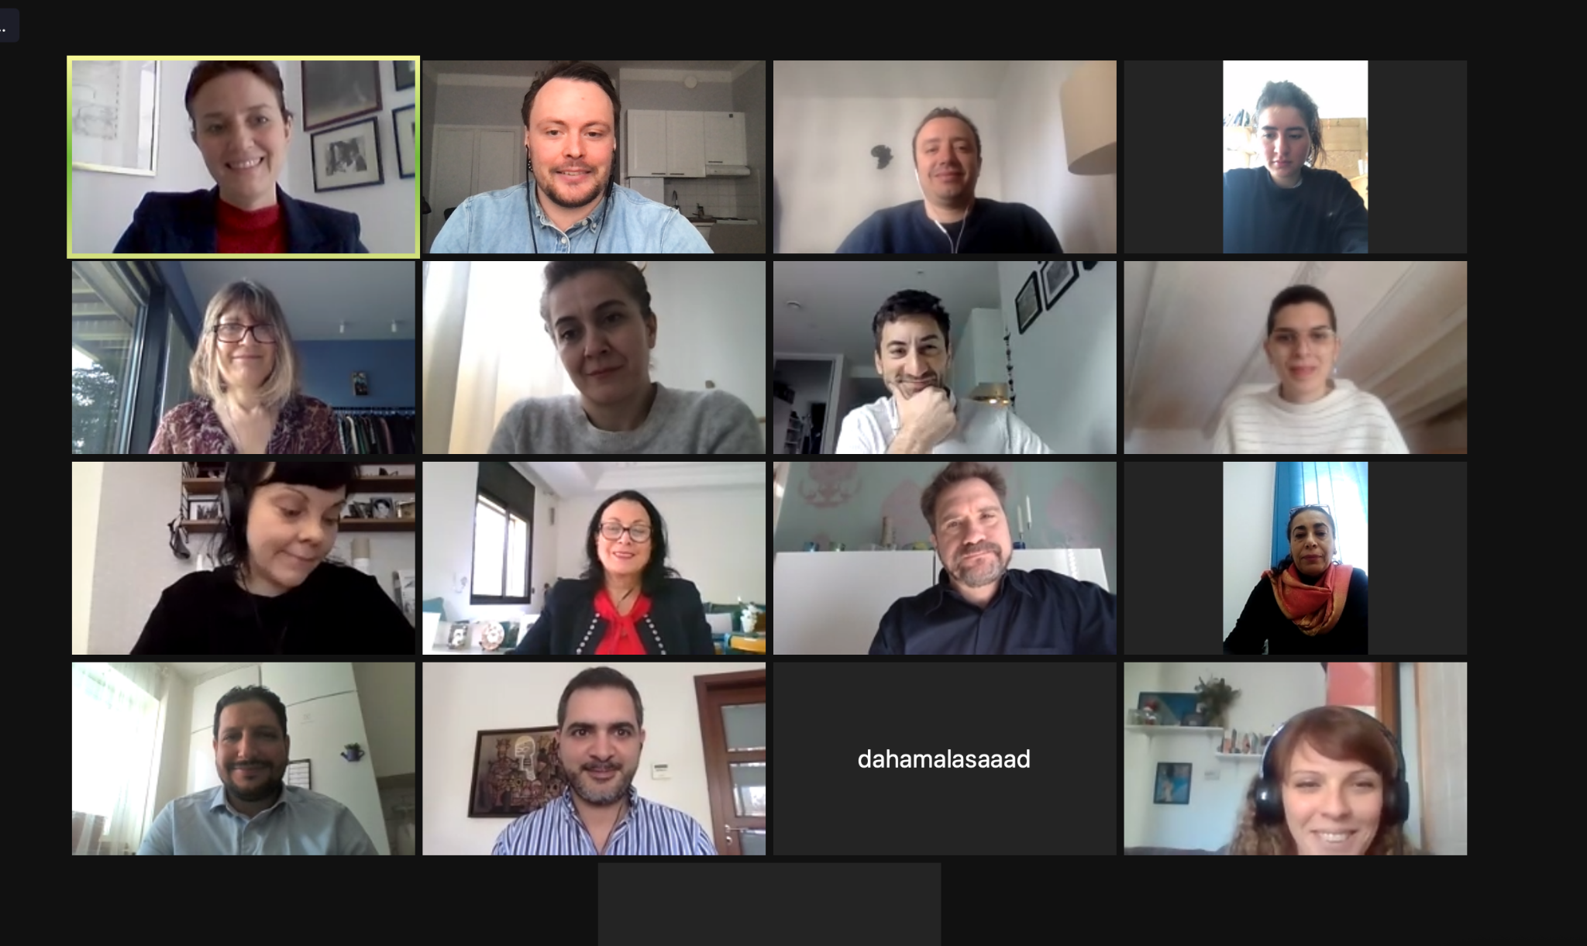

The Meeting 3
Summary of key challenges and recommendations 4
Annex 1: Press Release 7
Annex II Post-event Press Release 8
Annex III Agenda of the meeting 8
Annex IV Post-exchange Questionnaire 8

The Meeting

Background of the meeting

The Intercultural Trends and Media Platform brings together media, academia and civil society to debate on media narratives in relation to diversity and intercultural relations in the Euro-Mediterranean region.

A focus of the fifth Intercultural Trends and Media Platform was the media coverage of migration-related issues and coexistence within multicultural societies in the Euro-Mediterranean region.

The ALF shared results from the latest ALF-Ipsos Intercultural Trends Survey 2020 which gathered the views of over 13.000 people from both shores of the Mediterranean.

The event was, as previous platforms, conceived as a space for a facilitated discussion to exchange reflections on what can be done by journalists, academia, and civil society together to support intercultural relations and cooperation in the EuroMed region.

The following questions were used to orient the discussion during the meeting:

Since the outburst of the pandemic in which way the media has covered migration issues and cultural diverse communities within your country? Which good and bad practices could you share in relation to the portrayal of migrants and refugees within the current context?

What measures to promote diversity and dialogue via the media? What role could migrants and refugees and the media play for intercultural dialogue in the EuroMed region?

Summary of key challenges and recommendations

The fifth Intercultural Trends and Media Platform began with introductory remarks by Marcello Scalisi, Director of UNIMED and a presentation by Eleonora Insalaco, Head of Operations and Intercultural Research at the Anna Lindh Foundation.

In his opening remarks, Mr. Scalisi underlined that improving relations between academia, journalists and civil society in the Mediterranean is crucial to build unity among a Mediterranean generation. Speaking on the future of this generation, Scalisi underlined the opportunities that digitalization brings about in terms of enhanced networking among journalists, academics and civil society representatives. Furthermore, Scalisi predicted that Euro-Mediterranean issues will be back on the agenda after the passing of Covid-19. With this in mind, Scalisi called on all participants of the meeting to work on behalf of a better understanding of one another in the region.

In her introductory note, Eleonora Insalaco underlined that the Anna Lindh Foundation aims to give visibility to a variety of initiatives that promote dialogue in cities and at a grass-roots level in the Euro-Mediterranean. She also noted that the research of the Foundation also includes some statistics that are contradictory to certain stereotypes and contemporary populist discourses circulating in the public debates in the Euro-Mediterranean.

Insalaco also underlined that despite the prevalence of certain media narratives, a majority of respondents to the Intercultural Trends Survey of 2020 associate the Mediterranean region with positive values. For example, 93% of respondents in the North and 81% in the South associated the Mediterranean with a certain lifestyle and food, whilst 95% in the North and 90% in the South associated the region with hospitality.

With regards to migration, Insalaco also noted that perhaps in contrast to certain narratives dominating the news-cycle, the Intercultural Trends Survey conducted in 2020 reveals that 40% of Europeans would stay in their country of origin if they would be given the chance to start a new life somewhere else. Among the respondents in the Southern Mediterranean, 49% would prefer to stay in their country of origin, if given a chance to start a new life somewhere else. Furthermore, of these people only 20% would choose Europe as their preferred destination.

Lastly, Insalaco underlined the importance of taking the lessons learned beyond the virtual exchange of the meeting and think about the ways that each participant could, individually and through collaboration, promote dialogue and mutual understanding.

During the roundtable reflections, it was highlighted that Covid-19 has made encounters between journalists and people at the grassroots level more challenging, which is problematic as journalists depend on talking to people in different life situations, including migrants who found themselves in a particularly vulnerable situation. In this regard, it was also highlighted that the restrictions to travel presents an obstacle to foreign reporting on migration and data-collection for academic purposes.

Some participants to the meeting also shed light on the difficult situation they face with editors who do not want to publish stories on migration due to the pandemic.

The challenges that unaccompanied minors face were discussed, especially from the perspective of negative and masculine reporting of these minors. This reporting portrayed male minors as a threat whilst also ignoring the voices and experiences of unaccompanied minors who are female.

It was also noted that while migrants do receive some press coverage after having arrived in the destination country, few articles cover their journey from the country of origin.

Furthermore, it was acknowledged that working migrants are often on the front line during the pandemic, as they often work as taxi drivers or bus drivers or in other professions, that are not easily adaptable for remote work. Reflections also developed on how migrant communities have been blamed for high infection rates, which may lead to stigmatization.

It has also been reported that in some countries, migrants suffer from unequal access to vaccination, which is something that the media reported on poorly.

Reflections also developed around the question of migration being too often portrayed in the media as a problem. For example, in Sweden the public debate has focused on the country’s migration policies and as a result of this debate, some members of parliament have questioned whether the country should have asylum rights or not.

The gap between different news narratives was also discussed and it was acknowledged that migrants are too often either portrayed as victims or as a problem but seldom as something between the two.

Some journalists attending the meeting also highlighted that reporting on migration in the Mediterranean is thwarted by a lack of research or at least a lack of access to researchers and experts.

Recommendations

- More testimonies and stories from migrants themselves are needed for a nuanced public debate on the issue. Furthermore, more attention needs to be given to the bottom-up initiatives led by migrants themselves promoting integration, including advocacy.

- More media coverage is needed to shed light on the equal or unequal distribution of vaccines so that migrant communities won’t be left behind in this process.

- The media should bring nuance to the public debates on migration by telling the stories of for example families staying in their countries despite difficulties with the pandemic or otherwise and bringing a variety of people to tell their different stories.

- Education is crucial to promote dialogue and diversity and one way of doing so is through culturally diverse schools where children of migrants and the host communities go together.

- To encourage journalists to adapt to terminology used, to take into consideration cultural sensitivity. In order to do this, media literacy is crucial to build the capacities of media professionals.

Annex 1: Press Release

On the 8th of April and due to popular demand from participants to the fourth virtual Intercultural Trends and Media Platform, the fifth Intercultural Trends and Media Platform once again brings together media, academia, and civil society to discuss media coverage on migration, mobility and coexistence within multicultural societies in the Euro-Mediterranean region.
During the meeting, The ALF will share results from the latest ALF-Ipsos Intercultural Trends Survey 2020 which gathered the views of over 13.000 people from the region.
The following questions will be used to stimulate the discussion among participants:
- Since the outburst of the pandemic in which way the media has covered migration issues and culturally diverse communities within your country?
- Which good and bad practices could you share in relation to the portrayal of migrants and refugees within the current context?
- What measures to promote diversity and dialogue via the media? What role could migrants and refugees and the media play for intercultural dialogue in the EuroMed region?
About the Intercultural Trends and Media Platform
The Intercultural Trends and Media Platform is organised by the Anna Lindh Foundation and the Mediterranean Universities Union (UNIMED) bringing together media, academia and civil society to create a network and to discuss how perceptions between Europeans and Southern and Eastern Mediterranean people have evolved in recent years as a result of the growing migratory and refugee movements, the rise of populist’s discourses and phenomena of violent extremism.
If you are a journalist, member of civil society or academic who would like to participate in a future edition of the Intercultural Trends and Media Platform, please do not hesitate to contact us (Johannes.Jauhiainen@annalindhfoundation.org - Intercultural Research Social Media Executive).
For more information on the Intercultural Trends and Media work at the Anna Lindh Foundation you can contact: Eleonora.Insalaco@annalindhfoundation.org - Head of Operations and Intercultural Research.

Annex II Post-event Press Release

Pressing challenges of media narratives regarding mobility in the EuroMed discussed during the 5th Media Platform

As the pandemic has fueled the spread of fake news, populist discourses and disinformation journalists, academics and civil society need to collaborate to be able to contribute to a more nuanced and dialogue-driven discourse, in the media and elsewhere.

Issues relating to migration, mobility and media narratives are often subjects of heated public debates in Europe and the Southern Mediterranean, the Anna Lindh Foundation, together with the Mediterranean Universities Union organised on the 8th of April the fifth Intercultural Trends and Media Platform, which brought together media, academia, and civil society to discuss media coverage on migration, mobility and coexistence within multicultural societies in the Euro-Mediterranean region.

During the meeting the Anna Lindh Foundation offered participants insights from the latest ALF-Ipsos Intercultural Trends Survey 2020 which gathered the views of over 13.000 people from the region.

During the meeting the following recommendations were expressed, with regards to how the Foundation and other actors in society could promote nuanced and dialogue-driven media discourses:
- More testimonies and stories from migrants themselves are needed for a nuanced public debate on the issue. Furthermore more attention needs to be given to the initiatives led by migrants themselves promoting integration.

- More media coverage is needed to shed light on the equal or unequal distribution of vaccines so that migrant communities would not end up treated worse than the majority population.

- The media should bring nuance to the public debates on migration by telling the stories of for example families staying in their countries despite difficulties with the pandemic or otherwise and diversifying the voices relating their narratives

- Media literacy is important in order to promote dialogue and mutual understanding in the media.

- Education is crucial to promote dialogue and diversity and one way of doing so is through mixed schools where children of migrants and the host communities go together.

About the Intercultural Trends and Media Platform
The Intercultural Trends and Media Platform is organised by the Anna Lindh Foundation and the Mediterranean Universities Union (UNIMED) bringing together media, academia and civil society to create a network and to discuss how perceptions between Europeans and Southern and Eastern Mediterranean people have evolved in recent years as a result of the growing migratory and refugee movements, the rise of populist’s discourses and phenomena of violent extremism.
If you are a journalist, member of civil society or academic who would like to participate in a future edition of the Intercultural Trends and Media Platform, please do not hesitate to contact us (Johannes.Jauhiainen@annalindhfoundation.org - Intercultural Research Social Media Executive).
For more information on the Intercultural Trends and Media work at the Anna Lindh Foundation you can contact: Eleonora.Insalaco@annalindhfoundation.org - Head of Operations and Intercultural Research.

Annex III Agenda of the meeting
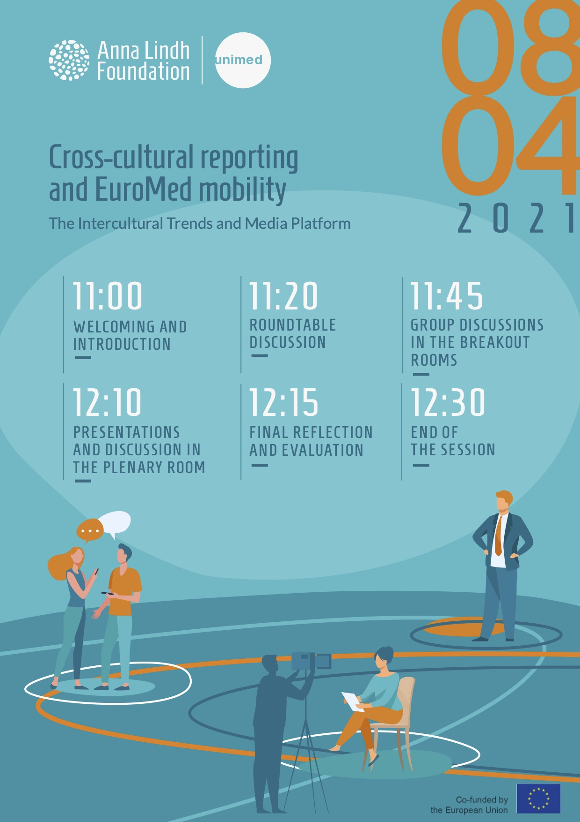

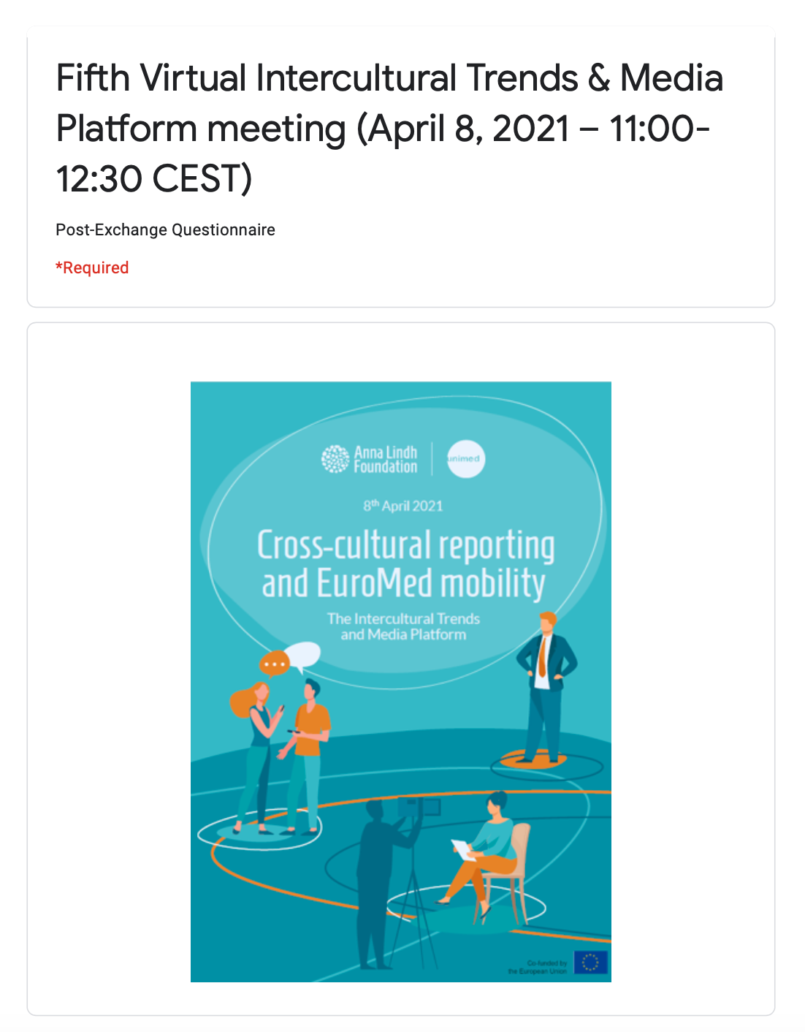
Annex IV Post-exchange Questionnaire
