Connecting with nature in Bodrum
(2023)
Nowadays we are often surrounded by tall gray buildings, countless people we don’t know, and heavy traffic. we often eat unhealthy food, spend lots of time on our computer checking emails, sending documents, always looking for new opportunities, or just wasting time. But at some point, we all get frustrated, we want to get away from city life and just become part of the beautiful, quiet nature for some time. This is exactly what we did from the 16th of January to the 26th of January after we met the director of “The Artemis Project” at one of the Anna Lindh foundation conferences in Eskişehir.
Before writing about my experience, I will briefly introduce the project. The Artemis Derneyi is an association of artists, craftsmen, experts, and sponsors for art, environment and climate protection, and environmental education. Artemis Dernegi also represents a broad concept of culture that includes dance, theater, performance, music, visual arts, and all forms of everyday culture. It promotes the (inter)national development, networking, and implementation of artistic ecological, feminist, and social projects that are cultural, democratic, and ideally innovative. Association also focuses on artistic and environmental education and support for children and young people, especially girls and young women of all nationalities, religions and social backgrounds.
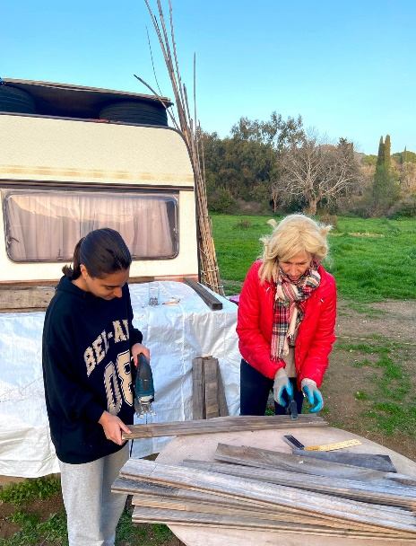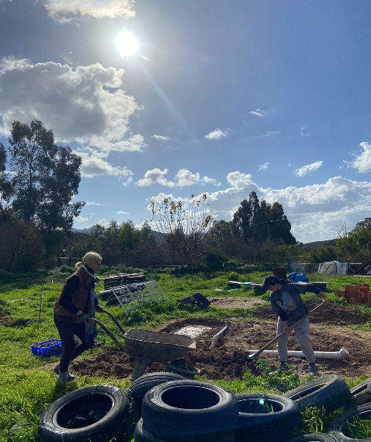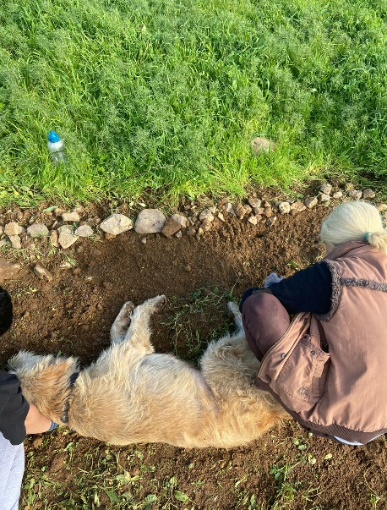
Picture 1 women empowerment (Bodrum,2023)

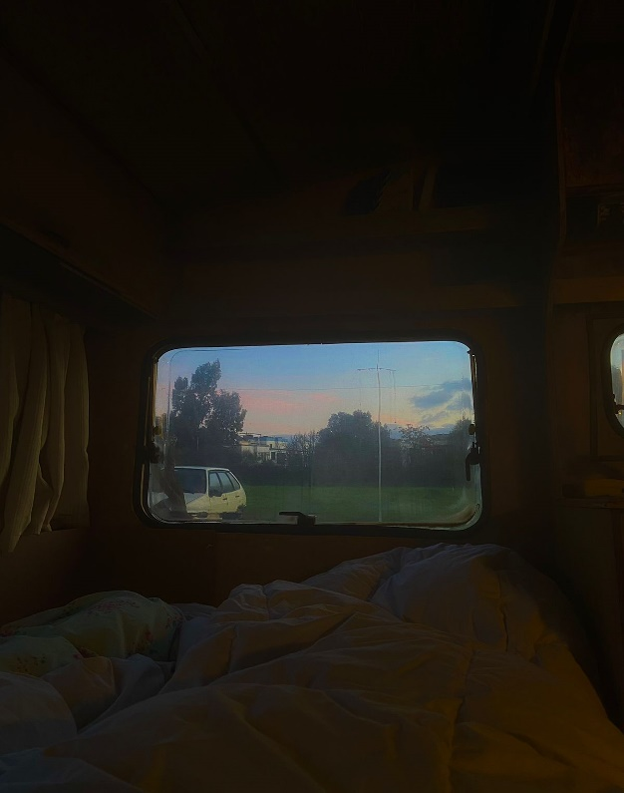
Living in a caravan:
Story of Mariam:
It is difficult to put all the emotions on paper after spending these days in Dereköy. waking up with 5 friendly dogs in the middle of nowhere, surrounded by green land ( although it is winter) is nothing but peaceful and magnificent. Every morning we used to wake up early and plan our daily activities while having organic breakfast in the Garden. Our ctivities usually involved: building a washhouse (the main topic of the project), preparing the garden for planting season, practicing yoga, dog training, and building small houses for them. Although some work required more strength than we had, it was still enjoyable and productive, because of the positive energy and good music.
Story of Ezra:
“My name is Ezra, and I’m a volunteer in the Artemis Project. I know there is not enough word to express my experience here in Derekoy, Bodrum, but I wanted to talk about it. I was always into nature and environmental activities, and this experience was great for me. I stayed in a camper van in a vast garden full of dogs. We wake up with the bright sunlight in the morning, starting our day first with breakfast and some stretching, and yoga activities. We have different tasks every day. We built a washhouse and two dog houses did some other gardening activities and did a lot of additional work. Elisa was a great mentor and coordinator, and we learned a lot from her. She helped us to have a better connection with the environment, get close to nature both physically and spiritually, find our power as women, and greatness of sharing and caring for others. We used permaculture techniques and recycled or recyclable materials in every activity and said stop to waste and climate change. I’m so grateful and appreciative of having a chance to be part of this project”

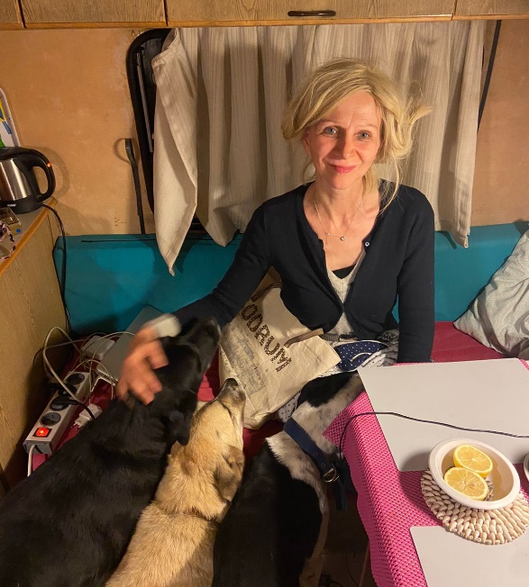
Interview with Elisa Gelewski
(The coordinator of the Artemis project )

Mariam : Why Did you choose to name the project ARTEMIS?
Elisa: ARTEMIS ist die vorchristliche Muttergöttin aus der westlichen Ägaisregion und steht für die Kräfte des Waldes und der Natur. Sie unterstützt und beschützt Frauen und Kinder. In diesem Sinne vertritt sie die Ziele und den Zweck unseres Vereins. (DE)
ENG : ARTEMIS is the pre-Christian mother goddess from the western Aegean region and represents the powers of the forest and nature. She is the guardian and protector of animals. She supports and helps women and children. In this sense, she represents the goals and purpose of our association.

Mariam: “Was the implementation of the project a difficult journey?”
Elisa: „Die Gründung des Vereins war sehr schwierig. Wir versuchten zuerst eine Zweigstelle unseres schon gegründeten deutschen Vereins in der Türkei zu eröffnen. Leider verloren wir viel Zeit und Rennerei damit und schlussendlich wurde uns alles von den Behörden in Ankara aus politischen Gründen abgelehnt. Es dauerte danach nochmals mehrere Monate die richtigen Mitglieder für einen komplett neuen türkischen Verein zu finden. Eine öffentliche Präsentationen in einem ökologischen Cafe war nötig um Mitstreiter für die Gründung anzusprechen und zu finden. Es waren dann vor allem Frauen, die die Ziele des Vereins positiv bewerteten und Gründungsmitglied wurden. Es gab viel viel viel Bürokratie zu bewältigen, viele Enttäuschungen mit Mitgliedern, die sich als völlig fehl am Platz herausstellten und uns gleich am Anfang im Stich ließen. 2016 war dann ein harter Schlag. Meine Partnerin und zweiter Vorstand verstarb an Lungenkrebs. Der Verein wackelte und es musste ein Ersatz gefunden werden. Aber Ausdauer und Durchsetzungsvermögen rentierten sich und unser Verein ist trotz aller Anfangsschwierigkeiten mittlerweile in Bodrum bekannt geworden.“ (DE)
ENG: ”The establishment of the association was very difficult. We first tried to open a branch of our German association, which had already been founded, in Turkey. Unfortunately, we lost a lot of time and running and finally, everything was rejected by the authorities in Ankara for political reasons. It then took another several months to find the right members for a completely new Turkish club. A public presentation in an ecological cafe was necessary to address and find fellow campaigners for the foundation. It was mainly women who rated the goals of the association positively and became founding members. There was a lot of bureaucracy to deal with, and a lot of disappointments with members proving totally out of place and letting us down right from the start. 2016 was a hard blow. My partner and co-chair died of lung cancer. The club wobbled and a replacement had to be found. But perseverance and perseverance paid off and our club has meanwhile become well-known in Bodrum, despite all the initial difficulties.”
Mariam: “Since the establishment of ARTEMIS how far have you come?”
“Die ersten Jahre waren sehr hart. Das Bewusstsein für Umwelt war noch weniger ausgeprägt als es jetzt immer noch ist. Wir leisteten wirklich Pionier Arbeit mit kleinen Umwelt Kampagnen. In kleinen Schritten ging alles langsam voran. Ein Meilenstein war dann endlich die Findung unseres Geländes in Bodrum / Dereköy. Die Vision rückte plötzlich näher! ARTEMIS Lebensgarten – Jugendliche pflanzen für die Zukunft wurde Realität. Doch es war nicht einfach. Die funktionale Entwicklung für Strom, Wasser, 120 Meter Zaun mit Eingangstor, Bachaushebung, Installation einer 8 Meter großen Wasserpipe, Müllentsorgung, normale Gartenpflege, etc. nahm wieder viel Zeit in Anspruch. Doch dann ging es endlich los mit den ersten Workshops im Lehmhausbau. Wir veranstalteten mehrere internationale Seminare und bauten ein rundes Lehmhäuschen. Unser Headquarter war gebohren, wir konnten ein Büro und eine Gemeinschaftsküche einrichten. Parallel dazu wurde der erste Caravan angeschafft um Schlafplätze in der Bauphase zu garantieren. Einige Straßenhunde fanden den Weg zu uns und verließen uns auch wieder. Einige sind geblieben und begleiten uns seitdem durch alle Höhen und Tiefen. Zwei Hundehütten konnten gebaut werden. Ein Storage 6 – Eck aus Paletten zur Aufbewahrung von Upcycling Materialien. Ein kleiner Gemüsegarten ist entstanden. Derzeit wird ein Lehm – Waschhaus gebaut und damit die sanitären Möglichkeiten abgedeckt.“ (DE)
ENG : “The first years were very hard. Awareness of the environment was even less pronounced than it is now. We really pioneered small environmental campaigns. Everything went slowly, in small steps. A milestone was finally the finding of our premises in Bodrum / Dereköy. The vision suddenly came closer! ARTEMIS Life Garden – Young people planting for the future became a reality. But it wasn't easy. The functional development for electricity, water, a 120 meter fence with an entrance gate, raising a stream, installing an 8 meter water pipe, waste disposal, normal garden maintenance, etc. again took a lot of time. But then it finally started with the first workshops in clay house construction. We held several international seminars and built a round mud house. Our headquarters were born, we were able to set up an office and a communal kitchen. At the same time, the first caravan was purchased to guarantee sleeping places during the construction phase. Some street dogs found their way to us and left us again. Some stayed and have been with us through all the ups and downs ever since. Two kennels could be built. A storage 6 - corner made of pallets for storing upcycling materials. A small vegetable garden was created. A clay washhouse is currently being built to cover the sanitary facilities.”

Mariam: “What is the main purpose of the project?”
„Der Hauptzweck des Projektes ist die Entstehung und Gestaltung eines Permakulturgartens, der als Eco Jugend Camp für inter/nationale Jugendgruppen zu allen Themen in Umwelt und Klimaschutz offen stehen soll, wie z.B. Umwelttechnologie, Upcycling, Biodiversität und Gärtnern.“ (DE)
ENG: “The main purpose of the project is the creation and design of a permaculture garden, which should be open as an Eco Youth Camp for international/national youth groups on all topics related to the environment and climate protection, such as environmental technology, upcycling, biodiversity and gardening.”
What advice can you give to the young generation??
Elisa: Wir unterrichten die Jugendlichen und Jungen Frauen in allen Seminaren und Workshops für Upcycling, Gartenarbeit, Nachhaltiges Bauen nach der Methode der Earth Charta und der Feldenkrais Methode. Jugendliche, StudentenInen und Junge Frauen kommen so ganzheitlich mit den Themen in Berühung. (DE)
Eng: We teach the youth and young women in all seminars and workshops for upcycling, gardening, and sustainable building according to the Earth Charter method and the Feldenkrais method. Young people, students, and young women come into contact with the topics holistically.

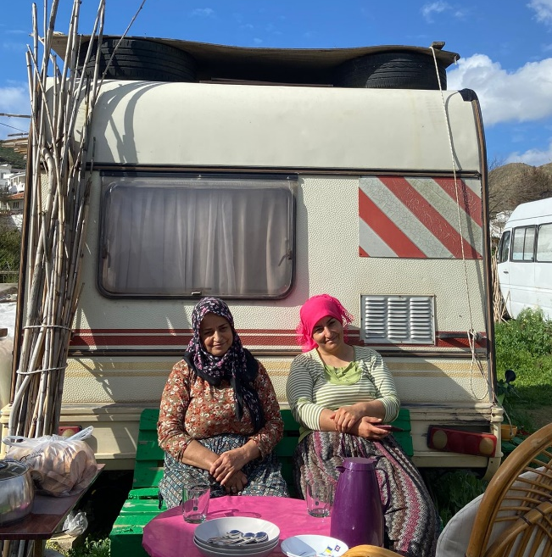
“we really like helping Elisa, because she is so kind. She always thinks about everyone: Dogs, people, the younger generation. She is always positive and tries to help every creature. This is why we always try to find time to come here and help her with work. She is building a place not only for herself but also for our children and grandchildren. We want to be a part of the project and recommend everyone to take part in it. I especially, we recommend young people to come to Bodrum and have the opportunity to leave a positive footprint in this world, starting with this environmentally friendly Project”
- Bilge ( local woman helping us build the washhouse)

Without any more words, you can feel how wonderful the project is. We, as volunteers of System and Generation, will continue planning further projects in Bodrum to help Elisa and open a youth center in Bodrum.

