ALF DK November 2024 NEWSLETTER

Introduction

Following the tragic escalation of the Israel – Palestine conflict on October 7, both ordinary citizens and civil society organisations in Denmark have been deeply frustrated by the one-sided position of the government’s position. As a results, tens of thousands of citizens and organisation have taken the issue in their hands and launched daily demonstrations on the streets across Danish cities and in front of the Danish Parliament.

The protest movements demand immediate and permanent ceasefires, unhindered access to life saving supplies like water, food, medicine, and the provision of shelters as well as to honestly address the root cause of the problem which has been festering for over 70 years. For this purpose, more than 50,000 signatures have been collected and delivered to the Danish Parliament on Monday. According to the Danish law, the Parliament is now obliged to take up the demands and vote on them.

Like everywhere across the Euromed region, the escalation has both shocked and disrupted the work of our ALF members in Denmark. It has been simply impossible to ignore the mass and indiscriminate massacres, starvation, displacement and destruction in Gaza following the October 7 killing and abduction of citizens in Israel.

In the face of this tragedy and the position of the Government, it has not been possible to continue talk about dialogue and intercultural exchange while we witness a tragedy unfolding before our own eyes. Therefore, we purpose that the upcoming HoNs meeting in Istanbul on 14-15 December be dedicated to serious and meaningful dialogue in the context the situation on the ground.

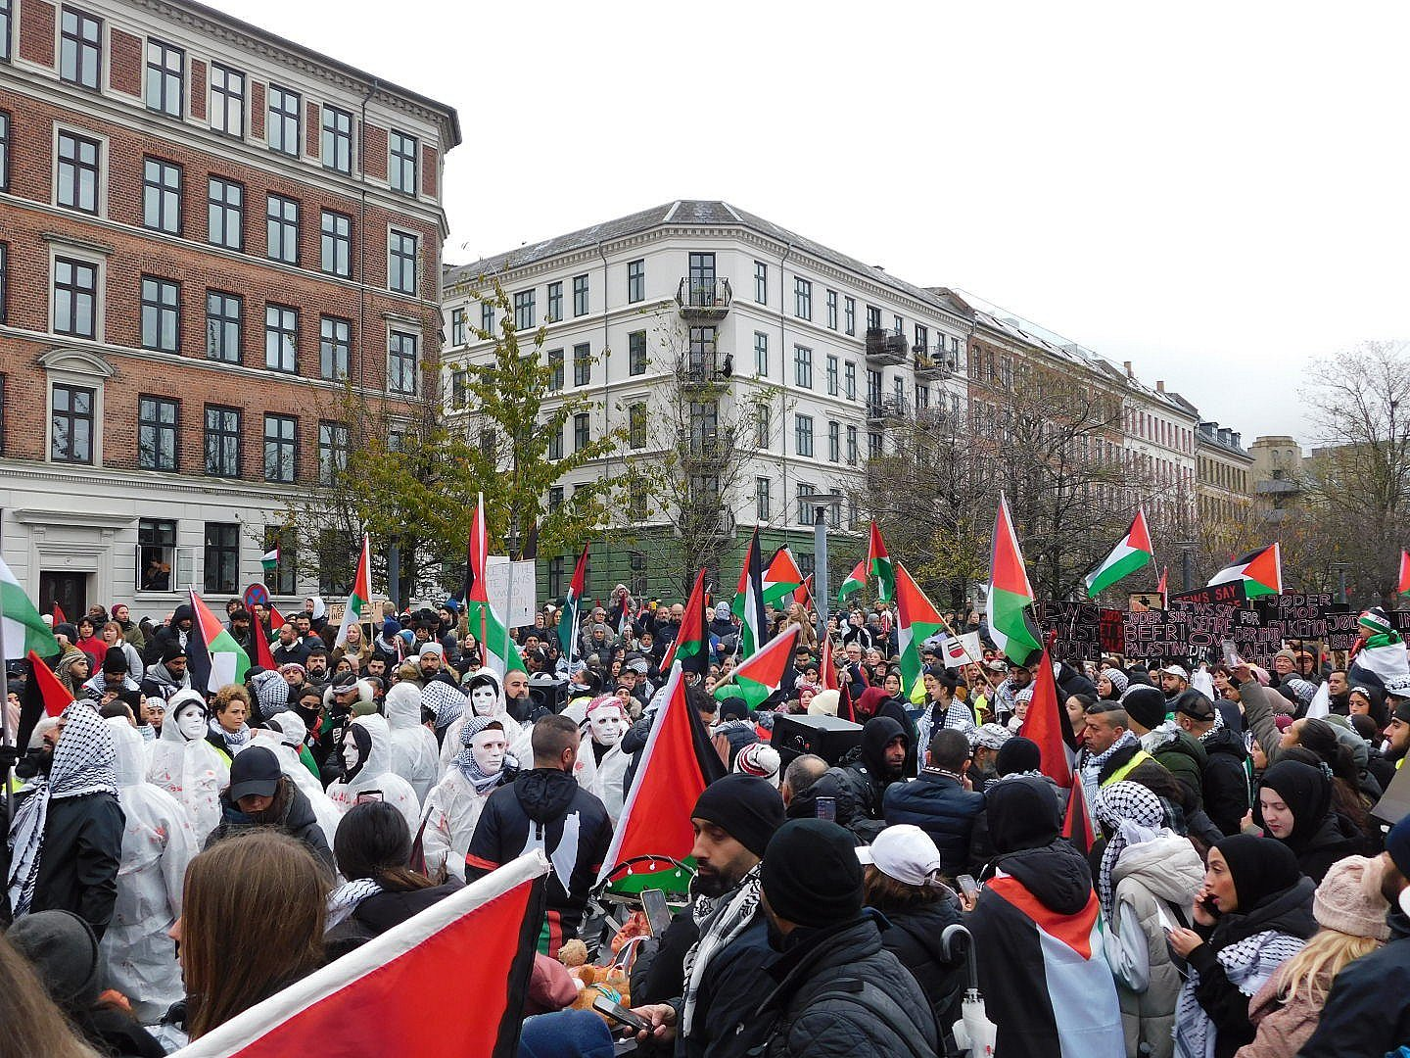
Migrantour with the International People’s College- IPC

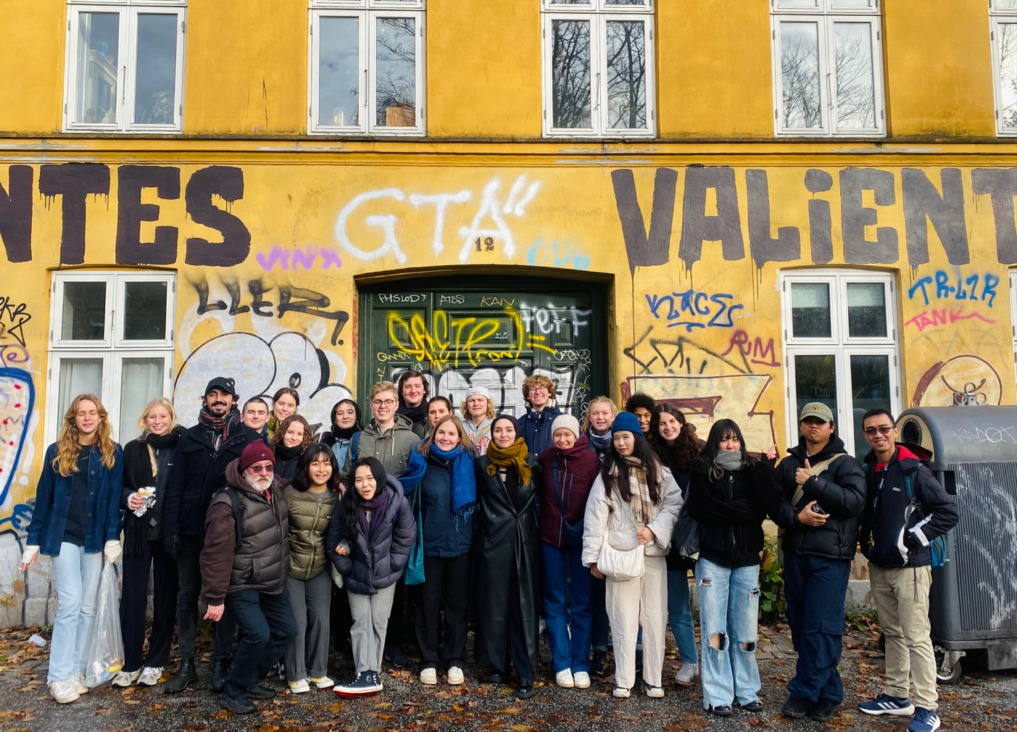

Organised by the Anna Lindh Danish Network, the event was a collaboration between Crossing Borders as Head of the Network and International People’s College as a member. The purpose of the Migrantour is to train and empower immigrants to tell their stories and the stories of the neighbourhoods they call home from their perspectives. The guides of the tour were Furkan Akay from Turkey and Maryam Alaouie from Lebanon.
After taking part in her first migrantour, Crossing Borders volunteer Margaret Maged Maher from Egypt wrote the following piece on her experience:
On my second day in Denmark 15 November 2023, I had one of the best experiences I’ve had in learning about a world I wasn’t aware of! How can one neighbourhood contain all these landmarks that highlight so many cultures?
I never thought that when I came to Denmark, I would see so much diversity and different ethnicities from many cultural backgrounds from all over the world.
On this migrant tour I was one of 23 international students from various countries including Belgium, Canada, Denmark, France, Japan, Korea, Mexico and Vietnam. After coffee and croissants, we were taken on exciting tour of NørreBro starting from the Cultural House UNION and through some 5 landmarks in the Nørrebro neighborhood which ranks as the coolest neighbourhood in the world in 2021 according to Time Out magazine.
Each landmark has its own story about the cultural background those immigrants brought along with and how they integrated into this new world while maintaining their own identity. The neighbourhood has both been shaped by as it shapes the new cultures.
At the end of the tour, I discovered that the migrant tour is one of the most important activities that emotionally affect a person and make him more connected to where he is.

Syrian Documentary Days

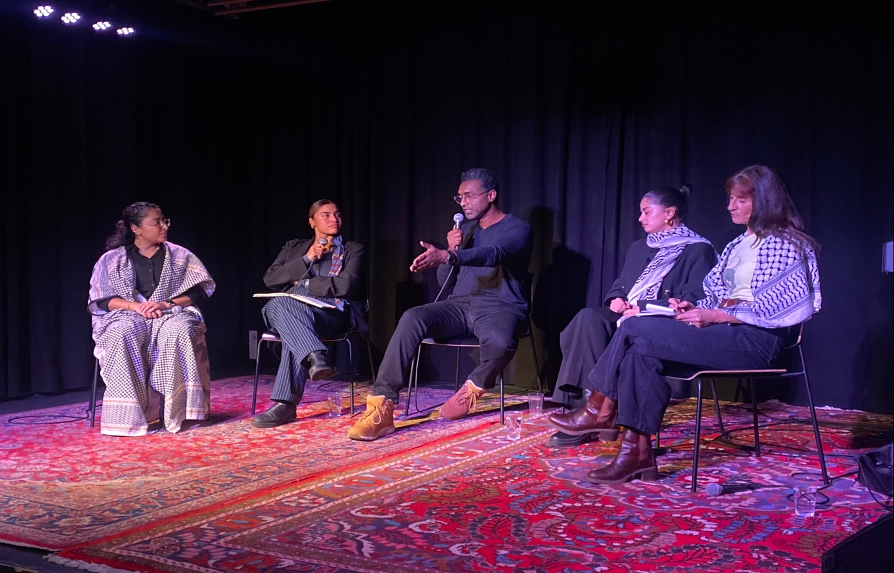

Syrian Doc Days, short for Syrian Documentary Film Days, is dedicated to stories about Syria that go beyond the general narrative. The festival took place in Copenhagen from the 22nd of November till the 26th organized by the Syrian Docs in collaboration with Crossing Borders, MS Action Aid, Union Cultural House, and online news outlet Globalnyt.

The festival included film screenings, talks, and other cultural activities. On the 24th there was a screening of the documentary, We Are the Giant. This film takes us on a journey through the revolutions of dignity in Libya, Syria, and Bahrain. Released in early 2014, it sheds light on the events that unfolded in these regions.

The screening was follow up by a panel discussion on what had happened in the region ever since 2011, what we have learned about revolutions and the forces that back dictatorships, and the importance of solidarity among the movements for democracy.

The panel members comprised the Sudanese political cartoonist Khalid al Baih, Bahraini human rights activist Maryam Alkhawaja, Afghani activist Manilla Ghafouri, and Syrian activist Wafa Ali Mustafa.

Annual Assembly 2023

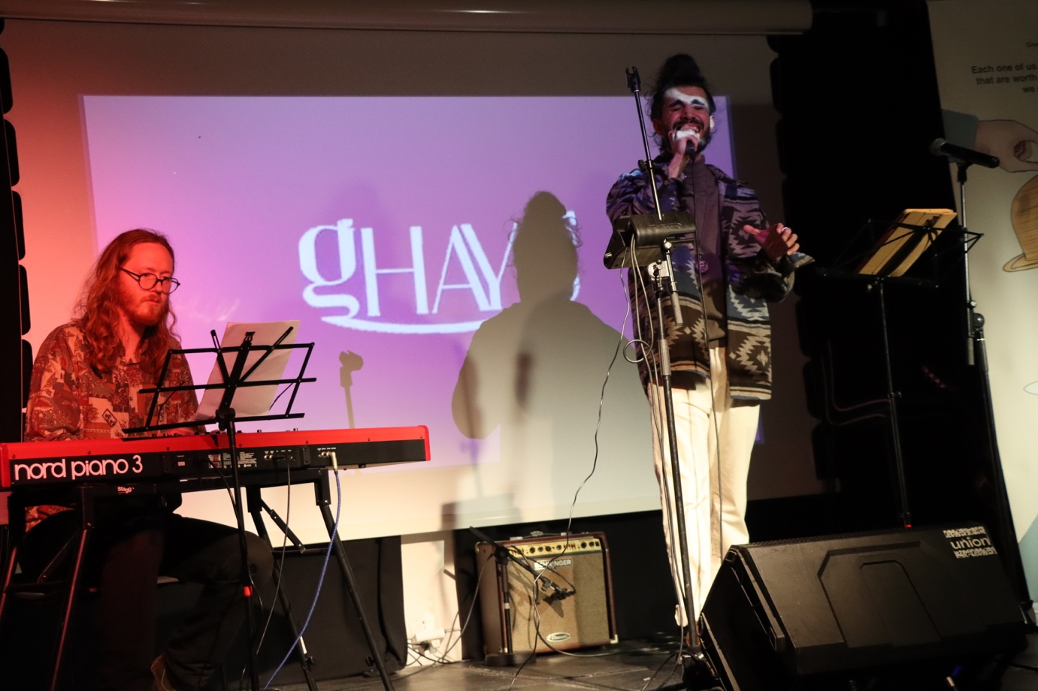

On November 23rd, Crossing Borders hosted a captivating night of international collaboration. The event featured powerful presentations, poetry performances, and musical delights by extraordinary artists and human rights advocates including Danish - Bahraini Human Rights Advocate Maryam Al Khawaja, Danish -Malian Slam Poet Sarah Diallo, Afghan author and poet Dr. Hamed Samay, and Syrian-German artist Ghays Mansour.

This event provided an exceptional platform to highlight the work of the DK ALF members and how these resonate with and the shed light on the mission, values, and goals the Anna Lindh Foundation. The evening served as a unique opportunity to attract new members and amplify awareness about the foundation's impactful initiatives.

Meet DK ALF Member of the Steering Committee Angel L. Vidal - Teacher, facilitator & "brain developer" at International People's College (IPC)

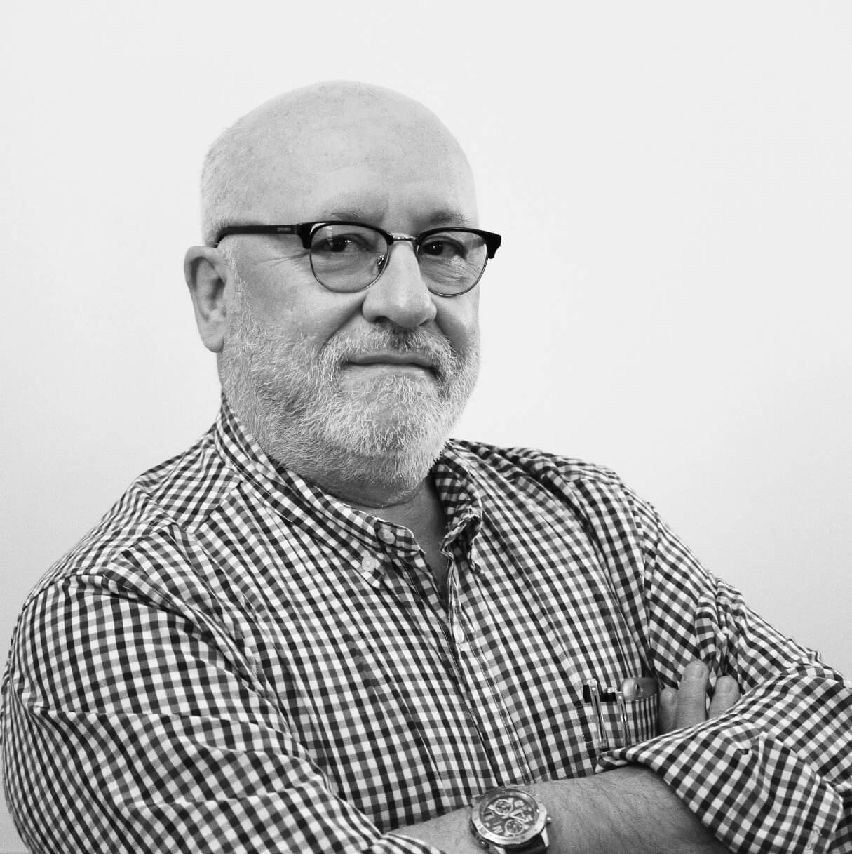
Angel has a long-standing experience in leading International Programs, Institutions, NGOs and training/learning institutions and projects Strategic vision, analysis and planning and innovation. Angel’s skills include integrating the use of ICT and social media in learning, management, team building, marketing, and intercultural communication. His background spans the UN, Nansen Dialogue Network & Nansen Center for Peace & Dialogue in Norway, the International People’s College in Denmark and various others. For more on Angel, see his linked

Brand E-book:

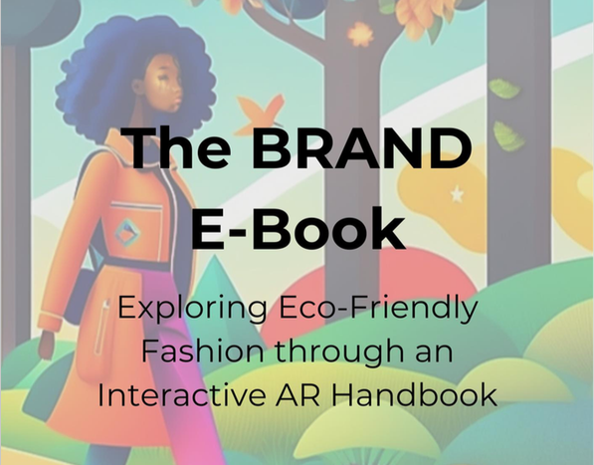

The E-Book of the brand project is the product of the collaboration with different ALF members. The consortium designed 12 BRAND Case Studies: sustainaBility stoRies in fAshioN inDustry, a digital catalogue of success stories in terms of ethical and sustainability-oriented ideas and initiatives originated from the fashion industry world (ethical /sustainability-oriented ideas and initiatives originated from the fashion industry).

It will present green sustainable practices and initiatives in the fashion world with special focus on recycling, on raising awareness, on behavioral change. The digital e-book will be a maximum of 40 pages and will be available through the website and will be also downloadable in a PDF format. The user will also have the option to display, download and use each case study and success story independently. For details, see here

