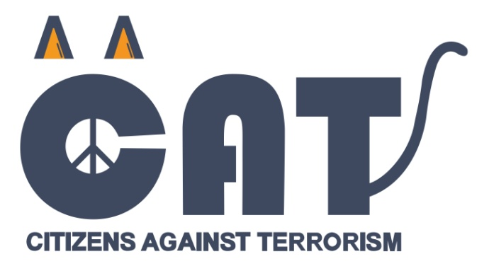
In 2020, the Youth Resource Center Tuzla, as part of the CAT Bosnia and Herzegovina campaign, worked on many activities. Our focus has always been primarily on young people, and we have managed to highlight even them and their ambitions through a pandemic through various activities and show how ready they are to engage.

If you followed us on social media, you could see that we did a lot of things in a year and showed that through different campaigns we can achieve everything that the community needs. In the following, we will make a small retrospective of everything that was current in the previous year.

The whole world knows that in March we were caught in a great pandemic which, unfortunately, has not yet come to an end. Namely, our Elda Lolić diligently performed her tasks even during quarantine, and interviewed young and ambitious people and thus showed their enthusiasm, creativity, optimism and desire to continue their activist engagement even through the online sphere.

Having already touched on the online sphere, it is important to note that we launched the first online CAT BiH Digital Academy in which we gathered twenty-three most motivated young social network managers from civil society organizations in Bosnia and Herzegovina. After the fourth module in October, the participants of the Academy were able to launch their digital campaigns in partnership with other participants. Seven successful campaigns have been launched, namely: #ispodfiltera, „Kupujmo srcem“, „Kako si?“, „Govor mržnje na internetu“, #mladimaprostora, „Građanski aktivizam – volonterizam“, „Šta žele mladi?“.

However, in the five-year year, you could mostly recognize us by the roles that Mirela Biković, Elda Lolić and Malik Sakić worked on, that is, by „#CatPatrola“, „PR(a)vo lice aktivizma“ and „#PodCat“. You can watch their fantastic engagement and all their shows on our YouTube channel.

In August 2020, we held a Team Building in Fojnica, after which 3 offline campaigns / street actions were launched. The training goals were to build a team and create street campaigns for new CAT local teams from Prijedor, Mostar and Bijeljina. Participants showed an enviable level of experience and productivity during the training sessions, and then, with the help of their mentors, campaigns were designed that were dedicated to ecology, breaking down prejudices and the problem of enrollment policy at the Faculty of Mining.

During all that time, our team actively worked on the documentary "Efednijin zavjet", which premiered on December 15, 2020 at the Tuzla National Theater, and then on Radio Television 7 (RTV7) Tuzla, which has long provided selfless support to our team, and works wit. ORC on the TV show "With cats in the community", in which we released 11 shows focusing on current social issues, the city, people, youth support, youth opportunities, civil society, social activism and which you can also watch on our YouTube channel.

One of the most interesting collaborations from 2020 is with satro.info and MAP in the #sjašite campaign. The #sjašite campaign was launched by several civil society organizations in BiH in order to draw public attention to the absurdity of the political narrative that prevails in Bosnia and Herzegovina. As part of the campaign, the show Uhljeb nedelje, daily mimes on the CATBiH website was launched, followed by a quiz in Sarajevo, and an activity in Mostar before the voting. And now the last, but no less important campaign is the support for the #TvojGlasJeBitan campaign, which was created as a kind of reaction to the results of the 2018 general elections.

The production of all the above campaigns and activities is signed by 10 enthusiastic young people, who come from northeastern Bosnia and Herzegovina, and you can see more about them here: https://www.catbih.ba/impressum/

And finally, our daily engagement as before, you can follow at:
YouTube , Web, FACEBOOK, TikTok, Linkedin and Instagram

