Partner organisation
New Organization ID (2020) |  | E10184065
PIC |  | 922540520
Full legal name (National Language) |  | Πολιτιστικός Οργανισμός Μακεδονίας –Θράκης  ΕΣΑΕΙ ΕΝ ΡΟΗ
Full legal name (Latin characters) |  | ESAI EN ROI Cultural Organization of Macedonia - Thrace
Acronym |  | EERcomt
National ID (if applicable) |  | 27639
Department (if applicable) |  | Dept. of EU Project Management
Address |  | 4, EratosthenousStr., AnthokipoiPolichnis
Country |  | GREECE
Region |  | N. Thessalonikis, Central Macedonia
P.O. Box |  | ---
Post code |  | 56429
CEDEX (only for France)
City |  | Thessaloniki
Website |  | http://esai.gr/eer
Email |  | eu@esai.gr
Telephone 1 |  | +306906982244
Telephone 2 |  | +306936597376
Fax |  | +302314042342
Profile
Type of organization |  | Non-governmental organisation/association/social enterprise
Is the partner organization a public body? |  | No
Is the partner organization a non-profit? |  | Yes
Accreditation
Has the organization received any type of accreditation before submitting this application?
Accreditation type |  |  | Accreditation reference
European Voluntary Service |  |  | Project Code 2018-1-EL02-KA110-003788
European Solidarity Corps |  |  | Quality Label as Supporting and Hosting Organization (2019)
Background and experience
Please briefly present the partner organization.
Esai en Roi Cultural Organization of Macedonia – Thrace is a Cultural Association activated in the Fine Arts era, in Cultural conscience & Cultural issues related to "Quality of Life" and "Sustainable Environment" development. EER is strongly connected to Fine Arts Innovation, Research & Education and supports youth activism via creativity and arts. Through regular artistic activities and festivals EER facilitates Artists’ sociability and Cultural Heritage vigilance. EER cooperates with public authorities and private associations or companies sharing common aims or interests. EER was a non-formal group of artists between 1997-1999. Since 2013 EER festivals have been acknowledged for their importance as to be nominated “under the aegis” of Ministries of Tourism, Infrastructure & Transport, Culture & Sports, Education, Foreign Affairs & Interior (Macedonia -Thrace Region). EER Activities EER collaborates with other institutions and Associations related to Fine Arts, Tradition, Research, Health and Education, Sustainable Environment, Social Solidarity and Quality of Life aiming to the quality EER services development linear to contemporary social needs and ICT standards; EER participates in research & innovation projects relevant to Sports and Fine Arts in education; health; ecosustainability; elite performance; innovation; social solidarity. For more about our Annual Activities, please visit our official website http://esai.gr/eer under the label SERVICES > “Projects”.

What are the activities and experience of the organization in the areas relevant for this application?
EERcomt & YOUTH
We strongly believe that quality of life could be generated through sharing the opinion that «everybody is as important as to influence community’s social status and cultural development». Youngsters are from their nature the most appropriate age-group as to attract the entropia of a better world. They just need guidance and support to learn how to use their power and how to build their self-protection through setting personal limits according to their needs and desires without annoying or disturbing the common «good». Thus, EER supports Youth Actions and Young Artist Activities claiming their importance in Social Life via Arts & Physical Rehabilitation in Society.

ACTIVITIES
Our volunteers are mainly young people, who are seeking opportunities for personal development or they are interested in gaining professional experiences in the sector of performing and visual arts. Some of our members are also interested in supporting activities of social interest or they have a minority social profile (youth with fewer opportunities, learning difficulties, mild mental disorders, disabled, etc). EER is interested in projects supported from the European Solidarity Corps, KA1, KA2, kA3 erasmus+ and Creative Europe Projects.

EER QUALITY & IMPACT
EER has an experience of over 20 years in project management of short term projects. During the last three years, we started on coordinating more complex activities with annual duration. Our activities are under the aegis of Ministry of Interior (Sector of Macedonia - Thrace) & for some cases, with the support or quality accreditation of Ministry of Education & Religion & Ministry of Culture & Sports. EER is: an official member of the International SKILLMAN Network in the educational sector as an Area Coordinator; subscribed in the Portal of Cultural Associations of the Ministry of Culture; accredited with the badget of Socially Responsible Organization 2020 in Sports era; member of the "Youth Work Today" Community of Professionals; ESC & EVS Accredited Organization; member and supported of the Life. Beyond Funding Campaign. EER has been awarded in 2021 with the Best Health and Wellness Award via Arts and Sports (by GHP International) and in 2022 has got official membership in Global Waste Cleaning Network.

COLLABORATIVE PROJECTS
EER collaborates with other institutions and Associations related to Fine Arts, Tradition, Research, Health and Education, Sustainable Environments and Quality of Life aiming on upgrading the quality of its services linear to contemporary needs and ICT standards. Some of the most important and regular affiliated partners are Institute of Nutritional Research & Education (support in QoL activities), Konstantinion Research Center of Molecular Medicine and Biotechnology (EER implication in Research), Children’s Creativity Center KDAP PLATON, Club of Sign Language Distribution, etc.

RESEARCH ACTIVITIES
EER is participating in research projects related to Fine Arts and a) education, b) health, c) elite performance, d) innovation and e) disabled.EER SOCIAL MINORITY ACTIVITIESEER is supporting Social and Special Population Minorities to participate in Art-Creation & Sport activities with a manner that promotes the positive rather the negative options and perspectives of their social identity. Disabled communities participate in the annual festival of inclusive culture, where we are one of the four main coordinators. Moreover, disabled youth 15-25 years old are able to participate to activities of talent promotion in the field of arts and all of our activities as active citizens offering their services, promoting our activities or participating in them (https://esai.gr/dhias.html).
Our upcoming festival, focusing to creative minds with much of innovation and contemporary fast-track skills and competences upgrades in fine arts is the handiedancefestival www.handiedance.com

CAREER ORIENTATION AND TALENT PROMOTION in ART-RELATED OCCUPATIONS
EER core has only one department concerning professionalism and career practice of youth. That is the EER Department of Dancetheater. Since 1997 is EER regularly producing dance-theater and dance performances, cooperating with several dance-companies, performers, choreographers, directors, musicians, scenography designers and technical assistants. The productions concern and deal with Greek social social topics or Greek culture and tradition. Moreover, since 2004 EER implements young artists' nights and since 2017 screening tests of young talents in Fine Arts (https://esai.gr/talent.html).

ECO-PROJECTS
EERcomt is located near to a former military camp, now on, a park without clear legal identity; nowadays it is claimed by many public and private bodies, which are arguing about its final formation. WE are trying to promote the idea of developing the area to one of the largest city-parks and to promote this idea across the citizens where the green is less and the pollution elevated. Our planned activities are sports & artistic events and campaigns about the park and its hidden treasures! Since Autumn 2019 we are trying to include those activities to ESC. We also started on claiming our participation to several local Eco-campaign activities of PavlosMelas Municipality of Thessaloniki Region (in which region we belong). https://karatasoupark.org

Exhibitions
EERcomt has to show very few regular Outdoor activities and more rarely Exhibitions were our Members have the chance to expose their sport or artistic talent through team work or independently.

Publications
EERcomt is supporting her own sector of Publishing. The publications are open to public and are related to EERcomt actions or aims.

Art-Studio
Members of EERcomt are meeting each other in outdoor places rather in a classical indoor dance-room, jamming through arts and creativity. All the activities are open to public. The seminars and studio activities are free of charge and concern the activated EERcomt members.

EER CLUBS
- Artistic club very Monday with EER artists guiding and supporting for making several creations within the park, interacting with the natural environment, recycling, etc. Also appropriate with disabled population
- Sport Club every Wednesday and Friday; fitness by utilizing bike or running routes that EER Volunteers created; cleaning the park; taichi, crossfit, yoga, aerobics, fitness, etc depending the will of the group and the trainer/ supervisor that leads the group
- EER mind game clubs: every Sundayavailable to all, several mind games for the public, available to all with the presence of volunteers throughout a non formal learning process (learning by others).
- EER touring: within park or to nearby parks and out of the city (with bus) depending the participation. This happens every 2 months (February, April, June, August, October, December)
- EER handiedance events: appropriate also for schools (several visits to schools after being invited) and every 2 months a special event within a park (every January, March, May, July, September, November).

Please give information on the key staff/persons involved in this application and on the competences and previous experience that they will bring to the project.
EER DEPARTMENTS
EER is sub-divided in three different DEPARTMENTS. Our main core is consisted by volunteers, who are employed out of EER context. Our members are circulated and are not always active within the year span but according to their interest and type of engagement. Our main staff deals with the logistics and project management issues. The salary of external professionals depends on EER needs and funding resources. An annual lump sum is agreed in the beginning of each year with the accountant and the counselor at law, according to organization's activities. The employed EER staff is occupied by contracts via third parties/ companies and according to funding resources. Extra payments are defined by the extra-working days and hours per year for each employed professional. Our organization deals with the following companies to apply administration and technical support: (a) GROMA reconstructions [https://www.groma.gr/]; (b) Rachatopoulos Accounting Office; other external professionals signing project contracts depending the case and the needs. EER is financially supported by its members for its basic functional costs. All sponsorships are received in kind and not in cash.1.1. DEPT. OF MANAGEMENT & ADMINISTRATIONEER is consisted of six main persons that work in administration: a counselor at law, an Accountant; a Project Manager; a web-manager; a graphic designer and a technician. Those persons are occupied according to the needs of the organization, for the present time, mainly part-time. This Department coordinates the:

SECTOR of ANNUAL ACTIVITIES
our annual activities are listed at: https://esai11.wixsite.com/esai/projects. Those activities are supported by local or regional sponsors of private and public sector.1.1.2. SECTOR of YOUTH: Youth is the main source of volunteers and MAIN EER projects' beneficiaries. EER is supporting them financially mainly by Erasmus+ and Creative Europe funding schemes.

DEPT. OF EXTERNAL PROFESSIONALS
EER is connected to a huge network of professionals with excellent performance and distinctions in their field of expertise. Most of them are teachers of Primary or Secondary Education, academics in the field of Fine Arts, Education, Architecture; Health Professionals and individual researchers. According to EER needs there are published invitations of interest and always newcomers are available resulting our network's extension.

DEPT. OF VOLUNTEERS
Our volunteers, if they are occupied for a few hours for basic administration support they are trained just a few days before the main event. If they have a leading role they are obligated to attend our training courses concerning volunteerism and basic axioms. Volunteers are of any age.

KEY STAFF
Eleni Kavazidou, Msc, PhD specialized in Sports, Music and Dance. She has an Msc in Physical Education of Special Populations, characterized by physical impairement, mental, physical or mental disorders. She has been specialized in Dance/Movement Therapy and studied on Eating Behavior of mentally disordered populations. She has a strong background in research activities with several publications and is author of 3 books related to movement and dance. She is experienced in various EU programs and national projects. She was for several years coordinator of courses, projects and trainings of Primary Schools concerning health, sustainable environment, cultural issues and career orientation topics. She is the EERcomt Projects’ Supervisor. She speaks English (C2), German (A2) and continues her linguistic studies with Italian and French.

Thomai Meladini, is EERco Secretary and supports administration tasks. She supports all the YouthActivities. She is our Social Mentor.

Nikolaos Kavazidis is our public relations manager and develops our dissemination strategies. Several Youth workers and EERcomt officers support ouractivities and are available for facilitating or implementing EU projects.

Paris Ioannidis is EERcomt technician, musician & music composer. He supports EERco in web design, graphic designs, new technologies and is the composer of EERco productions. He supportsall the Annual EERcomt activities through supervision of volunteers, networking of associated partnersand technicians within affiliate partners and support of new talents in music sector.
Legal representative
Title |  | Dr.
Gender |  | Female
First name |  | Eleni
Family name |  | Kavazidou
Department |  | Department of EU Project Management
Position |  | President
Email |  | esai@esai.gr
Telephone 1 |  | +306906982244
 | If the address is different from the one of the organization, please tick this box

Contact person
Title |  | Dr.
Gender |  | Female
First name |  | Eleni
Family name |  | Kavazidou
Department |  | Department of EU Project Management
Position |  | President
Email |  | eu@esai.gr
Telephone 1 |  | +306936597376
 | If the address is different from the one of the organization, please tick this box
EU Programme | Year | Project Identification or Contract Number | Applicant/BeneficiaryName | Title of the Project
ESC11 | 2020 | 2020-2-EL02-ESC11-005955 | EER | KAIZEN Youth for Health
ESC11 | 2020 | 2020-1-EL02-ESC11-005770 | EER | Young Active Citizens support Ecological Actions
Erasmus+ KA152 | 2021 | 2021-2-EL02-KA152-YOU-000040526 | EER | Push Up Sports and Arts Balkan
Erasmus+ KA105 | 2022 | 2020-1-IT03-KA105-018571 | Vedogiovanne | Sport Actions 4 Inclusion
Erasmus_ KA105 | 2022 | 2020-2-MT01-KA105-074262 | NECI Malta | Youth Environmental Project
Erasmus+ KA154 | 2021 | 2021-1-EL02-KA154-YOU-000012405 | EER | Rethinking Youth – The Future in our Hands
Erasmus+ KA105 |  | 2020-2-BE04-KA105-002762 | asbl Loryhan | StéréoTrip
Erasmus+ KA105 | 2020 | 2020-2-HU01-KA105-078962 | MOSTart Nemzetkozi Kulturalis Kozcelu Egyesulet | Spotting Your Blind Spots; Let's Explore Our Unconscious Bias
Erasmus+ KA105 | 2020 | 2019-2-RO01-KA105-064322 | Vedogiovane | We are the Challengers
Erasmus+ KA105 | 2019 | 2019-2-RO01-KA105-064322 | Team 4 Excellence | Media 4 You
Erasmus+ KA105 | 2019 | 2019-1-IT02-KA105-016093 | Vedogiovane | Together We Live
Erasmus+ EVS | 2018 | 2018-2-EL02-KA125-004348 | EERcomt | Maximize Arts and Creativity AUTUMN
Erasmus+ KA105 | 2018 | 2018-2-HU01-KA105-047886 | MOSTart Nemzetkozi Kulturalis Kozcelu Egyesulet | Unleash Your Creativity & Bring Great Ideas to Life
Program YOUTH  Youth Exchange | 2006 | 1.1/R1/2006/33 | EERcomt | Tasty Art Pollution
Program YOUTH  EUROMED  Youth Exchange | 2005 | GR1.2.-14-2004-R5 | EERcomt | Folklore meets Progressive
Travel costs
In accordance with the decision of the travel expenses of the European Commission and Erasmus +, calculate mileage is calculated push on the calculator, from place of registration the organization (Town: THESSALONIKI, Country: GREECE) to the venue of activities.
http://ec.europa.eu/programmes/erasmus-plus/tools/distance_en.htm
Have you participated in a European Union granted project in the 3 years preceding this application?

EERcomt Quality Certification:
Official Member of the SKILLMAN Network

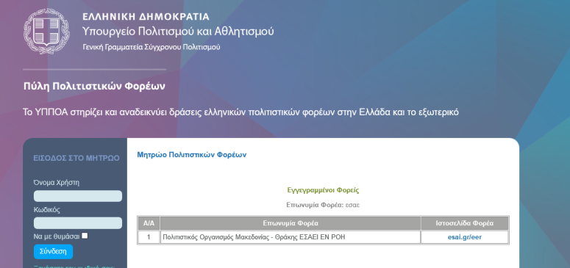
Registered Cultural Organization in the Main Directory of Greek Cultural Associations by the Ministry of Culture and Sports

Accredited with the Badget of "Socially Responsible Organization" | Member of the Youth Work Today Community | Member of the International Virtual Exchange Network | Member of the Life Beyond Funding Campaign
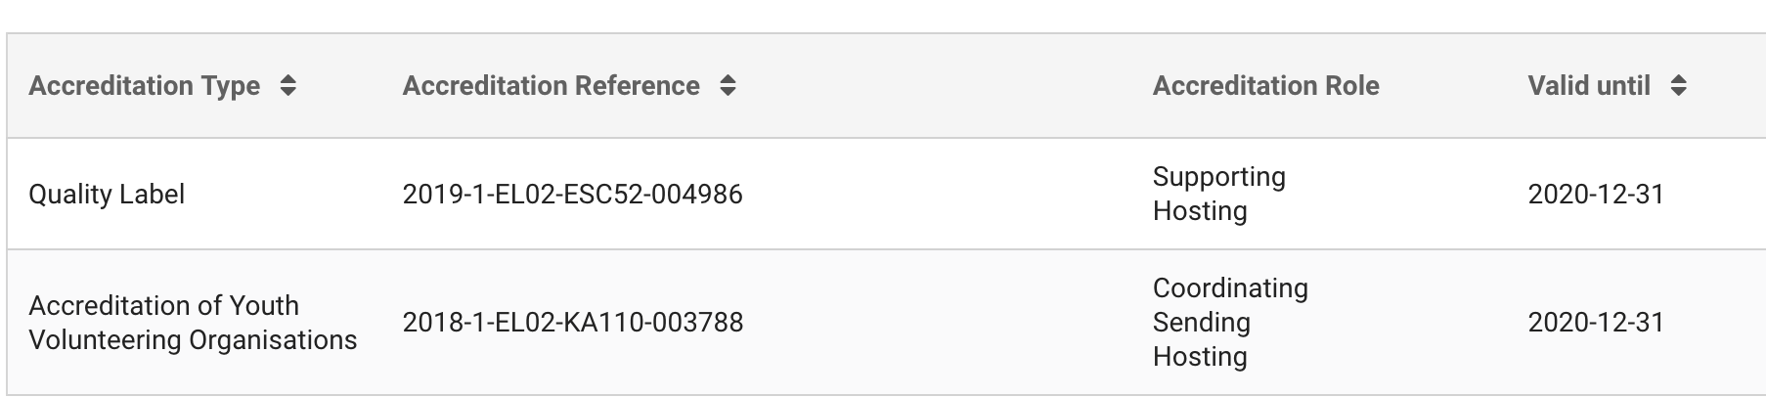

ANNEX
ACTIVITIES 1999-2019
EERcomt as a coordinator of the following activities of national or international level:

Deaf and Hearing People Festival of Inclusive Culture 2013-
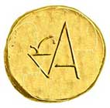  http://esai.gr/dhias.html | A festival that promotes activities were people with different abilities or some disabilities, defficiences or differences communicate and cooperate as actors, teachers, athlets or spectators and enjoy activities of healthe lifestyles, as for example, walking, climbing, running, cycling, sailing, singing, plaything theater, dancing, painting, etc. In 2020 the festival takes place in 8 cities : Chania, Athens, Nafplion, Preveza, Dion-Olympus, Thessaloniki, Thasos, Maronia-Sapes. The festival runs every year within the context of EUROPEAN WEEK OF SPORTS and with the cooperation of GR General Secreteriat of SPORTS (Ministry of Culture and Sports).

Terpsichore Award 2004-
http://esai.gr/awards.html  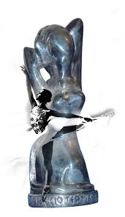 | The result of yearly research about an important artistic personality that offered to the development of the dance art in Greece and wider.  Until the present time, the award is nominated to artists that offered to the development of art of dance in regional and national level. Some of the honored artists had international career and are famous worldwide (as for instance, Daniel Lommel, Gesch Michof, Dino Fanara, Kyrki AgrafiotouAmalia Strinopoulou, Dora Stratou, Amalia Strinopoulou, etc).  The CV of the artist is publicated to the Magazine of Alternative Culture INDEPENDENT.GR & the analysis of the biography is often provided with the accompanyement of EERcomt specialized staff, to students of Secondary Education.

Melthaleia Award 2018-
http://esai.gr/awards.html  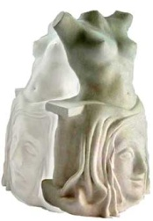 | The result of yearly research about an important artistic personality that offered to the development of drama & acting in Greece and wider.  Until the present time, the award is nominated to artists that offered to the development of art of drama in regional and national level. In 2020 the award is nominated to the famous actress and politician MELINA MERKOURI. The year 2020 has been entitled from the Greek Ministry of Culture and Sports as year in favour/ memory of Melina Merkouri.  The CV of the artist is publicated to the Magazine of Alternative Culture INDEPENDENT.GR & the analysis of the biography is often provided with the accompanyement of EERcomt specialized staff, to students of Secondary Education.

Eyterpe Award 2019-
http://esai.gr/awards.html  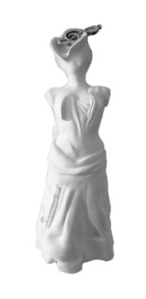 | The result of yearly research about an important artistic personality that offered to the development of music in Greece and wider.  Until the present time, the award is nominated to artists that offered to the development of music in international level. In 2019 we honored Reggina Reinhard Stamatiadou and in 2020 we are going to honor Mikis Theodorakis.  The CV of the artist is publicated to the Magazine of Alternative Culture INDEPENDENT.GR & the analysis of the biography is often provided with the accompanyement of EERcomt specialized staff, to students of Secondary Education.

Polymnis Kalliepousa 2020-
http://esai.gr/awards.html  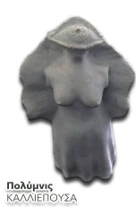 | The result of yearly research about an important artistic personality that offered to the development of conjectural arts in Greece and wider.  Until the present time, the award is nominated to artists that offered to the development of conjectural arts in regional level. In 2020 we nominate Tsaras George, a Professor of Arts in Aristotle University of Thessaloniki, School of Fine Arts (Dept. of Conjectural Arts).  The CV of the artist is publicated to the Magazine of Alternative Culture INDEPENDENT.GR & the analysis of the biography is often provided with the accompaniment of EERcomt specialized staff, to students of Secondary Education.

KLEIO Award I 2021-
http://esai.gr/awards.html  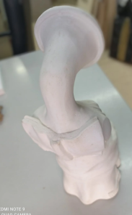 | The result of yearly research about an important artistic personality that offered to the development of literature relevant to historic events or sociologic topics in Greece and wider.  The CV of the artist is publicated to the Magazine of Alternative Culture INDEPENDENT.GR & the analysis of the biography is often provided with the accompanyement of EERcomt specialized staff, to students of Secondary Education.

Career Counseling and Orientation in Artistic Professions
MOUSON KAINOPRAGIA Phase I 2017-
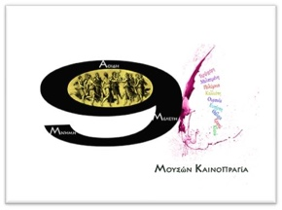  http://esai.gr/talent.html | For Dance and Drama A 3 hours’ process of measuring and evaluating basic fitness skills and special dance or drama skills, in combination with evaluation of eating habbits and improvisation abilities. Personality traits are also screened according to standardized research tools.  For Music and Art (Painting/ Sculturing) The specific process is going to run for 1st time in May in Chania. There is not yet refference available.  Sometimes we have called and disabled to participate in the process that are talented in a specific ty pe of art, but we didnt have any response. In 2020 we are going to promote talent exhibition within disabled in cooperation with some officers of public sector of secondary education.

New Artists’ Night
MOUSON KAINORAGIA Phase II 2004-
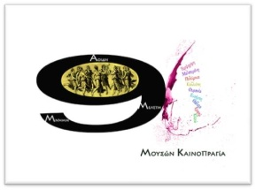  http://esai.gr/talent.html | Artists that participated in MOUSON KAINOPRAGIA Part I (Autumn), have the chance to expose themselves to the public and to present their own creations with the supervision of their tutor (Spring).  IN THIS PARTICULAR EVENT WE ALWAYS PROMOTE MINORITIES OR DISABLED, whatever the age, trying to promote a new sense and logic of arts ! As more different THE ARTIST, as more interesting and STRANGE the artwork, OUT OF THE ORDINAL & ORDINARY, a pure source of inspiration… and a reason for starting ritorics and philosophy !

Sign Language DANCETHEATER 2005-
Dance Methodology for Deaf and Hearing People by using Signings and Sign Languge
https://handiedance.com  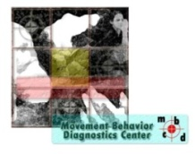 | EERcomt promotes SL and dancetheater as a new very interesting process for improvisation, innovation. The current option of creative processing supports and enhances collaboration with deaf community, not necessarily.  EERcomt has shown 7 projects with SL dancetheater since 2005.  In 2022 we decided to bring an innovative perspective of signing movement of the hands and we promoted a new method of dancing based on digitalism, filming and half up body movement (upper body, arms, hands, face) in several variations as to be possible and for handicapped and we promote the HANDIEDANCE FESTIVAL. First year lanched: Masy 2022

Jam Rhythm Dance 2015-
Dance Methodology for People with Attention Deficit or Hyeractivity Disorder
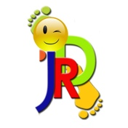 | JRD is a new method of approaching ADHD youth. The concept concerns the synthesis of dance, fitness and music tools within a context that is friendly and attractive to those persons. Many objects, materials, myths and stories are used as familiarly in DMT applications and programs.

Artivia EU Youth Magazine 2018-
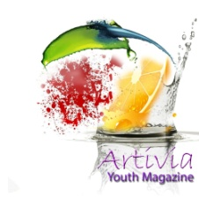  http://artivia.gr | It is a website where there are uploaded articles written by our Youth, that participates to our projects. The 2nd volume (2019) will be very soon published online.

YOUNG ACTIVE CITIZENS SUPPORT ECOLOGICAL ACTIONS
https://karatasoupark.org  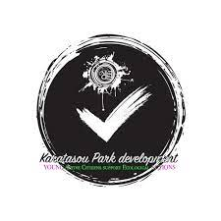 | New action concerning Sustainable Environment (SINCE 2019), major focuse during 2020 and after.  Arts and Sports in benefit of quality of life and Sustainable Environment. Young active volunteers set new elements and promote the local parks and hidden treasures of the city.
Achievements 2022/ entrance in the communities of:
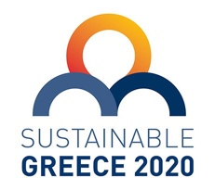
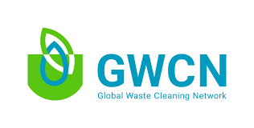

Distinctions in 2021
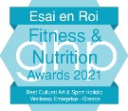
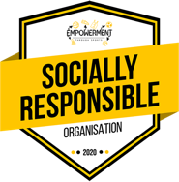

Official Member of
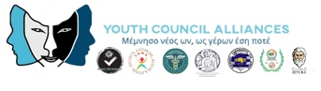

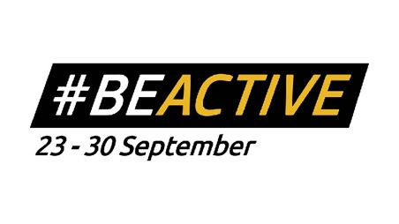
Standard Cooperation with:

