Tunis, the 04/04/2023

General Presentation

General context:
The Association Tunisian International Model United Nations (TIMUN) employs UN simulation methods in an approach that seeks to engage youth in addressing pertinent issues, such as gender equality, through an innovative and inclusive means of drafting policy briefs.

About TIMUN:

Overview: Identity and Mission
Partnering with the Tunisian International Model United Nations (TIMUN) offers numerous benefits and opportunities for collaboration. Established in 2009, TIMUN is dedicated to fostering diplomacy, enhancing international relations, and promoting awareness of human rights among the youth of Tunisia.
One of TIMUN's key strengths lies in its Over the years, TIMUN has successfully equipped its members with the essential skills and knowledge necessary for excelling in Model United Nations simulations. Through structured programs, hands-on experience and unwavering commitment to academic training and mentorship., TIMUN cultivates critical thinking, research proficiency, and effective communication skills among its participants.
These attributes make TIMUN members invaluable partners in collaborative efforts, as they bring a wealth of expertise and insight to the table and through strategic alliances with prestigious organizations TIMUN provides access to a dynamic pool of individuals who are passionate about international affairs.

Our Network: A decentralized structure
 | Club
Regional clubs | TIMUN BIZERTE
 | TIMUN SOUSSE
 | TIMUN Monastir
 | TIMUN SFAX
 | TIMUN EZZAHRA
University clubs | TIMUN FSJPST
 | TIMUN ISLT
 | TIMUN TBS
 | TIMUN INSAT
 | TIMUN FLAHM
 | TIMUN CAMPUS
Highschool clubs | TIMUN LPM8
 | TIMUN LPA
 | TIMUN LPBT
 | TIMUN LP Medenine
 | TIMUN ISC

Having a significant presence throughout the Tunisian territory, the TIMUN association has experienced significant regional expansion since 2016 and continues to encourage Tunisian youth to excel in regions, high schools, and universities by providing them with support mechanisms and assistance.
The community network of the TIMUN association comprises (16) national clubs, including (05) clubs at high schools, (06) at universities, and (05) clubs in the regions with over 450 active members.

Our activities: Striving for Excellence & Embracing Diversity
TIMUN has demonstrated excellence since its establishment through a diverse range of activities addressing various humanitarian issues, showcasing its commitment to fostering positive change and involvement among young individuals.
Some of the key milestones include:

Event | Description
COP 21 simulation project for 2015 | TIMUN is the first Arab and African Model United Nations to have simulated COP21 in its September 2015 edition, four months before the actual event took place in Paris. Participants had the opportunity to debate the issues surrounding climate change and to vote on a bold and pioneering UN resolution project.
The National Grand Simulation for 2015 | On October 16, 2015, following an invitation from President Beji Caid Essebsi, the Secretariat members of the 2015 simulation and the national office took the opportunity to present a document to the late president. This document outlined the outcomes of our significant conference, focusing on addressing the topics of counter-terrorism efforts and the advancement of human rights principles on the global platform.
National Assembly of Representatives of People Committee for 2019 | A simulation of the Assembly of the Representatives of the People was attempted in our national Simulation of 2019, where participants, acting as deputies, addressed the issue of Individual Liberties and equality in Tunisia, based on the COLIBE Report.
UN /TIMUN human rights regional tour for 2024 | In partnership with the United Nations Office and the United Nations High Commissioner of Human Rights, TIMUN successfully orchestrated a tour across five regions of Tunisia: Tunis, Benzart, Mednine, Sousse, and Sfax. The tour featured bootcamps focused on regional issues, sustainable development, and the history of the UN system.
Advocacy competition for 2024 | In collaboration with ASF, TIMUN organized an advocacy competition centered on a case addressing gender and personal status issues. This event provided a unique opportunity for selected law students from various universities in Tunisia to receive training from experts in the field and apply this knowledge in a competitive and engaging manner.

Our Partners: A Legacy of Strong and Trusting Relationships

By effectively managing skills and demonstrating professionalism in its collaborations, TIMUN has earned a strong reputation and established solid relationships with well-respected organizations and civil society.
Below is a compilation of some of our strategic partners of this year:

- United Nations Office
- United Nations Volunteers (UNV)
- United Nations High Commissioner for Human Rights (HCHR)
- United Nations Population Fund (UNFPA)
- United Nations Development Program (UNDP)
- Avocats Sans Frontières (ASF)

Respectfully submitted, by the academic department of the TIMUN Association,
Accepted and confirmed by,
Abir Ben Abdallah,  National Secretary General  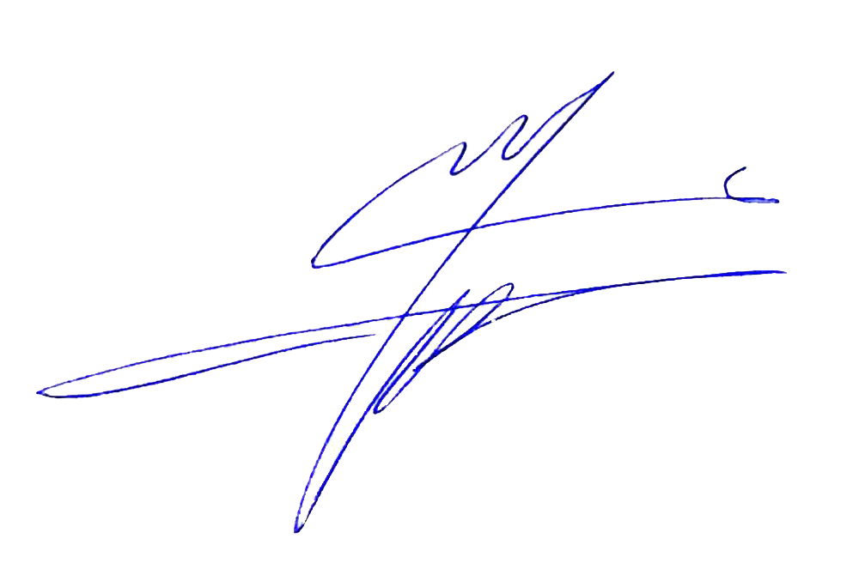  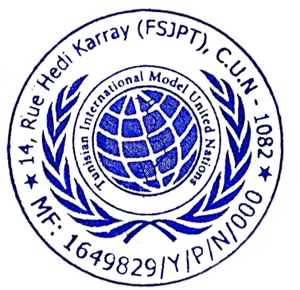  in charge of Academic Affairs | Mohamed Ali Dhrioua,  President

