Dura Municipality

Dura municipality was established in 1967, it is a semi-governmental organization which delivers different services to the city of Dura. Dura city lies to the west of the city of Hebron, at an altitude of 839 meters above the surface of the sea, bounded from the east by Yatta and Hebron, (The lands of 1948), and from the south, Samo’a and Al-dahriya.

Dura municipality includes a number of departments through which services are provided to the citizen. Dura municipality has a number of facilities, including the Dynamometer, Dura International Stadium, Cieena Park, the Municipality's Public Library, the Dura Cultural Center, the Museum and many other government directorates in the city.

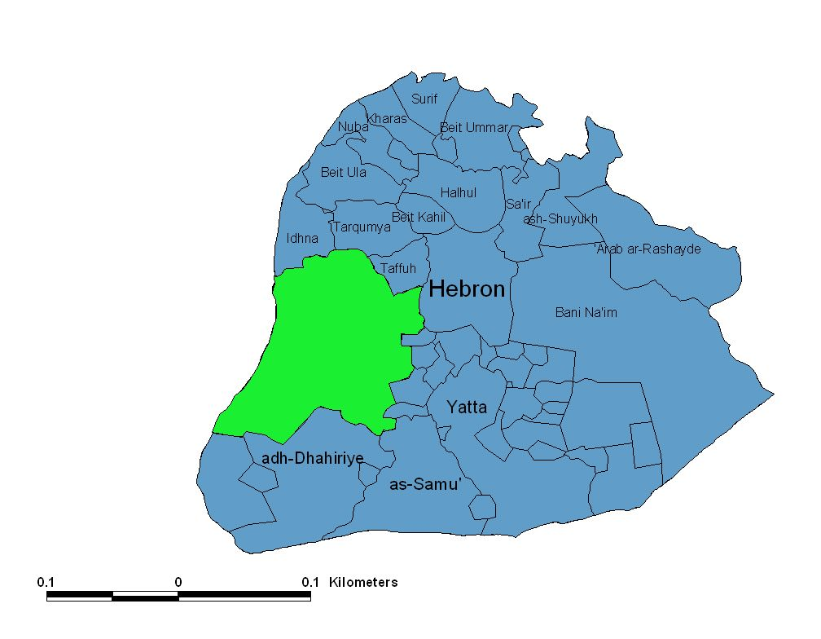

Dura has an important geographic location between the Negev and the occupied Palestinian coast. The city of Dura is the urban center of a group of surrounding communities that reached 99 communities before 1948. Following the Nakba, the city of Dura consists of a main center and 53 human settlements from towns, villages and population centers. The population of the city of Dura and its surrounding villages is about 130,000 and the area of ​​the city of Dura and its villages is 240,000 dunums, of which 95 thousand dunums were occupied by Israel in 1948. The remaining area after the war is 145,000 dunums. Moreover, Dura now is located on the borders which is sieged by the apartheid separating wall.

Dura Municipality Goals
- To enhance the role of Dura as a strong, stable and diverse economic, social and cultural center.
- Improving the standard of living, developing Dura's infrastructure; and diversifying the basic services provided to citizens.
- Developing human resources and stimulating the creative potential of young people.
- Structural, and detailed planning; and the development of Dura as a stable urban system.
- Maintaining public health and safety of citizens, combating pollution, epidemics and health hazards; and promoting health and community protection and education.
Brief history
It is thought that Dura is located on the spot of the city of Urim which Rehoboam fortified for fear of his Jewish people who rebelled against him. In the Roman era it was mentioned in the name of Adora as a works of Beit Jibrin. It has long been known for its vineyards and grapes. In 712, the great King Issa al-Ayyubi was arrested on the Ibrahimi Mosque.
And the roots of the city of Dura in the history where the Canaanites lived about (5000) year.
In the late Ottoman period, the city of Dura was administratively considered as "township". During the Mandate period, it was abolished and returned to "village". In 1961, the city was declared a "district administration".
Religious and historical places
There are many archeological and historical sites in the city of Dura, including the Prophet Noah shrine, the shrine of Abu Arqoub, the shrine of Sheikh Hassan, the tomb of Matta, and the city's archeological site containing the remains of a tower built with stones, a mosaic floor, architectural pieces and Sehreej.
Impact of the Israeli Occupation
The town is surrounded by four settlements, the Beit Hagai settlement, to the east of Dura, and to the settlement of Adoraim, to the south of the city, the settlement of Gal Yehuda (Negohot), located to the south-west of the city, The city is affected by the roadblocks on the roads leading to it, especially the checkpoint at the entrance of Fawwar, where the Israeli occupation forces on a daily basis to make temporary checkpoints on the main entrances to the city.
The Israeli occupation forces uprooted 780 olive trees, 500 grape trees, 350 almond trees, 900 other trees, destroyed many houses, and confiscated or isolated large areas of land.
The percentage of refugees in the vicinity of the city of Dura (24%) of the total Palestinian population living in urban areas and constitute 22% of the total population of the city's countryside, and 94% of the total population of the neighboring camp Fawwar.

