GREEN ELEPHANT FOUNDATION

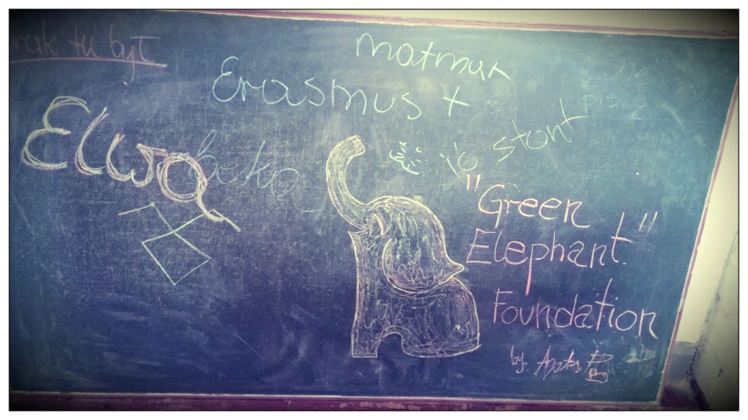
The Green Elephant Foundation (Fundacja Zielony Słoń) is an NGO located in Lublin, Poland. We organize events in Zakopane, the winter capital of Poland in Tatra Mountains, Lublin and Wisznice in rural region of eastern Poland. The foundation has been established by a Polish writer Mr. Jacek Rębacz in 2012. Since then are committed wholeheartedly to the development of education level among the adults and the youths particularly with use of non-formal education methods.
We support and promote civic education, readership, literacy, organize educational initiatives and European projects. We believe the need for self development is one of the basic human needs and a primary factor driving the development of civilization.
Green Elephant Foundation is experienced both as a coordinating institution and as a partner in European and national projects in the field of non-formal education and vocational education.
Visit our website to take a look at our projects, check our FB for latest news and updates and click the pitcures below to play movies!
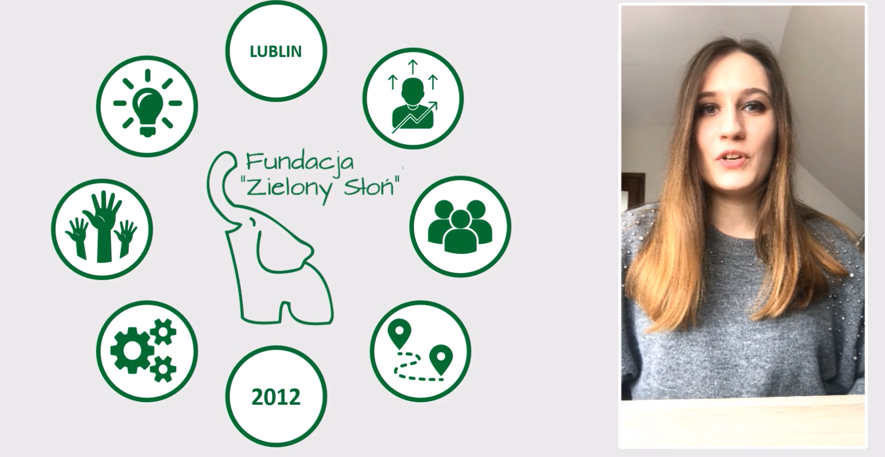

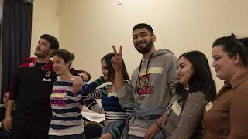

.

OID:
E10092909

Full legal name | Fundacja “Zielony Słoń”
Full legal name (English) | Green Elephant Foundation
Acronym | FZS
Address (adres) | Andrzeja Struga 63, 20-709 Lublin
City | Lublin
Country | Poland
Region | Lubelskie
Email | zielonyslon@greenelephant-foundation.com  greenelephant.foundation@gmail.com
Telephone 1 | +48 792 573 548
Facebook | https://www.facebook.com/FundacjaZielonySlon
WWW | https://www.greenelephant-foundation.com
Youtube | https://www.youtube.com/c/FundacjaZielonySlon
PIC | 946223167
European Solidarity Corps Quality Label | 2020-1-PL01-ESC52-083032
VAT/Tax no. (NIP) | 7123270025
Register no. (REGON) | 061380334
Organization ID number | E10092909
EID | PL-2019-FKP-2002091860
Type of Organization | Non-governmental organization / Foundation
Is the partner org. a public body? | No
Is the partner org. a non-profit? | Yes
Has the organization received any type of accreditation before submitting this application? | YES – European Solidarity Corps Quality Label 2020-1-PL01-ESC52-083032

Legal Representative
Title | Mr.
First Name | Adam
Family Name | Rębacz
Position | President
Email | zielonyslon@greenelephant-foundation.com
Telephone | +48 792 573 548
Contact Person
Title | Mr.
First Name | Adam
Family Name | Rębacz
Position | President
Email | greenelephant.foundation@gmail.com
Telephone | +48 601 814 019
B. PROFILE

C2.3 Background and Experience
Please briefly present your organization (e.g. its type, size, scope of work, areas of specific expertise, specific social context and, if relevant, the quality system used).
Green Elephant Foundation is a non-governmental organization established with an aim of providing lifelong learning to the youths and adults. We focus in particular on educational activities aimed to face social problems like violence, discrimination, racism, hate speech, problem of inadequate level of education, or problems the youths encounter while starting their adventure on the labor market, raising entrepreneurial and civic awareness, ecological awareness, projects focused on sustainable development. We implement also projects to set work placements abroad, support vocational education of young people, create online educational products and solutions. We are also implementing projects embracing individual career development, vocational courses and traineeships on national level, aimed at adult unemployed or disabled people.
Thank to our experience in the youth sector, we are one of the authors of Polish National Agency publication about youth projects https://wymianymlodziezy.frse.org.pl/przewodnik-dla-wnioskodawcow-juz-dostepny/?fbclid=IwAR2fe0lj0aavFfE7l8nl0vASFODbx10EiTE4CehK-yYMBqGjGPkmA-ViR0Q
We care for the values expressed in European Programes like Erasmus+ and for Human Rights, what was the reason to submit a petition in this subject to European Parliament in October 2020 which is going to be evaluated
We cooperate in the field of social activities and infrastructure with the city of Lublin on basis of agreement no. 24/IPS/21.
We are officially registered as a publishing institution in Poland no. PL/e-ISBN/12513 with an own publications and we are also officially registered training institution no. 2.06/00062/2019.
We are also granted Quality Label enabling us to provide sending and hosting opportunities for European Volunteers under European Solidarity Corps 2020-1-PL01-ESC52-083032.
Our youth target group with fewer opportunities are graduated youths of local highschool in Wisznice town, in eastern Poland. That is a remote rural area. The participants often are facing economical and geographical fewer opportunities as they come from remote rural areas and poor families. There are around 50 graduates each year and many of them with sufficient English skills and motivation to participate in a youth project. They are aged around 19. The youths are involved often in our initiatives which we undertake in that region and they are aware of our presence there, thus we believe there wouldn't be needed open recruitment, but only selection of present candidates. Five of them have already submitted their own application under ESC Solidarity Projects Call. We have worked with them within our Youth exchange located in that town and KA3 projects also located there and involving local young people, entrepreneurs and politicians. We are also sending these youths abroad within KA105 projects where we are partners in.
We have also experience in working with a similar target group in the town of Krasnystaw in eastern Poland. Those participants were students of vocational school and we organized for them vocational placements in Italy and Spain under VET projects.
FZS is experienced coordinator and a partner in implementation of projects. Our staff had managed or participated in large number of international and national projects for several years. The staff, trainers and volunteers are experienced in international project management, cooperation with external institutions, organization of educational activities for youths, youth workers, adults.
Owing to the fact that nowadays people live in a fast-pacing, requiring changes environment, we extended our interests in terms of active lifestyle. It can be wider understood as “Sport” and “Healthy Lifestyle”. The primary mission that we took up is to fight against the obesity (very common phenomenon worldwide, in Poland). According to the “Wprost” Newspaper (10.04.2019), right now the obesity rate in Poland is 25,2% (30% male, 26% female). This rate is going up every day. These statistics are tremendous - that’s why Green Elephant Foundation strives to take up certain measures to overcome them. One of the activity speaking for this action is “Sport the YOUth”. This youth exchange has been accepted and is going to be implemented in the nearest future. The activity has been initiated together with the Serbian organization “KOSARKASKI SAVEZ GRADA NISA”. Green Elephant Foundation has significantly contributed to proclaiming the concept of the healthy lifestyle, proposing activities to the Youths - how can they be more active in the everyday life as well as implementing good practices during projects (providing food rich in nutritional values, conducting activities outside on the fresh air), and many more.
In the same time we are a cultural organization which is proud of supporting literacy and reading. We have a number of old books under our care including unique printouts which dates back to XIX and XVIII century. We promote the culture of reading and preserving the books. We also promote other traditional activities like local handcrafts - often organize workshops with people who make homemade foodstuffs.
We use our networks of social media contacts, mailing lists and cooperating institutions and media which include: association "Stowarzyszenie Aktywne Pogranicze", vocational schools in Krasnystaw (ZS no. 1) and "Lider" in Lublin, mayor of the Wisznice commune, Piotr Dragan, the mayor of the Sławatycze commune Arkadiusz Misztal, the head of the Piszczac commune, Kamil Kożuchowski or even lower ranks, such as the mayor of Żeszczynka, Krystyna Karpiuk. We work as a social partner on the basis of an agreement also with the Department of Social Initiatives and Programs of the City of Lublin. We have contacts within regional networks of social and civic organizations. We cooperate with Słowo Podlasia or RadioBiper in Biała Podlaska.

What are the activities and experience of your organization (partner organization) in the areas relevant for this project?
We have organized several week-long training events in our resorts in Poland for almost 400 youth workers and young people from all over EU and the partner countries.
We cooperate with schools in remote rural areas and in the city if Lublin. Our aim of cooperation is to involve young people in the process of self development to make them more open-minded, more critical thinking, more communicative and more active members of society. We have supported them in the field of vocational development by sending them to traineeships abroad and in non formal education by organizing foreign mobilities with our youth workers. We have involved so far over 250 people into foreign mobilities to international projects under Erasmus+KA1 youth and adult sector, so they were able to develop themselves in multicultural environment.

We organized foreign vocational mobilities for almost 50 Polish students Italy and Spain. We implemented VET project in 2016-17 with workplacements in Sicily for students of vocational school in Krasnystaw, POWERVET-2016-1-PL01-KA102- 024895). Currently we are providing career consultancy, vocational courses and workplacements unemployed people in the region of Lubelskie (RPLU.10.04.00-06-0029/18) and the disabled (national range, „(Od)Ważni na starcie!” ABS/000004/03/D). and in 2018-19 VET project with workplacements in Spain or students of the vocational school in Krasnystaw and "Lider" in Lublin (2018-1-PL01- KA102-048055). Regarding this field of work, within our projects we address our support to students of vocational schools in Lubelskie region, particularly to students of the Vocational school in Krasnystaw (ZS nr 1) because their students are often people with fewer opportunities due to living in remote rural areas, poor living standard or other obstacles. Due to location of their homes and the school, there is huge need for this sort of support. We also cooperate with the private vocational school "Lider" in Lublin. We involve there also people with fewer opportunities due to migrant/refugee background. They are often Ukrainians forced to move from Ukraine due to the recent war. Apart from that their learners are often also with fewer opportunities due to economical reasons.

With our capital of know-how we also belong to the authors of the Polish National Agency publication about youth projects https://wymianymlodziezy.frse.org.pl/przewodnik-dla-wnioskodawcow-juz-dostepny/?fbclid=IwAR2fe0lj0aavFfE7l8nl0vASFODbx10EiTE4CehK-yYMBqGjGPkmA-ViR0Q

We have implemented 2 international Erasmus+ Key Action 2 strategic partnership project aimed to share good practices to create educational guide and toolpack for youth workers in the field of preventing hate speech and discrimination online and aimed to work with youths on their start-ups in rural areas. Now we are implementing Erasmus+ Key action 2 strategic partnerships: one aimed for women empowerment and equal rights and 2nd one for sustainable development and reduction of plastic in the environment. We are also implementing Visegrad+ strategic partnership to empower young people to set social enterprises using modern technology and intangible cultural heritage to support rural areas.
We have implemented local projects in Erasmus+ KA3, projects of structural dialogue. These projects embraced over 70 schoolkids and were aimed to increase heir social, civic awareness and make them more active members oft he democratic society of the European Union.
We have also organized youth projects for local youths in eastern Poland meant to raise awareness of the youths in area of entrepreneurship and new opportunities given by social media, internet journalism, European programmes and its reference to the youth policy in the region. We have involved local politicians, journalists and other specialists to share their experience, knowledge and create new products, new quality in the dialogue with the youths.
Within Erasmus Adult Education sector we implement project aimed to send adult educations staf for courses abroad to institutions sharing good practises in the field of folk universities and 3rd Age Universities.
We have implemented also a number of national projects funded by national funds. These were aimed to support youths in their educational experiences and to support people working with disabled kids. These domestic projects embraced almost 100 local youths.
We have also organized a self-funded initiative #KairKapsztad with aim to support the sole hitchhiking journey of Monika Masaj who explored in 2016-2018 the real life all across Africa.

What are the skills and/or expertise of key persons involved in this project?
We have teams specialising in certain areas of our activity: in the field of youth (including cooperation with schools), in the field of vocational education (also including cooperation with vocational schools), and in the field of adult education.
The key person in charge of all the actions is Mr Adam Rębacz, the president with 10 years of experience in implementing activities in all these fields and involved also in this area.
Apart from him, the team in this field consist supporting project coordinator who takes care together with the president for administrative, financial and management in a project: Mr Pawel Kita or Mrs Kinga Rębacz. We always involve local "school" coordinators who maintain stable and direct contact with school authorities, personnel, and its students: Mr Andrzej Rudzinski or Ms Monika Łepik.
Supporting role in this sort of projects have also Ms Marlena Strus the career development advisor (performs individual consultations with our learners regarding their IPD- individual action plan and career counselling which are later used to organize certain vocational courses), and a language teaching specialist to organize language support in certain project Ms. Patrycja Gontarczyk.
There is also in this field with possible support role Mrs Barbara Lebedowicz, a professional career coach who work with the adult learners using the FRIS methodology, Mr Jacek Rębacz who is the writer and author of several published novels is leading non formal educational activities aimed to increase general literacy and the Key Competences, and Arkadiusz Rębacz who is our ICT master, works also as a commercial producer of several online games and online solutions. He provides digital literacy education, online and software solutions and products if needed, and he assures implementation of the EU Digital education priorities.
Apart from the people listed above we have also accountancy bureau to deal with overall accounting and bookkeeping. In the youth sector, educational content is responsibility of Ms. Monika Stepien and Karolin Karpiuk.
Monika is regularly responsible for issues related to the programme of events, details of project implementation, management, project products. Monika graduated from English Studies in 2019 with the title of translator. She started to work in Green Elephant Foundation at the beginning of the year 2019. As a participant of many external projects, not only Erasmus+, she has a huge expertise in the field of Training Courses and Youth Exchanges. For the past year, her main interests was to write projects in the field of Hate Speech, Extremism, Critical Thinking (and other related) as well as host them, being a representative of Green Elephant Foundation. Apart from working in the Foundation, she had been working as a Team Leader in „Energa Gdańsk“ Stadium. Her main tasks, for instance, setting out/distributing tasks to the young employees (9-20 people), performing logistics and burreaucracy proves that she is capable of managing the team of participants during Erasmus+ projects. Self-motivated, ambitious and demanding at the same time she develops her interests and becomes a better youth worker every day.
Ms. Karolina Karpiuk – a student of Business Translation, currently on a Master Degree. Apart from working in the Foundation, she currently develops herself as a teacher in the language school. She proved numerous time to be an efficient and effective employee. She started her career with Erasmus+ programme in 2013 as a participant. Now, she is working as a trainer in Green Elephant Foundation. Karolina is unique in terms of strong personality that makes her an excellent trainer. She mainly specialises in the fields of Hate Speech, Extremism, Media Literacy, Dialogue (her interests are covergent with the interests of Green Elephant Foundation). Her debut project as a trainer took place in Lublin, 2019, during the project „Hate is not my mate“. This project certainly states for Karolina's reliability as a trainer owing to the power and effort she has put into creating it from the very beginning. Now Karolina is undergoing many trainings on effective teaching and new non-formal methods in terms of Erasmus+.
Our staff is regularly undergoing many trainings related to the efectiveness of the projects, for example: emotional management, new non-formal methods in terms of teaching youth learners, as well as many trainings related to the topics of the project (Hate Speech, Extremism, etc.).

Has your organization (partner organization) participated in a European Union granted project in the 3 years preceding this application?
If yes, please indicate:
PROJECTS WE PARTICIPATED IN AS BENEFICIARY OR PARTNER ARE LISTED HERE:
EU Programme | Year | Project Identification or Contract Number | Applicant/Beneficiary Name
Erasmus+ | 2014 | 2014-1-PL01-KA104-001551 | Fundacja Zielony Słoń
Erasmus+ | 2014 | 2014-3-PL01-KA105-013189 | Fundacja Zielony Słoń
Erasmus+ | 2015 | 2015-1-PL01-KA347-014120 | Fundacja Zielony Słoń
Erasmus+ | 2015 | 2015-1-IT03-KA105-005597 | Fattoria Pugliese Diffusa
Erasmus+ | 2016 | 2016-1-BE04-KA105-001773 | Intermundia
Erasmus+ | 2016 | 2016-1-CY02-KA105-000653 | C.I.P Citizens In Power (PO.SI Polites se Ischy)
Erasmus+ | 2016 | 2016-1-LV02-KA105-001131 | ERFOLG
Erasmus+ | 2016 | 2016-2-EL02-KA105-002493 | Loutraki Youth Center
Erasmus+ | 2016 | 2016-2-HU02-KA105-001718 | A Veszelyeztetett Szucsmesterseg Megorzeseert Egyesulet
Erasmus+ | 2016 | 2016-2-PL01-KA105-027042 | Fundacja Zielony Słoń
Erasmus+ | 2016 | 2016-2-PL01-KA105-027397 | Fundacja Zielony Słoń
Erasmus+ | 2017 | 2017-1-LU01-KA105-023921 | Amities Luxembourg - Armenie a.s.b.l.
Erasmus+ | 2016 | 2016-2-HU02-KA105-001778 | Dél-Alföldi Eurotender, Ifjúsági, Kulturális, Oktatási és Környezetvédelmi
Erasmus+ | 2016 | 2016-2-CY02-KA105-000816 | Filodasikos Syndesmos Agrou (Cyprus)
Erasmus+ | 2016 | POWERVET-2016-1-PL01-KA102- 024895 | Fundacja Zielony Słoń
Erasmus+ | 2016 | 2016-3-DE04-KA105-014568 | JUBUK
Erasmus+ | 2017 | 2017-1-EL02-KA105-003080 | System and G
Erasmus+ | 2016 | 2016-2-UK01-KA105-024790 | Kairos Europe Ltd.
Erasmus+ | 2017 | 2017-1-HU01-KA105-035416 | Motiváció Oktatási Egyesület Motivacion Community
Erasmus+ | 2016 | 2016-2-ES02-KA205-008301 | DRAMBLYS: Social Creativity Lab
Erasmus+ | 2017 | 2017-2-EL02-KA105-003343 | System and G
Erasmus+ | 2017 | 2017-1-LV02-KA205-001502 | „Creative Ideas“ Society
Erasmus+ | 2017 | 2017-2-TR01-KA105-047209 | Pi Youth Association
Erasmus+ | 2017 | 2017-3-EL02-KA105-003588 | SYSTEM AND GENERATION ASSOCIATION
Erasmus+ | 2017 | 2017-3-ES02-KA105-010511 | Lidia Férez Díaz
Erasmus+ | 2017 | 2017-3-UK01-KA105-046628 | VEREIN FUR BILDUNG POPEDU
Erasmus+ | 2018 | 2018-1-AT02-KA105-002041 | VEREIN FUR BILDUNG MLADIINFO
Erasmus+ | 2018 | 2018-1-CY02-KA105-001187 | C.I.P. CITIZENS IN POWER
Erasmus+ | 2018 | 2018-1-DE04-KA105-016475 | Schoolclash eV
Erasmus+ | 2018 | 2018-1-EL02-KA105-004111 | SINDESMOS SISTIMA KAI GENIA
Erasmus+ | 2018 | 2018-1-NO02-KA105-001138 | TERRAM PACIS
Erasmus+ | 2018 | 2018-1-TR01-KA105-057088 | Kultur Koprusu Egitim ve Genclik Dernegi
Erasmus+ | 2018 | 2018-2-CY02-KA105-001300 | C.I.P. CITIZENS IN POWER
Erasmus+ | 2018 | 2018-2-CZ01-KA105-048324 | ALVIT - inovace a vzdelavani s.r.o.
Erasmus+ | 2018 | 2018-2-DE04-KA105-016881 | arco - Erlebnispädagogik e.V.
Erasmus+ | 2018 | 2018-2-IT03-KA105-014110 | Librotondo società cooperativa sociale ONLUS
Erasmus+ | 2018 | 2018-2-IT03-KA105-014122 | BOND OF UNION SOCIETA' COOPERATIVA SOCIALE
Erasmus+ | 2018 | 2018-3-CY02-KA105-001374 | C.I.P. CITIZENS IN POWER
Erasmus+ | 2018 | 2018-3-CY02-KA105-001375 | C.I.P. CITIZENS IN POWER
Erasmus+ | 2018 | 2018-3-DK01-KA105-059828 | DRAFT COPENHAGEN
Erasmus+ | 2018 | 2018-2-IT03-KA347-014004 | Cultura Democratica
Erasmus+ | 2018 | 2018-2-LT02-KA105-005975 | Neribota-ateitis
Erasmus+ | 2018 | 2018-2-PL01-KA105-051326 | Fundacja Zielony Słoń
POWERVET | 2018 | 2018-1-PL01-KA102-048055 | Fundacja Zielony Słoń
Erasmus+ | 2019 | 2019-1-NL02-KA105-002417 | Stichting Schoolclash
Erasmus+ | 2019 | 2019-1-PL01-KA105-062358 | Fundacja Zielony Słoń
Erasmus+ | 2019 | 2019-1-PL01-KA105-062377 | Fundacja Zielony Słoń
Erasmus+ | 2019 | 2019-1-PL01-KA105-062846 | Fundacja Zielony Słoń
Erasmus+ | 2019 | 2019-2-PL01-KA105-065945 | Fundacja Zielony Słoń
Erasmus+ | 2019 | 2019-2-PL01-KA105-065954 | Fundacja Zielony Słoń
Erasmus+ | 2019 | 2019-2-PL01-KA105-065972 | Fundacja Zielony Słoń
Erasmus+ | 2019 | 2019-1-IT02-KA204-063155 | Petit Pas
RPO WL | 2019 | RPLU.10.04.00-06-0029/18 | Fundacja Zielony Słoń
POWER | 2019 | POWERAE-2019-1-PL01-KA104-  062958 | Fundacja Zielony Słoń
Erasmus+ | 2019 | 2019-3-PL01-KA347-077535 | Fundacja Zielony Słoń
Erasmus+ | 2019 | 2019-2-RO01-KA105-064279 | Filiala Asociatiei Se Poate
Erasmus+ | 2019 | 2019-2-TR01-KA105-078741 | Youth Internship Academy
Erasmus+ | 2019 | 2019-2-SK02-KA105-002160 | SYTEV
Erasmus+ | 2019 | 2019-2-UK01-KA105-062327 | Bauhaus Cafe CIC
Erasmus+ | 2019 | 2019-1-PL01-KA104-062643 | STOWARZYSZENIE AKTYWNE KOBIETY
Erasmus+ | 2019 | 2019-3-IT03-KA105-017725 | Cooperazione Senza Frontiere
Erasmus+ | 2019 | 2019-3-MT01-KA105-074036 | International Alliance for Integration and Sustainability
Erasmus+ | 2019 | 2019-3-RO01-KA105-077940 | Directia de Asistenta Sociala a Municipiului Piatra Neamt
Erasmus+ | 2019 | 2019-3-AT02-KA205-002603 | bit Schulungscenter GmbH
Erasmus+ | 2019 | 2019-3-IT03-KA105-017178 | Associazione AKIRA
Erasmus+ | 2019 | 2019-3-CZ01-KA105-076857 | Brno Connected z.s.
Erasmus+ | 2019 | 2019-3-CY02-KA105-001656 | C.I.P. CITIZENS IN POWER
Erasmus+ | 2019 | 2019-3-CY02-KA105-001664 | C.I.P. CITIZENS IN POWER
Erasmus+ | 2019 | 2019-3-SE02-KA105-002667 | MILLENIUM SWEDEN
Erasmus+ | 2019 | 2019-3-SK02-KA105-002268 | SYTEV
POWER | 2020 | POWERAE-2020-1-PL01-KA104-081106 | Fundacja Zielony Słoń
Erasmus+ | 2020 | 2020-1-PL01-KA105-079372 | Fundacja Zielony Słoń

