Law and Society Institute
Organizational Profile
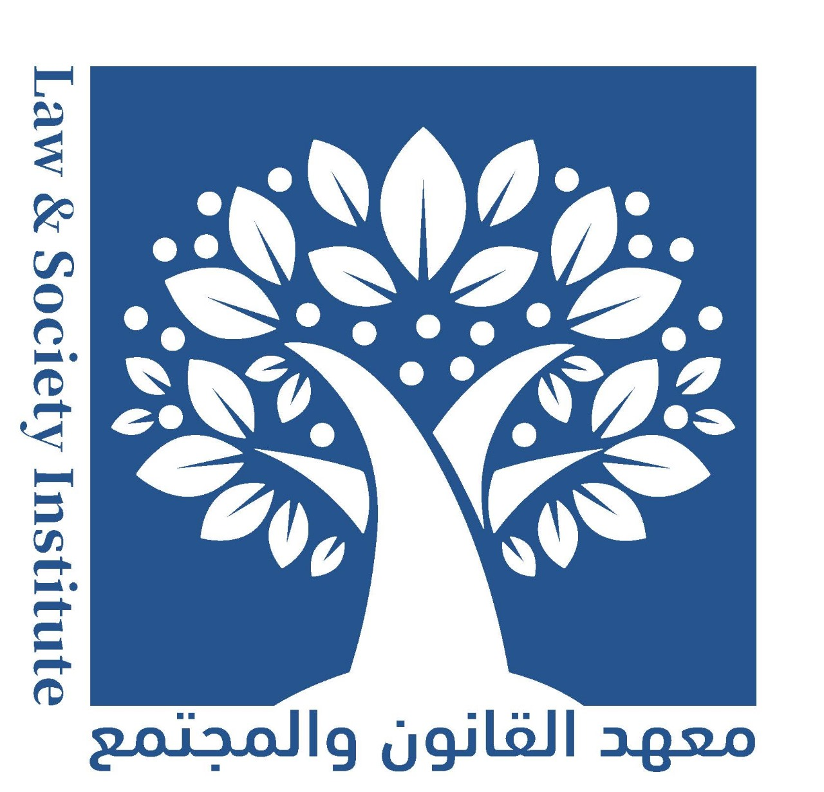
About Law and Society Institute:
Law and Society Institute (LSI) was established in 2023 in Jordan as a Civil Society Organization that aims to promote and protect human rights , Rule of law and fundamental freedoms in Jordan. It seeks to promote and protect human rights in accordance with international standards, achieve sustainable development, pursue good governance as a means of strengthening the unity and cohesion of society, and consolidating and strengthening the rule of law, justice, equality, non-discrimination and social justice.
LSI is a research and advisory center specialized in studying and understanding the relationship between law and society. PSI consists of a specialized team of elite lawyers, researchers, and specialists in law and social sciences, who combine experience in teamwork and legal work.
PSI is intellectually independent organization. It seeks to promote human rights principles, the principles of good governance and rule of law using different methodological approaches including capacity building, research, and advocacy.
Vision:
“To build a just, civil, and enlightened society in Jordan and the Arab region, where law prevails and human rights and community participation are respected. We work to enable individuals and communities to effectively interact with and influence legal systems by enhancing awareness, knowledge, and developing capabilities. LSI seeks to achieve this vision through research, education, partnerships and comprehensive interaction between law and society.”
This vision reflects a dedication to promoting justice and human rights and encouraging community participation through understanding and influencing legal systems.
Mission:
LSI’s mission is “to enhance communication and understanding between legislation and society, and to enable individuals and groups to access justice and protect their rights. We work to direct our efforts towards developing individuals’ knowledge of laws and justice systems and enhancing their participation in formulating and implementing legal policies. We seek to achieve this mission through evidence-based research, outreach, training and collaboration with our community and legal partners.”
This mission expresses the need and necessity to increase awareness of laws and empower individuals to participate effectively in developing and implementing laws to promote justice and protect human rights.
Goals:
- To increase awareness of laws and legal systems, through awareness campaigns and educational programs.
- To enhance community participation, and to promote the participation of individuals and communities in policy formulation and legal decision-making processes.
- To promote and protect Rule of , human rights , civic space, social justice through educational programs, research and advocacy.
- To strengthen partnerships and collaborations with legal institutions and relevant stakeholders to enhance interaction and achieve common goals.
- To contribute to developing the legal system and provide constructive recommendations to improve local and international legislation and laws.

Working methodology:
- Writing and submitting reports on Rule of law, civic space and human rights situations to the relevant committees, organizations and competent authorities and publishing them.
- Submitting information, complaints and petitions regarding human rights violations to the competent and authorized authorities.
- Conduct legal studies and research related to LSI’s goals and objectives.
- Implementing training course that target people who are active and interested in rule of law and human rights issues.
- Declaring legal positions related to human rights issues or humanitarian situations and issuing statements thereon.
- Holding specialized lectures, seminars, conferences and workshops related to the LSI’s objectives and participating in similar activities while adhering to the provisions of relevant applicable legislation.
- Issuing periodic and non-periodic reports and bulletins.
- Contributing to programs, seminars, television and radio dialogue, and preparing press materials.
- Exchanging information and experiences with national and Arab associations and organizations, and regional and international institutions
- Making recommendations and presenting the necessary suggestions to preserve human rights and fundamental freedoms.
- Create a database to be used in analyzing rule of law and human rights situation.
- Annual review of activities and implementation, follow-up, evaluation, and planning for future work.
- Issuing policy papers, position and legal and legislative analysis on all issues related to human rights.
- Providing legal and legal assistance to groups most vulnerable to violations and contributing to the development of relevant policies and legislation.
Target group/s:

- Parliament members
- Law enforcement agencies, particularly the General Security
- Ministry of Political and Parliamentarian Affairs
- Ministry of Interior and Administrative Governors.
- Secretary General of the Associations Register
- Ministry of Justice
- Civil Society Organizations
- Community-Based Organizations
- Youth and University Students
- Academic Institutions
- Research Center

