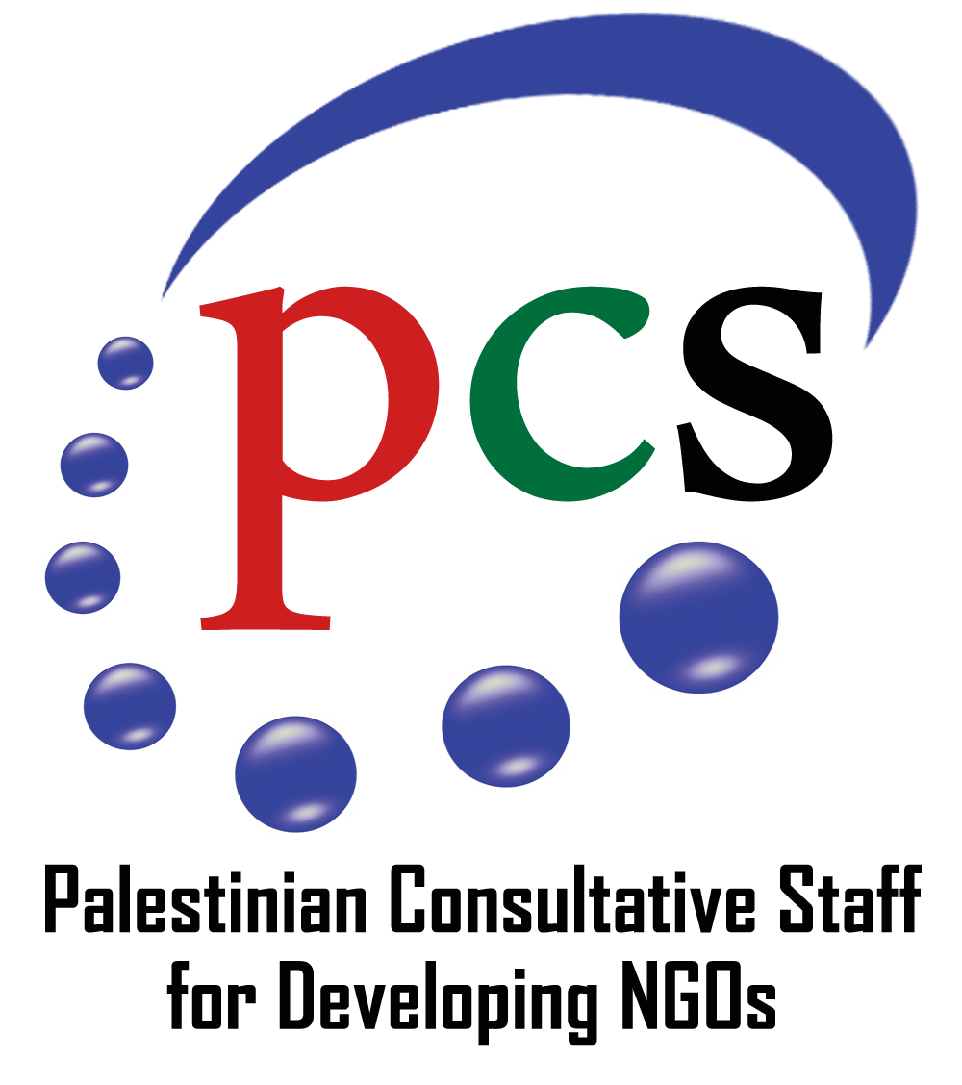
PCS Profile
General Information
- Association Name: Palestinian Consultative Staff for Developing NGOs (PCS)
- Head Office Address: AlBareeq Building-5th floor, Haifa street, Jenin, West Bank, Palestine
- Phone Number: 0097242501989.
- Website Address: https://pcs-palestine.org/ar/
- Facebook page: https://www.facebook.com/PCSPalestine.
- Association Status: civic and non-governmental organization, its legal status from the Palestinian Ministry of Interior on December 2005, under registration Number JN-897-B.
- Contact Information of the Person in Charge (Ahmad Hijawi, Executive manager, 0594229922,ahmadhijawi25@gmail.com)
Association Details
- Date of Creation: 2005.
- Mission: PCS is an umbrella for the NGOs and CBOs in West Bank and Gaza seeking to improve their capacities, increase their coordination, and call for their joint interests.
- Vision: Towards effective and entrepreneurial Palestinian NGOs and CBOs that lead their communities, uphold their values, develop their capacities, and mobilize their resources towards sustainable development.
- Main objective/ s:
- Contribute to strengthening the position and roles of local institutions in achieving sustainable development.
- Contribute to the promotion of the human rights system and Sustainable Development Goals SDGs 2030.
- Contribute to promoting entrepreneurship and economic empowerment.
- Enhance PCS's governance and institutional structure in order to achieve its goals.
The three core program of PCS are:
- Economic Empowerment and Entrepreneurship.
- Human Rights and Democracy.
- Capacity Building Program and Incubator for Civil Society Institutions.

- Main Geographic interventions: PCS has intervention in the West Bank (from 2005), Gaza(from 2010), Jerusalem and 48 areas (from 2014) it works with the Palestinians everywhere in Palestine. Mainly PCS looks for the most marginalize people and targeted them, such as area C, Jordan valley and people with disabilities (PWD). Through three offices at Jenin (head quarter), Ramallah and Gaza, and a network of more than 60 CBOs PCS reached their beneficiaries effectively.
PCS has two incubators that shape the dynamic part of its work, IDEA for small businesses company (non-for Profit Company) and NGO incubator for Civil Society Organizations (Local NGOs and CBOs from different field of work background, like women, youth, PWD, education, culture, etc).

Palestinian Consultative Staff for Developing NGOs (PCS) Profile

List of Board of Directors
Number of Board of Directors: 7(2F, 5M) and the chairman is female.
- List of key Management
Number of Employees: 10 (7F, 3M)
Qualifications | Sex | Position | Name
Ph.D. Sociology | M | Executive Director | Ahmad M. S. Hijawi
Master of Accounting | F | Financial and procurement officer | Amneh O. I. Qtuit
Master’s degree in commercial law | F | Human Rights Unit Officer | BissanShami
BA in Media | F | Media Officer and field coordinator | DeemaAlawni
BA in business administration | F | Administrative and procurement assistant | Wa’ed Samara
BA in translation | F | Outreach officer and coordinator | Zahra Abed
BA in business | M | Coordinator\Gaza | Zaher Algoul
BA in Finance and Banking | F | Executive manager of IDEA | Mai Sinan
 | M | Logistic officer | Marwan Mahajne

- Experts or consultants work with PCS
Qualifications | Sex | Position | Name
Master in Law | M | Legal Adviser | Mohammad Kamanji
BA in IT | M | IT officer | TareqAlbzour
Master in law | F | Legal advisor and expert in social protection | GhadaShadeed
Master | F | Social worker and psychologist | Mostaham Salameh
Master’s degree in social science. | F | Expert in Monitoring and Evaluation (M&E) . | SamahZahalqa

- PCS has an extended network of CBOs that contains many volunteers that support the implementation of PCS’s activities.

Technical
PCS serves as a representative platform of 60 Community Based Organizations (CBOs) that are working across the West Bank and Gaza. This has helped PCS remain grassroots oriented, as well as reach out to remote and marginalized communities serving a wide range of societal segments, including those most marginalized. Moreover, this wide grassroots network has paved the way for PCS to be a leading organization working on bottom-up advocacy that informs responsive policies at the heart of citizen needs and priorities.
Economic Empowerment and Entrepreneurship :
Our interest in economic empowerment began early and evolved as our experience in this domain got broadened. Our-vary first experience in this field involved supporting small economic projects for youth and persons with disabilities in 2012. Then our work has been further broadened to entrepreneurship and economic recovery projects. Within this framework, a business incubator (Idea) was founded in 2015 to embrace and support young entrepreneurs who have innovative ideas which are expected to evolve into successful projects by providing them with financial and technical support. Besides, PCS has built national and international networks with many Incubators and NGOs to build the capacity of young entrepreneurs and enrich their experiences. Moreover, PCS has put in enormous efforts to influence national economic policies that have, in certain cases, negative impacts on the future of entrepreneurship in Palestine: the Taxation- and registration-related-policies, and other legal issues.
Within this program, two main projects were carried out: "Economic recovery" funded by Drososs and "Promote Cross-Border Economic Coordination, Cooperation Exchange and Joint Ventures" funded by the EU.
Our Achievements within this program during the last two years:
- (115) individuals have received (615) hours of vocational and technical training distributed among (9) training courses.
- (15) youth entrepreneurs have been supported in starting or expanding their business, either through seed financing or through the investment in cooperation with the business incubator (Idea).
- (5) Major investments, under the investment scheme, have been made targeting wider beneficiaries. Around (28) have beneficiated from Holy Land Cooperative in the Organic Farm investment.
- (2) Youth entrepreneurs were provided a spatial incubation by (Idea) in an attempt to help them overcome the high cost of rent of real estate.
- (7) business incubators in the West Bank, Jerusalem, and Occupied Palestine are supported by developing their performance to efficiently provide their programs to economic youth entrepreneurs within the Cross-Border Economic Cooperation project.
-“Promote Cross-Border Economic Coordination, Cooperation, Exchange, and Joint Ventures”, the EU project with a budget of 871,685 Euros, aimed to promote Cooperation towards creating an enabling economic situation for business and entrepreneurship, specifically, to drive advocacy ventures between Palestinians all around West Bank, Jerusalem, and Israel. As an economic empowerment project, it supports several business incubators and 50% of the individual beneficiaries are women, who have the chance to own their enterprises.
- Youth Entrepreneurship in Rural Areas in Mediterranean countries, (YERAME), (2023-2024). Funded by (ERASMUS), Implementing in Greece, Spain, Italy, Tunisia, Palestine, Egypt. By PCS, Spiros, Voulgaris, Innovation Hive, DEFOIN, CEIPES.
This project aim at increasing the capacity to provide learning opportunities for entrepreneurial skills of organizations working with young people in rural areas. As a result, the project expects to have improved the entrepreneurial skills of the rural youth of Mediterranean region to promote the creation of sustainable businesses that are not fully dependent on tourism and that can therefore tackle the depopulation those areas are suffering.
Capacity Building Program and Incubator for Civil Society Institutions
In 2019, PCS has established the Incubator of NGOs in the Jenin Governorate, to create an environment that embraces and develops the work of grassroots NGOs in the governorate to overcome the challenges they face in terms of providing locations, logistics, and administrative expenses in a way that contributes to strengthening the roles of NGOs and the development of networking by including currently (8) grassroots NGOs.
The impact of this program on the ground during the last two years could be demonstrated as follows:
- More than (100) grassroots NGOs and local bodies (municipalities and village councils) in the West Bank and Gaza Strip were provided with support and guidance in their various forms: planning and implementing capacity building and providing follow-up support throughout the process, institutional review and capacity assessment, strategic planning, systems development that includes monitoring and evaluation, developing financial and administrative systems, legal aids, writing project proposals, promoting continuous access to resources, and working to review government policies and measures related to establishing associations.
- In the field of human rights, (15) NGOs for persons with disabilities were capacity-built and their internal environments were developed so that they become more responsive to the needs of the target groups.
-In the field of economic empowerment, the capacities of more than (300) young people of both genders were built in areas related to economic empowerment before being integrated into the labor market or receiving grants for projects.
PCS had published a manual for CBOs organization on management and financial measures and their relation to corruption.
PCS prepared different studies related to the entrepreneurship sector like the Index of the Palestinian Incubators (PCS produced two editions and working on the third one), besides four economic studies with the titles:
- Nonprofit Companies between Law and Reality ........... Aspects for Change
- COVID-19 and its Impacts on Palestinian Entrepreneurship Sector.
- The Impact of the Suspension of the Coordination between Israel and the Palestinian Government on Trade Relations and the Economy in the Context of the Corona Pandemic.
- Funding Priorities in the Business Incubation Sector in Light of the Corona Pandemic.

Inclusion of gender equality in organizations’ activities and objectives
The Palestinian Consultative Staff for Developing NGOs (PCS) devotes significant attention to gender equality considerations as its main priority. This is illustrated by the percentage of female staff members working within the organization, which is 70%, and the priority of the recruitment of women in projects and programs implemented by PCS. Besides, PCS is a network of grassroots organizations, where there are 20 grassroots women organizations within its framework, and they benefit from its programs. In this context, it should be mentioned here that PCS is led by a woman, Farha Abu Al-Hija, a woman's rights activist and the Head of the Board of Directors.
Regarding gender discrimination issues, all the regulations consider gender values and explicitly prohibit discrimination based on sex. It’s prohibited to work, network, cooperate, and collaborate with parties that violate women's rights and do not believe in the values of gender equality. Also, PCS imposes preventive measures against discrimination. For instance, in programs and projects and within the organization's standards, women must constitute 50% of the beneficiaries, whether in economic empowerment programs, capacity-building, or other programs and at the individual and institutional level.
As for planning, the organization's strategic plan 2020-2023 includes direct interventions related to empowering women at multiple levels in the socio-economic and political fields to enhance their participation in its various forms.
PCS has implemented several projects that sought to empower women by identifying the needs and priorities of vulnerable groups, especially women, to be addressed in strategic planning in municipalities. They also focused on enhancing women's economic participation in the labor market, as well as improving their participation and situation in political and social life. Other projects and programs worked on preventing violations of and combating discrimination against women with disabilities. Through its Gender Unit within the Human Rights Program, violations against women inside and outside the organization are monitored, documented, and followed up.
Gender equality and the empowerment of women and girls:
The PCS has considerable experience in working with Women’s Rights Organizations, adopting a core strategic objective to support the efforts of Grassroots Women’s Rights Organizations to provide better outreach and inclusion of women in their communities. The following is a list of key projects and achievements in this regard:
-Women labor rights in the private sector, Euro-Mediterranean Foundation of Support to Human Right Defenders, €20,000, which aimed to amplify women's voices demanding their equal rights in the private sector.
-Advancing social and economic rights for vulnerable groups, EU-funded €500,000 which aimed to empower CBOs in monitoring, documenting, and following up on violations of social and economic rights for vulnerable people, while activating national mechanisms of protection.
-Disability mainstreaming in policies and programs: Worked with MoL to mainstream PWDs rights in the workplace, particularly for women with disabilities (WWDs). PCS worked with several MoL directorates on adopting mechanisms for mainstreaming PWDs in their operations including PWDs cards. One of the projects in this field is (Enhancing and Protecting the Rights of Persons with Disabilities in the Occupied Palestinian Territories, EU-funded 491,716Euros).
-The Action of Advocating for Grassroots & Institutional Mechanisms to Advance Social & Economic Rights for Vulnerable Groups in the oPt, the EU-funded project is implemented in the West Bank and Gaza, in partnership with Bunian Association for Community Development and Student’s Forum Institute from Gaza, and more than 60 CBOs from West Bank and Gaza as third parties. Through all the implemented projects by PCS the participatory approach, working groups, and sharing information with all the main actors is a must, different techniques are used like Facebook pages to be on-touch and have day-to-day contact, besides using WhatsApp application. With a budget of 478,453 Euros.
-Cordaid, a total of €50,000 for two projects which aimed to advance income-generating opportunities for women through improving their linkages with business development services, and facilitating their linkages to the market.
-UN Women, in partnership with Mothers schools in Nablus, for a total of $200,000. The project aimed to enhance women’s participation and role in the job market through forming a civil consortium that addressed women's labor rights, including equal opportunity for employment, equitable wages, social protection, and engagement in the Tripartite dialogue between the public, private, and governmental sectors.
--PCS with shashat under the project (Let's Watch a Movie) implemented three films with the aim of entertaining.(300) females and (300) males of different age groups who participated in public activities in public squares attended. People with disabilities participated by (10%) of the total The number of attendees at these activities
- “Female Campaigning School”, funded by Elda Academy. Is a five-part project that enables a total of 90 participants from the Palestine and Lebanon to develop, realize and publish their own campaigns. The campaigns deal with gender justice, female empowerment and women's rights and make them publicly visible in the target countries. The participants receive input and practical exercises from our international experts. As an outcome of this project, various media- and publicity-effective campaigns are developed in joint project work, which promote the equal rights of women in the target countries. In the final phase, the best campaigns are awarded.

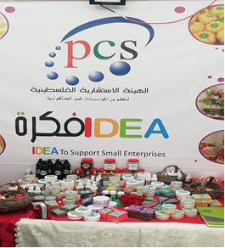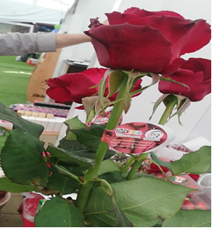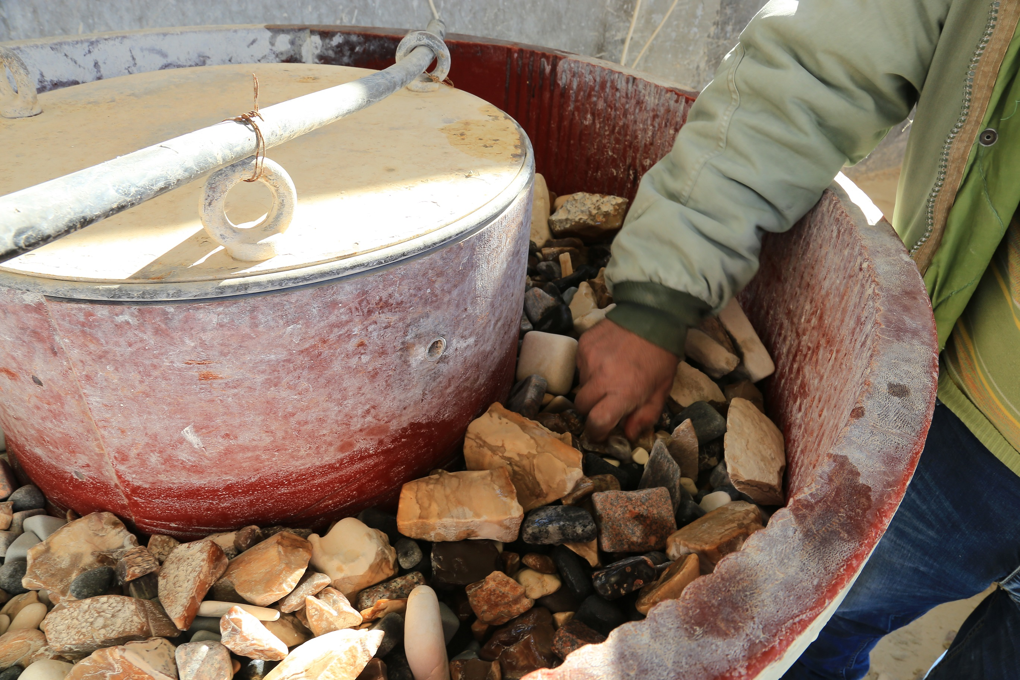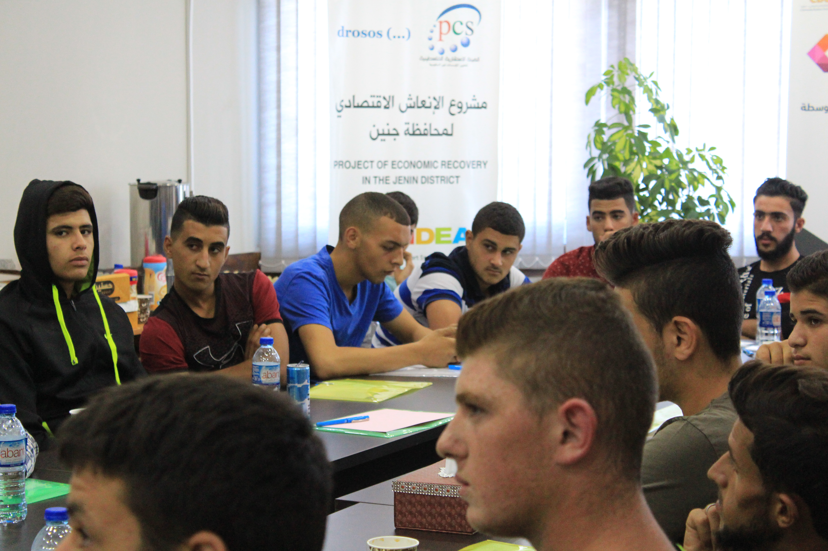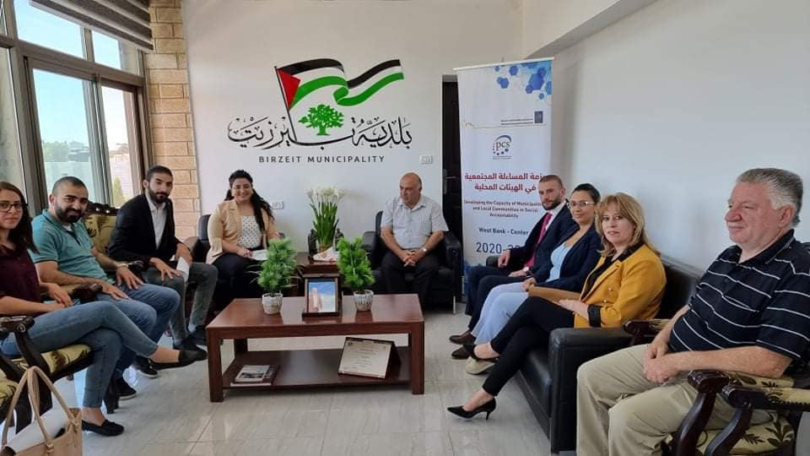

Human Rights and Democracy
It could be described as a major program due to its notable achievements as it succeeded in amplifying the voice of the vulnerable groups and broadened their space to clearly articulate their needs and rights. the work within this program funded by EU has been concentrated on the following areas: disability, social accountability, influencing policies, and the social and economic rights of vulnerable groups. Although the scope of work was expanded in some areas, especially in the Complaint Unit, the results were impressive. The program has been able to positively affect more than (12,000) beneficiaries directly and nearly (5,000) beneficiaries indirectly yearly reported.
- PCS has launched the (100 Days Campaign of Government Accountability) in cooperation with the Independent Commission for Human Rights (ICHR), PNGOs, AMAN Transparency Palestine, and Palestinian National Institute for NGOs with the participation of (84) civil society organizations of all national and grassroots levels in West Bank, Gaza and Jerusalem. The Campaign aimed at examining the extent of government commitment to the letter of assignment issued by President Mahmoud Abbas, and based on which the government was formed as well as encouraging the citizens and the civil community in terms of active community participation and motivating the government to raise the performance efficiency and implement promises made to citizens. The campaign resulted in an extensive report outlining mainly facts that disclose the current performance of the government and what is needed to be done to improve that performance.
- In partnership with the Palestinian Education Coalition PEC, PCS has launched (The ask the Government) campaign to assess the points of view of the parties involved in the educational process (students, teachers, parents, researchers, etc.) about the appropriateness of the Palestinian curriculum, especially the new textbooks, the methods of teaching, and the school environment to achieve eventually an access to a quality and equitable education for all. Around (10400) people participated in the campaign and expressed their opinions on Palestine’s new curriculum, and a workshop was held to discuss the results of the campaign with the participation of the director-general of curriculum and civil society organizations. The campaign coincided with the seventieth anniversary of the Universal Declaration of Human Rights, where the right to education plays a central role in empowering and strengthening other rights.
- The project Contributing to constructive relations between citizens and the state funded by GIZ aimed to strengthening the existing relations between local authorities and their citizens in planning processes by improving the quality of participation, and thus increasing transparency and accountability in the local government sector in the West Bank. PCS works on constructive relations with the citizens of the state (with 15 local communities) in the local government sector in Palestine which is driven by the Policy Paper on Social Accountability launched by the Ministry of Local Government in 2015, which sets out national guidelines for the implementation of social accountability in Palestine.
- "Empowering early childhood education", funded by Welfare association, (16) kindergartens have been rehabilitated in the Jordan Valley to be able to provide healthy, secure and comprehensive educational services, (40) teachers and directors of kindergartens targeted (1000-1500 children), (20) educational and visual circles Produced in childhood. In addition to increasing the integration of Bedouin children in the Jordan Valley in childhood education. Establishing an effective kindergarten network. National advocacy campaigns to support the right to early education in the Jordan Valley.
-The project "Elections are a Right...and Youth at the Forefront" funded by the United Nations Development Program (UNDP), which aims to raise awareness and participation of youth in the electoral process.
-PCS has support (41)municipalities funded by (MDLF), to institutionalizing social accountability.

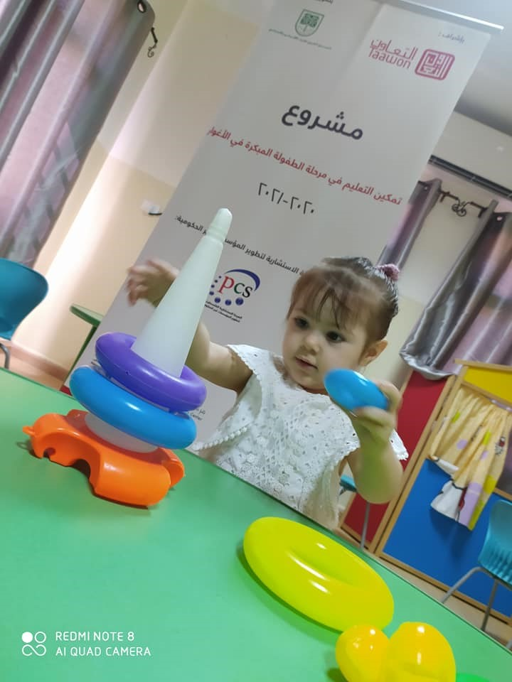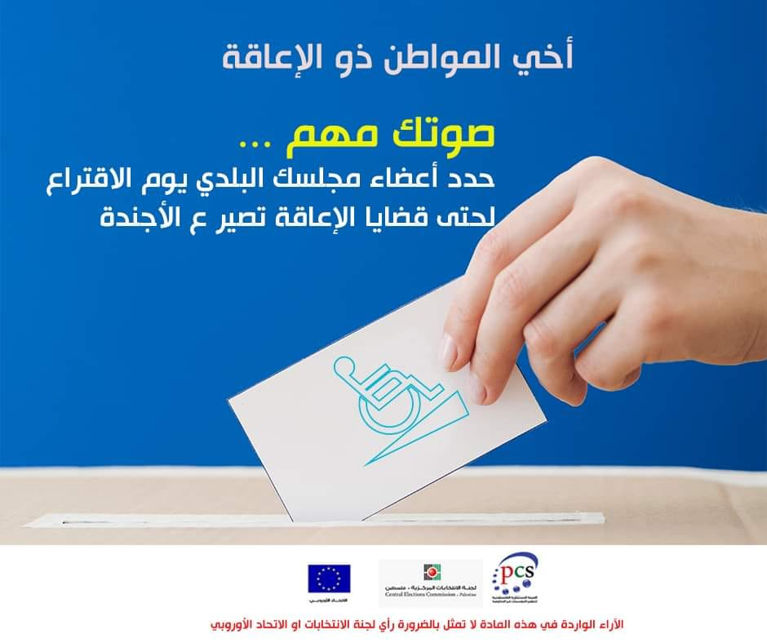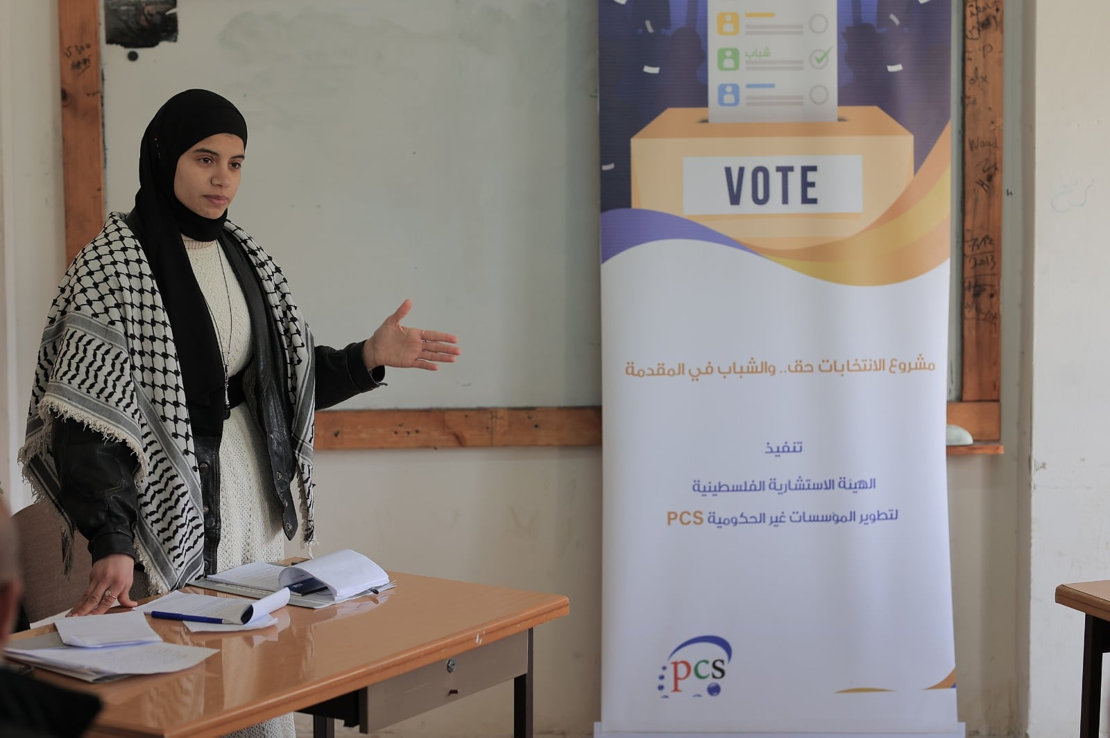
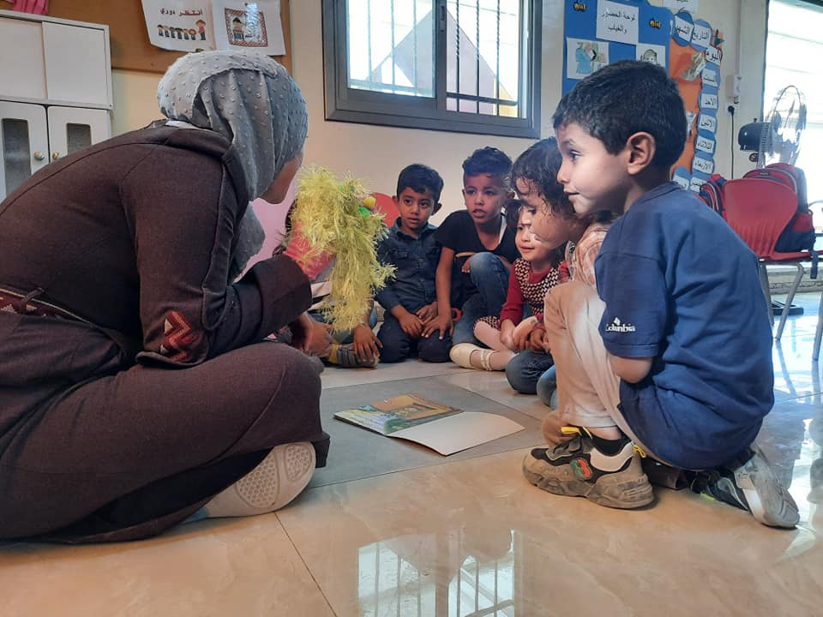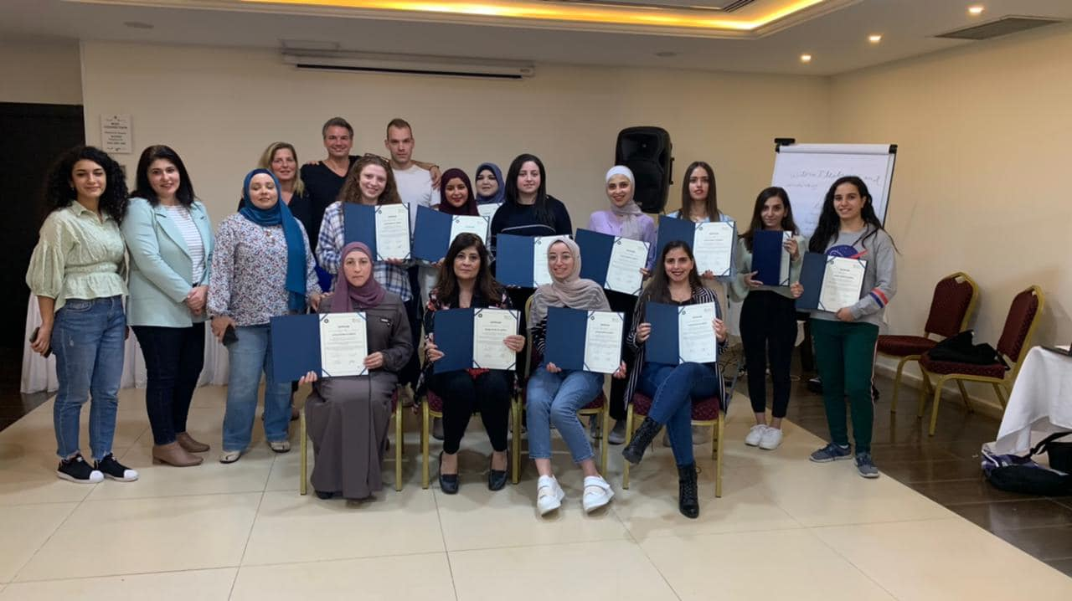
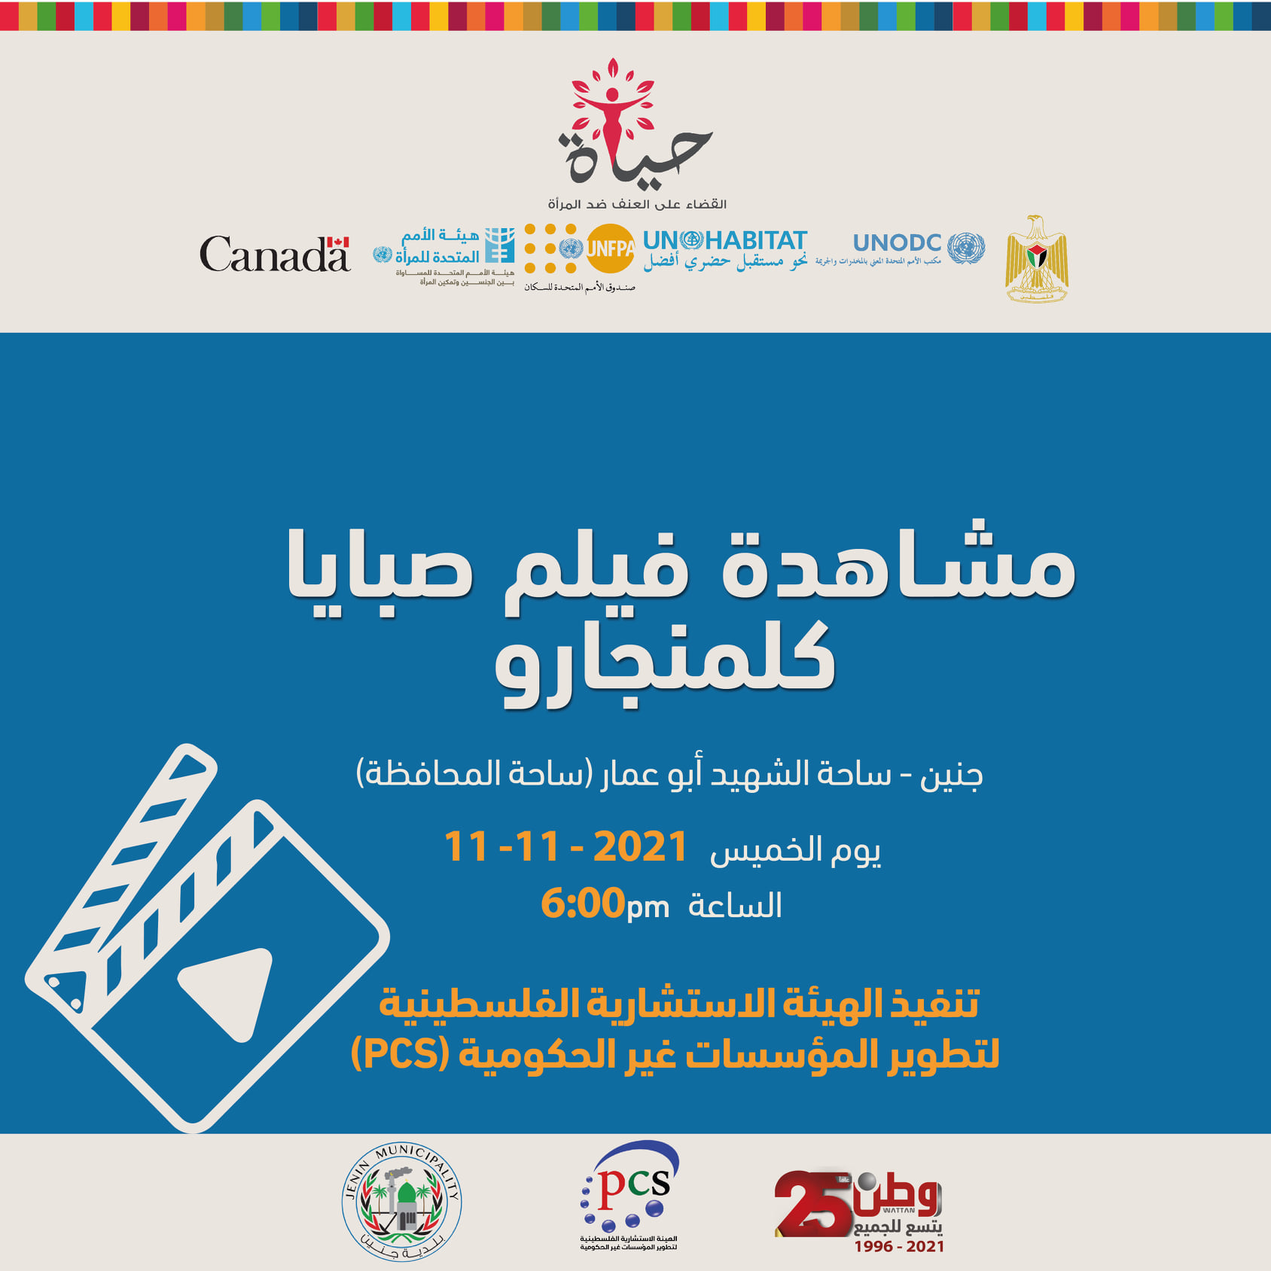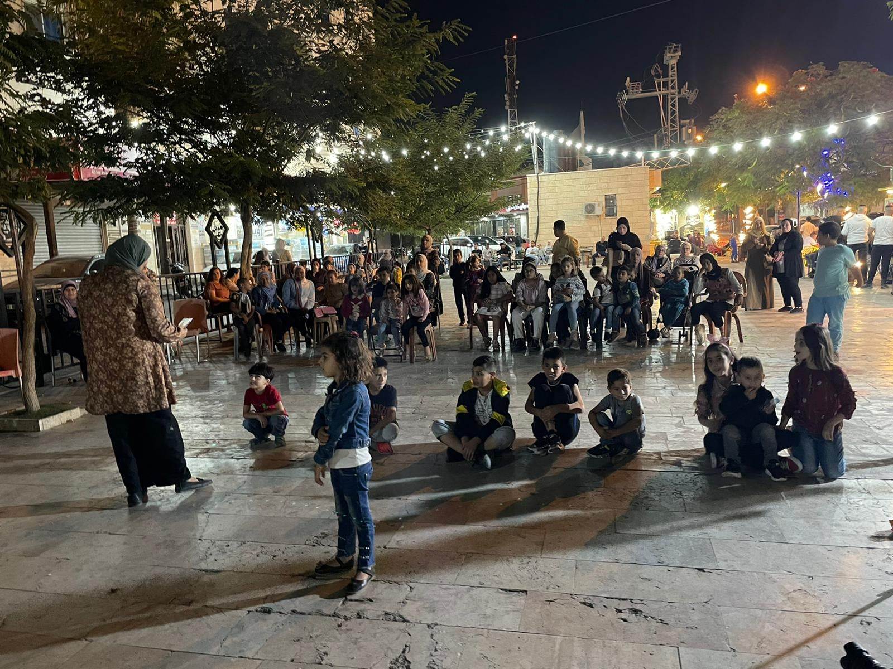

PCS Membership in National and International Networks:
International: PCS had consultative status in the social and economic council in the UN, a member of the Youth Business international network,GNDR Global Network for Civil Society Organizations for Disaster Reduction,ANNA LINDA Foundation" network for cultural dialogue at the national and international level,ANSA Network,- International Network for Social Accountability, Affinity Group of National Associations (AGNA), UBI GlobalMember of Arab State league – Cairo,- Member of Network of Democrats in the Arab World (NDAW)– the UK,- CIVICUS World Alliance for Citizen Participation, which is considered among the most important international networks working on advancing social accountability in SDGs,Member in the board of directors of the Arab Campaign for Education for All which is working on activating social accountability on SDG4 and a member of the Palestinian Education Coalition Secretariat, TAP NETWORK "Transparency, Accountability, and Participation for 2030.
Local-level:- Education Cluster under Emergency/ OCHA, The Secretariat of Palestinian Education Coalition, The Secretariat of Arab Campaign for Education. Protection Cluster,Member of the consulting commission for a national inquiry on the rights of persons with disability to livelihood,Member of the Human Rights Council Advisory Committee,Member of Palestinian National Institutes for NGOs (PNIN).
- Palestinian General Federation of Trade Unions.
- Member of the Coordination Council for Palestinian NGOs (CCP-NGOs).
- Member of the National Committee for Social Accountability.
- Member of the “Partners to Review” international network sponsored by GIZ which is working on social accountability on SDGs.
- Member at “The Network of Organizations Providing Services to Green Entrepreneurs in Palestine.”

ANNA LINDA Foundation | 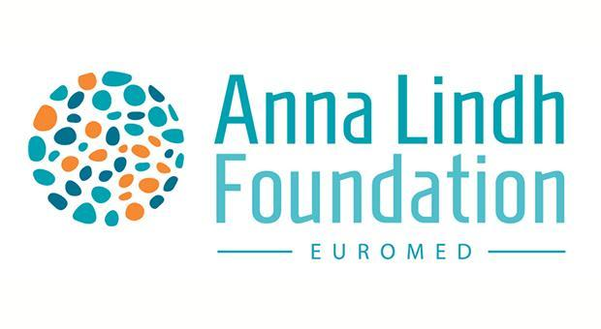
Network of Democrats in the Arab World (NDAW) – UK | 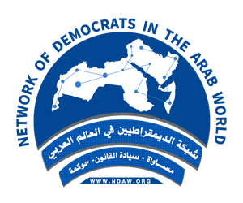
CIVICUS World Alliance for Citizen Participation | 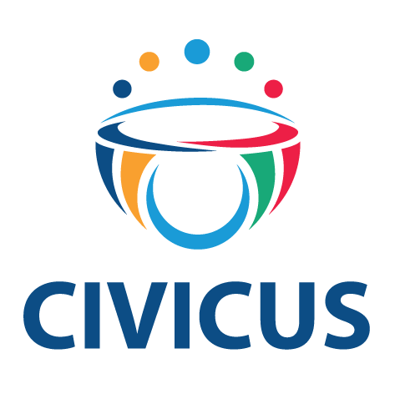
Palestinian National Institutes for NGOs PNIN | 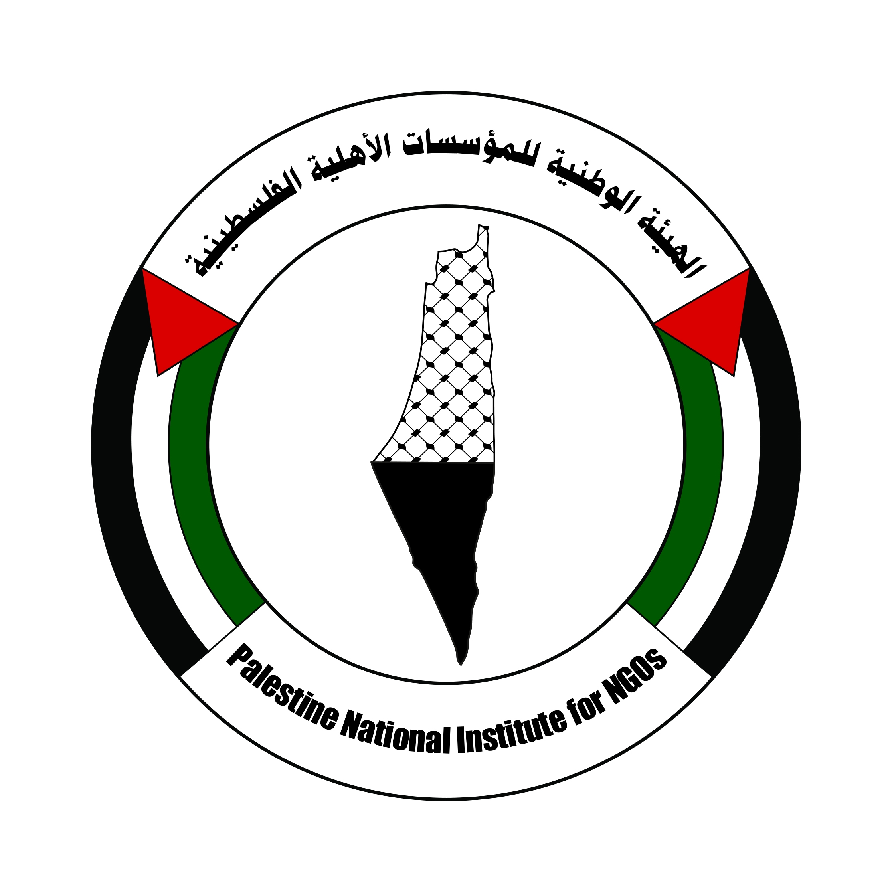
The National Committee for Social Accountability – Palestine | 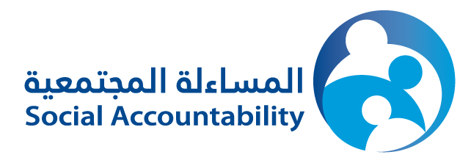
Affinity Group of National Associations (AGNA) | 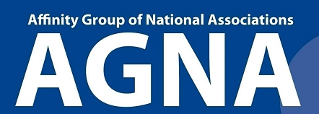
Global Partnership for Social Accountability-World Bank
Social Forum – Palestine | 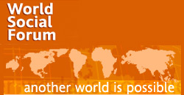
Palestinian Education Coalition - The Global Campaign for Education (GCE) | 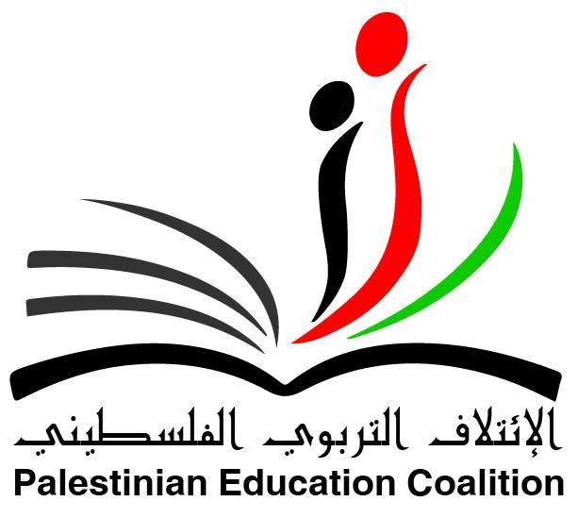
Palestinian Anti-Corruption Commission | 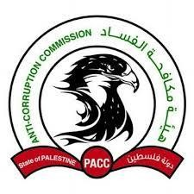

Donor | Project Name
German development Service DED | The project of reactive the role of women in NGOs 2006
UNDP /PAPP | The project of capacity building of youth NGOs in Jenin governorate
Consulate General of France in Jerusalem | The project of capacity building of NGOs 2008
German development Service DED | The project of promoting the rights of disabled youth 2008\2009
European Union | The project of capacity building of NGOS in human rights and democracy field2008\2009
Save the children U.S/NASSEJ | The project of development through youths 2009
Welfare Association | The project of rehabilitation the teachers to treat with disables 2009
German development Service DED | The project of integration the disabled persons through media 2010
DIAKONIA/NAD | The project of lobbying and advocacy for the disabled persons 2010-2014
United Palestinian Appeal UPA | The project of Rehabilitation the kindergartens 2010
Welfare Association | The project of integration the disabled persons through media 2010
Canadian International Development Agency CIDA | The project of Establish Strengthen Classes for difficulties learning students 2011
The Italian Cooperation | The project of Strengthening the Palestinian Electoral Participation2010 / 2011
The Euro-Mediterranean Foundation of Support to Human Rights Defenders | The project of Combating Discrimination against Palestinian Women Working in the Private Sector2010 / 2011
German International Cooperation | The project of enhancing political participation of disabled 2011
DROSOS Foundation | The project of supporting pioneering projects for youths 2011 / 2012
CORDAID | The Project of Capacity Building of Women CBOs in Jenin 2012-2013
European Union | The action of enhancing and protecting the rights of persons with disabilities in the Palestinian territories 2012-2014
Trancparency Palestine (AMAN) | The Project of Promoting transparency in Palestinian NGOs Watch-Pal-NGOs 2013
Consulate General of France in Jerusalem | The Project of Rehabilitation and Developing Kindergartens to integrate Children with Disability in Northern Governorates 2013
German Representative Ramallah Office | The Project of Rehabilitation the Kindergartens in Jenin Governorate 2013-2015
German International Cooperation | Project of Enhancing the Social Accountability in Palestinian Local Authorities 2013
International Labour Office  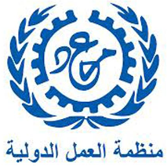  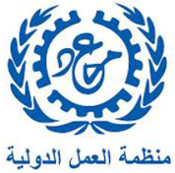 | The Project of Mainstreaming Disability in Policies and Programmes Supporting Employment in Opt
The Euro-Mediterranean Foundation of Support to Human Rights Defenders | The action of Protecting the right to form Associations in Palestine
HR/IHL Secretariat | The project of Enhancing and Protecting the Rights of PWDs 2014-2015
UNDP/ SAWASYA | The Project of Creating Sustainable Community Awareness Mechanisms of Anti-Corruption 2015
Diakonia /NAD | Capacity Building for DPOs  2015-2017
DROSOSS Foundation | The Economic Recovery  2015-2019
EU | The project of Enhancing and Protecting the Rights of PWDs 2015-2018
BRITISH COUNCIL | Arab Youth Voice  2015-2018
GIZ | The Project of Enhancing the Social Accountability in Palestinian Local Authorities
UNDP/ SAWASYA | The Project of Community Police  2016
GIZ | Enhancing Social Accountability in local governance  2017-2018
World Vision | Facilitate Businesses,2018
EU | Promote cross-border economic coordination, cooperation, exchange, and joint ventures. 2018-2022
EU | Aadvocating for grass root and institutional mechanism to advance social and economic right for vulnerable groups in OPT. 2018-2021
Polish Aid Development program of the Ministry of Foreign Affairs of Poland | Educational Toys for Improved Learning for Children with Disabilities,2020
World Vision | Improving Economic Situation through Providing Chicken to the West Jenin Villages Project,2019
CIVICUS | National Dialogues: Enabling Environments for Domestic Resource Mobilization,2019- 2021
GIZ | Contribute to constructive relations between citizens and state in Palestine,2019-2022
World Bank through the Municipal Development and Lending Fund (MDLF) | Developing the Capacity of Municipalities and Local Communities in Social Accountability, 2020-2022
Arab Fund for Economic & Social Development with the supervision of Welfare Association | Empowering early childhood education- Jordan Valley, 2020-2022
Shashat | Habitat, 2022
Central Elections Commission-Palestine | I have the right to vote and be elected, 2021-2022
Elda Academy | Female Campaigning School,2022
ERASMUS | Yerama,2023-2024

List only previous similar assignments successfully completed in the last 5 years.
Duration | Assignment name/& brief description of main deliverables/outputs | Name of Client & Country of Assignment | Approx. Contract value (in US$ equivalent) | Role on the Assignment
2012-2013 | "Strengthening Social Accountability in Palestine 2012-2013" | GIZ | 40.000 Euros | Sole
2014-2015 | Institutionalizing Social Accountability in PALISTINE :West Bank | GIZ | 30.000 Euros | Sole
2017-2018 | Strengthening state (LGUs) – citizen relation through the instituonalization of social Accountability in the local governance sector in Palestine, (Northen West Bank), | GIZ | 30.000 Euros | Sole
2019-2021 | Contribute to constractive relations between citizens and staste in Palestine. | GIZ | 40.000 Euros | Sole
2016-2017 | Enhancing the Social Accountability in Security Sector | UNDP | 60,000 USD | Sole
2018 - 2020 | Using grassroots advocacy to advance social and economic rights | EU | 800,000 USD | Lead
2012-2018 | Using social accountability as tools to engage citizen in evaluating the performances of ministries | EU | 600,000 USD | Lead
2016-2017 | Roll out social accountability tools across 4 line ministries to assess their level of responsiveness and accommodation to the needs of PWDs | Human Rights Secretariat | 70,000 USD | Sole
2019-2020 | National Dialogues: Enabling Environments for Domestic Resource Mobilization | CIVICUS | 20,000 USD | Sole

2. List only those assignments for which the Consultant was legally contracted by the Client as a company or was one of the joint venture members. Assignments completed by the Consultant’s individual experts working privately or through other consulting firms cannot be claimed as the relevant experience of the Consultant, or that of the Consultant’s partners or sub-consultants, but can be claimed by the Experts themselves in their CVs. The Consultant should be prepared to substantiate the claimed experience by presenting copies of relevant documents and references if so requested by the Client.

