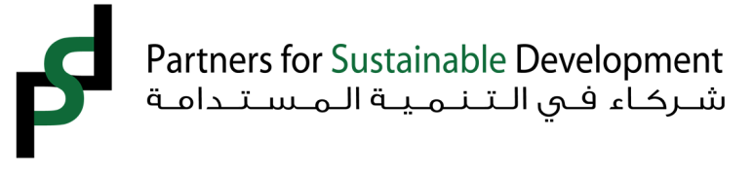

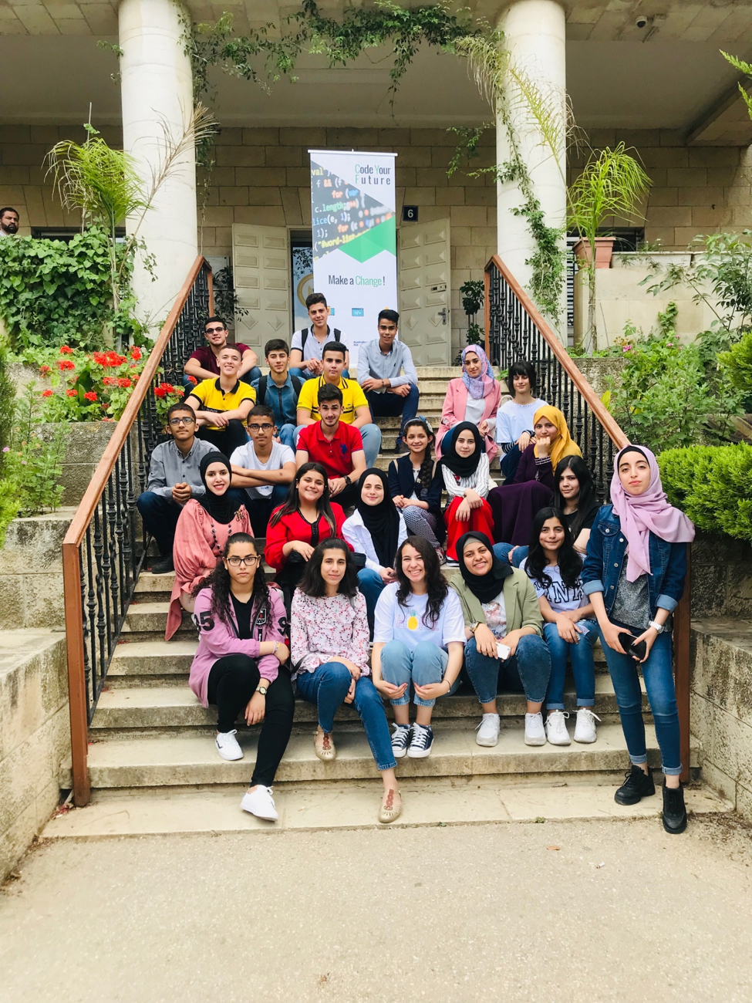

# About Partners for Sustainable Development

Partners for Sustainable Development (PSD) is a non-profit organization established in 2009 to equip young Palestinians with the knowledge and skills required by an increasingly complex and demanding 21st century. PSD’s main programmatic interventions are centered around three main pillars: equitable education and educational content development, fourth industrial revolution (4IR) skill development, and finally employability and entrepreneurship.

## What we do:

* Digitize the Palestinian curriculum and develop interactive educational content
* Equalize learning opportunities by bringing educational resources to marginalized communities
* Create “Edutainment” games that complement the curriculum or address specific social and environmental issues
* Help youth develop the skills required for the fourth industrial revolution (IR4) and scale up innovative solutions to some of the societies’ greatest problems via training and mentoring
* Expanding youth’s and women’s employability by providing them with in-demand professional skills and know-how to pursue online freelancing opportunities
* Strengthening youth’s agency and belonging through service of their communities

## How we do it:

* By leveraging on public-private partnerships with ministries, municipalities, educational institutions, private foundations, companies, and service providers
* 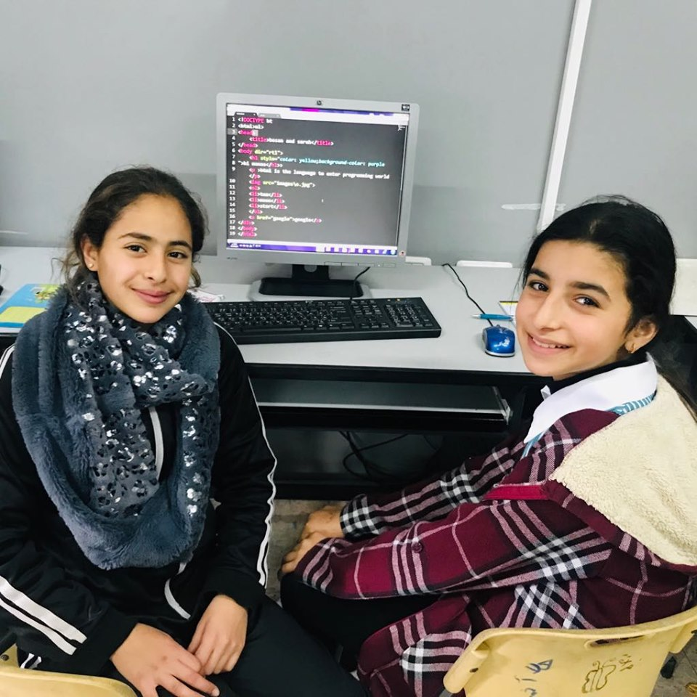By utilizing holistic approaches in program design and implementation that incorporate human-centered design, design thinking, service learning and civic engagement, design thinking, and learner centered pedagogy

# Programs

PSD’s main programmatic interventions are focused on three main pillars: educational content development, IR4 skills development, and youth empowerment and engagement.

# The Rule of Community Learning and Development Centers (CLDC)

A key PSD value is the belief that acquiring knowledge stretches beyond the corners of the classroom. PSD’s Community Learning and Development Centers (CLCDs) were formed with the intent of providing channels by which the community can be involved in their own continued educational process. CLCDs introduce a new way of development that relies on people themselves. Through this model, disparate community members are able to collect and analyze information about both the problems of their communities and the capabilities of those communities to solve them. This allows this same group of dedicated community members to solve problems in such a way that they remain solved. In a field whose very nature demands that each generation takes charge of its own development, the CLDC serves as a constant and as a resource in a changing development environment.

PSD established, 7 CLDCs have been established in Jenin, Salfeet, Nablus, Hebron, Tubas, Tulkarim, Hebron, Bethlehem, and Qalqiliya.

Service Learning, a learning strategy adopted in all of PSD’s CLDCs, integrates meaningful community service with instruction and reflection to enrich the learning experience, teach civic responsibility, and strengthen marginalized communities in Palestine. Through service-learning, students use what they learn in the curriculum to solve real-life problems. They not only learn the practical applications of their studies, but they also become actively contributing citizens and community members through the service they perform.

PSD is focused on education as a primary means to achieve its goals. Through after school programs, integration of Information and Communication Technology (ICT) in education, and by shifting the focus of existing school models, PSD is gradually reshaping the norms of formal and informal education in Palestine.

Positive youth development strategies, recreation and prevention activities are at the core of PSD’s after school programs. Such activities may involve the performing arts, music, physical recreation, promotion of health/nutrition, career awareness, engaging in community service and other youth development programs based on the students’ needs and interest.

PSD’s ICT program is dedicated to improving critical thinking, collaboration, communication and creating student-centered classrooms. Students and teachers are engaged in project-based learning processes and practices that give them the tools to identify the challenges in their community and use local resources to solve the issues faced by its members. In addition, teachers are provided with the knowledge and skills needed to adapt their teaching and learning methods as needed in an evolving world.

## Educational Content Development

PSD’s main educational content development activities occur under the NETKETABi program. The program works towards providing a multidimensional approach to addressing the gap between the educational system and the ever evolving demands of the 21st Century. NETKETABi refers to both the physical learning device and the educational content within. Within the device, students have access to the digitized Palestinian curriculum through interactive books for grades 5-9, access to thousands of educational material through 1700 instructional videos in partnership with Khan Academy, 1009 study collections in partnership with Gooru, and educational and assessment games. While teachers have access to a classroom management application that enables them to manage the class, share educational tools with students, as well as give synchronized exams.

PSD trains both students and teachers on the integration of information communication technology ICT in the classroom and learning process, as well as the use of NETKETABi, its content, and its integration in their lives. PSD also works with parents to familiarize them with the solution and enhance their understanding, and support of interactive learning tools.

Municipalities and local councils have been instrumental partners in PSD’s digitalization initiative. PSD engaged them in training, deployment, and student led initiatives. Local communities were mobilized to cover the cost of NETKETABi devices for schools and teacher training. Municipalities opened their facilities for teacher, student, and parents training.

## 4IR Skills Development.

In 2014, PSD expanded its programming towards the integration of technology, particularly coding, to reinforce ICT, problem solving, critical thinking, creativity, and teamwork as core skill among Palestinian students. Innovative projects such as iCode introduced coding skills to middle and high school students throughout the West Bank and Gaza who had limited or no previous exposure. ICT themed projects utilize a two-tiered training approach where PSD trains university students who in turn train younger students. By the end of the training youth not only learn coding skills but also gain problem solving skills, digital confidence, and a better understanding of their communities due to the integration of civic engagement and design thinking concepts in the project design.

PSD implemented several successful cycles of iCode and partnered with international companies and organizations, in 2017 PSD implemented IOT and microcontroller kit with TKP labs at Birzeit university and 20 public schools; in 2019 upto now PSD implementing coding program in partnership with World Learning organization targeting university students. PSD will continue training new cohorts of students, ensuring the sustainability of the project and its wide reach among Palestinian students. Other projects that focused on IR4 skills included TechCamp, Internet of Things training, and Polyup.

**Program Snapshot **

PSD has been implementing the Polyup program since 2018. Polyup is STEAM program focusing on computational thinking playground where students can experiment with elements of mathematics and computer science to solve real life challenges. Polyup’s 3D playground allows anyone to create an activity, design robot and coding to solve real life challenges focusing on SDG’s by using mathematical equations and numbering and share with anyone else to play said project. In this sense, Polyup is an open platform where communities can come together to create and problem solve. PSD has been holding Palestine Challenge, a weekly community events that encourage learning and sharing of educational content. During the implementation of Polyup activities, municipalities sponsored students training and offered prizes to encourage student’s participation in the community challenges while also providing them with relevant information and figures.

## Empowerment

PSD’s empowerment projects seek to enhance youth’s and women’s skills to expand their opportunities and cement their role as active change agents.  Thus projects often utilize service learning, human centered design, and design thinking as approaches and provides tools for youth to not only develop themselves, but also become the driving force behind sustainable community development. In addition, PSD provides students with opportunities to enable them to bridge the gap between their formal education and the needs of the market, enabling them to gain the professional experience that would expand their skill set and increase their employability. PSD has implemented many projects under this programmatic component such as Youth Earn, Youth Engagement in Economic Development (YEED), Virtual Institute for Employment and Work (VIEW), and most recently the Makkeni project.

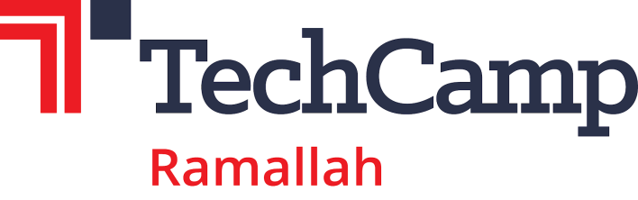**Virtual Institute for Employment and Work**; In the response to the employment situation outlined above, PSD devised a comprehensive program that enhanced student’s awareness of freelancing as a concept, enhanced their capacity in industry specific technical skills and general soft skills valued by employers, launched an employment portal that connected employers with freelancers and freelancers with employment opportunities locally and worldwide, and facilitated the payment mechanism between freelancers and employers.

**Program Snapshot** Makkeni fosters the economic empowerment of fresh female graduates to prepare them to enter the market in the fields of digital marketing and digital media. 100 graduates took part in life skills training followed by technical trainings in multimedia and graphic design, digital marketing, and social media management. The participant will also partake in training that introduces them to freelance work and guides them on building their portfolios. The top 20 performing participants will receive access to grants and will be connected with the relevant stakeholders in their communities to provide them with services in the mentioned specializations.

The project aims to work towards expanding women’s opportunities and participation in Palestine’s growing economy by developing women’s talents, providing networking opportunities, and encouraging entrepreneurship. Specifically, the project addresses three outcomes:

* Project participants have access to decent and productive living through market-oriented skills training
* Increased number of financially empowered women through the access to finance stage and connections with local organizations/private sector as their clients
* An enabling environment for women empowerment in the rural areas has been created by encouraging women access to local CBOs, organizations, and private sector

**TechCamp** Ramallah: Business Success through Academic Excellence provided university students the critical thinking skills, tech savvy, and ability to innovate that they need to survive and thrive in the private sector. This workshop and activities strengthened linkages between students and Palestinian businesses by focusing on the power of technology to solve real-world problems and drive economic growth. The program emphasized a skills-based curriculum that addresses private sector needs.

**Medial Information Literacy** 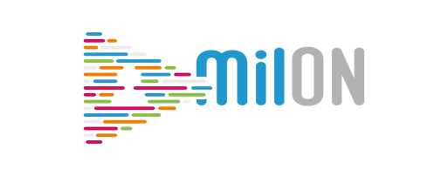

Partners for Sustainable Development working on Media and Information Literacy (MIL) to allow Youth to create and produce their own media and technology whilst learning about the creation of media in respect to the 7 competencies of MIL (Comprehension, Creativity, Critical thinking, Citizenship, Consumption; inter-cultural Communication and Conflict resolution). Technologies and media education and content building are usually approached in conflict zones as a top down. The MIL educates Youth in a holistic manner that will allow freedom of expression in an informed and responsible manner.

PSD implemented ECOFOLI project aiming at fostering sustainable conflict resolution strategies through the study and ownership of the common Mediterranean culture, in particular local cultural heritage. The project helped youth see the positive aspects of their communities, starting with their cultural heritage. By the end of the project, youth participants felt greater pride in the communities and cultural heritage. They have gained skills to not only be on the receiving end of media information, but also to be Ambassadors, who can positively express their opinions through their own media creations.

Partners for Sustainable Development created videos, Info graphics and Edutainment games about (self-expression, stereotypes safety on the internet, misinformation, disinformation Malformation, hate speech, cyberbullying, e-blackmailing and other topics; the content available for youth, teachers and educators on Multilanguage platform with lesson plans, training materials and interactive forum. <https://milon.media/> .

# Awards and Recognition

### Haidar Abdel Shafi prize

### PSD won the Haidar Abdel Shafi prize for voluntarism for its work in mobilizing youth and local community organization and engagement of volunteers in its programs.

### Game Jam Palestine 2015

During a competition on educational game development, PSD content team won Game Jam Palestine 2015 competition for developing a reading promotion educational game. As a prize the team participated in AMAZE Berlin Festival 2016.

### Word Summit Award

NETKETAB was the national winner for the Word Summit Award 2015, receiving an award for electronic content and creativity in Education in regards to the digital content produced by PSD team.

### Certificate of Honor from Higher Council for Innovation and Excellence2015

The Content Package project, which contains content development resources and applications, was honored as one of the creative products in education in Palestine. The Content team received an award and a certificate of honor from the Palestinian president

### Google Rise Award

Partners for Sustainable Development received the Google RISE Award as one of 28 organizations in 16 countries receiving a 2016 Google RISE Award. The Google RISE Awards is a grant program for informal education organizations around the world that promote computer science (CS) for K-12/pre-university age youth that are traditionally underrepresented in CS. PSD received a Google RISE Award to support K-12 students by promoting entrepreneurship culture through technology.

### Best Educational App

Partners for Sustainable Development received the first prize for the best app in the education category at the 2016 Palestine Expotech. The app promotes the entrepreneurial culture among youth by teaching them the steps required to become entrepreneurs.

### iBridges Contest

Partners for Sustainable Development’s “Nooro Pedia” was selected a one of the best 20 entrepreneurial ideas among 200 ideas submitted from 23 participating countries. The team was invited to pitch during pitch fest which centered on games with positive educational and social impact.