FOKUS ALBANIA PROGRAMATIC INTERVENTIONS 2019

TABLE OF CONTENTS
About the Centre
Values and Mission
Programs and Activities
- Promoting the Rights of the Child through services and information
- Research and Studies
- Advocacy and Awareness
- Capacity-building
- Partnerships and Networking

Forewords

I am delighted to present our Annual Report for the year 2016- 2018. You will see as you go through our pages what we do and what we have accomplished during the year.
It has been a very productive year of addressing individual issues through our services, advocacy and lobbying, participation and representation role as well as identifying many important systemic issues for the children’s well being.

We have been assisting considerable number of families, through their children – helping them understanding their development, and their health.

We have worked to secure equality, inclusion and justice for children with mental disabilities, providing us the opportunity to not only highlight particular stories but more importantly allowed us to identify what needs to change in the system to ensure the best services are provided to our most vulnerable.

We had the opportunity to get out more into our communities across Albania. It was our pleasure and privilege to meet so many dedicated professionals who continue to strive to ensure services are available where there is most need. Meeting and connecting with the children and youth as always is its own reward.

We are proud of the work we have accomplished this past year and we continue to be dedicated to further enhance the various service & advocacy roles we can offer to children all over the country.

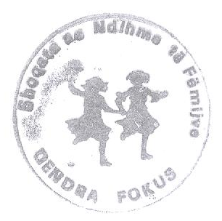
I hope you take the time to read through our report and become more informed of not only what we do but also of how you too can be part of ensuring our children and youth have their voices heard and their rights respected.
Dr. Anita PILIKA

Core Values

FOCUS’s core values are respect, cooperation, creativity, accountability and professionalism.

We are respectful. We therefore:
* respect the human dignity of every human being and particularly of a CHILD
* see a human being not a helpless victim

We are cooperative. We therefore:
* seek sustainable cooperation with other civil society organizations, especially NGOs assisting through services, universities and human rights activitists
* are a learning organisation – we listen to and learn from others
We are creative. We therefore:
* have a critical approach towards disability and human rights issues
* challenge the status quo
* seek innovative approaches to our work where appropriate

We are accountable. We therefore:
* seek to be accountable to people with disabilities
* encourage disabled people’s organisations help us set our goals and evaluate our work
* aim to include users of mental health services in our board of trustees and staff

We are professional. We therefore:
* ensure high standards in all our work and staff development

Our vision is a society of equality – where emotional, mental and learning differences are valued equally; where the inherent autonomy and dignity of each person is fully respected; and where human rights are realised for all persons without discrimination of any form.
Our mission is to advance the rights of children with intellectual disabilities or psycho-social disabilities. We achieve this through three organisational objectives:
1. Creating a body of progressive case solutions
2. Instigating reforms and changes with regards to mental health
3. Empowering children and families and promoting participatory politics
We operate within four intersecting programs:
- Services (direct services and counseling for children)
- Advocacy (for changes)
- Research and monitoring (studies and attitudes)
- Capacity-building (training and seminars)
- networking (participation and engagement)

History and FOKUS Milestones

The activities of the FOCUS initiated in 1997 by a group of professionals who decided to work together for helping the children with mental health problems in Albania. This group was compound mostly by psychiatrists, psychologists, social workers, nurses, teachers, parents.
The first activities were exhibitions, recreational activities, concerts organized with children with mental health problems. Important activities have been also trainings and capacity building with mental health professionals, students, parents, aiming to provide information about early identification and treatment of childhood most common problems.
Since then FOCUS has organized different projects, focused in early and late childhood as well as adolescent problems. In 2001 the organization has expanded its focus and interventions through various indicators, such as advocacy, and research.
The number of members is increased with people from different professional fields like: lawyers, police officers etc. What brings them together is the good will for working with children.
During 14 years of its existence the FOCUS projects have developed standards and impact regarding children’s Protection , child abuse, child traffic, domestic violence, gender role, education programs in schools, projects against drug abuse, environment care, health care etc.
Staff: Staff refers to full time, part time, or casual persons working in FOCUS Secretariat or for FOCUS members, and those engaged on short term contracts such as but not limited to: consultants, researchers, photographers etc. working in any project location.

Child protection:
In its widest sense, child protection is a term used to be describe the actions that individuals, organisations, countries and communities take to protect children from acts of “harm’” maltreatment (abuse) and exploitation e.g., domestic violence, exploitative child labour, commercial and sexual exploitation and abuse, deliberate exposure to HIV infection, physical violence to name but a few. It can also be used as a broad term to describe the work that organisations undertake in particular communities, environments or programs that protect children from the risk of harm due to the situation in which they are living.

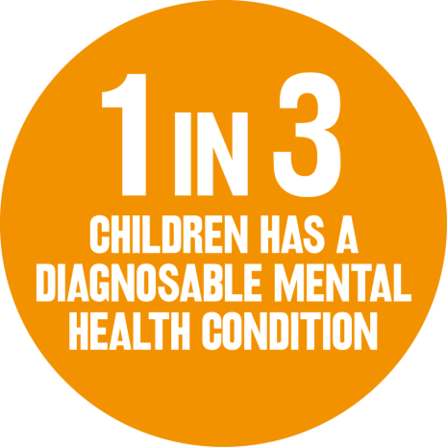

Programs and Activities

Promoting the Rights of the Child through services and information

Albania has ratified the two most important conventions which determine the rights of children with disabilities, the Convention on the Rights of the Child (CRC), and Convention for the Rights of Persons with Disabilities (CRPD). Both these conventions emphasize the fact that children with disabilities shall have the same rights as the other children, such as the right to medical care, social inclusion and protection from violence, abuse and neglect.

The CRC outlines the rights of all children, including children with disabilities, and includes two Articles which refer to them: Article 2 outlines the principle of nondiscrimination and includes the disability as the basis for protection against discrimination; Article 23 is dedicated to the rights of children with disabilities The CRPD refers to the rights of persons with disabilities through: a) explaining the principles of human rights in the context of persons with disability; b) offering an authoritative model to use when developing laws and national policies; c) creating more effective mechanisms for monitoring the rights of persons with disabilities; d) determining the international standards related to the rights and freedom of persons with disabilities; e) laying the foundation for a broader participation and independence of all persons with disabilities in the world; and f) requesting the active involvement of persons with disabilities and their representative organizations.

Regardless of the fact that all rights determined in the CRPD are also applied to children with disabilities, the convention specifically addresses the rights of children with disabilities, in some of its articles. Thus,
Article 7 outlines the liability of all States Parties to take measures to ensure: the full enjoyment by children with disabilities of all human rights and fundamental freedoms on an equal basis with other children; that in all actions concerning children with disabilities, the best interests of the child shall be a primary consideration, and that children with disabilities have the right to express their views freely. In addition, Article 23 of the CRPD defines the right to a family life, and Article 24 promotes the right for inclusive education.

Regarding all the legal framework, the FOCUS has given priority to Early Identification and counseling.
‘When E. was younger, I would worry that he was no t developing as the other kids, but relatives
would tell me “Boys learn how to walk later than girls”; “He is just a shy kid”; etc. So I went to theneuro-pediatrician when E. was 5 years old. I will never forgive myself.’ (Parent of a child with a disability)
“When my daughter went blind at the age of 4, the doctors told me that if I had gone to them when she was a baby, we could have operated her, and saved her sight, even if limited. But I had not realized it before. Now there is no more hope.’ (Parent of a child with a disability)

The parents, as well as the professionals’ lack of knowledge and skills, is one of the most important obstacle to early detection. These results show not only the late interventions in the children with disabilities, but also bear the risk of “mislabeling” some children.

‘During the last year there have been some trainings for educators on autism, but being insufficient, sometime they had the reverse effect. When we monitored them, we noticed alienated children that would be left alone in the corner of the toy room, since the educators had identified them as having autism. Actually, they were just kids with mild emotional problems that would become worse when the child was isolated. (Psychologist)

Research and Studies

We carry out our research and monitoring in collaboration with a range of partners – persons with disabilities, academics, social scientists, people working for governments or intergovernmental organisations. Our research takes a human rights-based approach, is multidisciplinary, credible and of utility in a broad range of forums and stakeholders. Our research is exploratory in that it investigates issues previously inadequately scrutinised. It is descriptive, in that it reports on attitudes, on practice and on progress, gathering systematically in one place, information previously scattered. It is evaluative in that it analyses pertinent issues such as laws, policy, their implementation and impact and the external environment driving these issues. It is emancipatory in that it engages and empowers research “subjects” through active participation. Finally it is strategic in that it allows us to respond to analysis through our other three programmes of strategic litigation, advocacy and capacity-building.
“Thank you from the bottom of
my heart for your continued
support and going to bat for us.
We feel everything that we are
receiving is because
of your involvement”.
-Client.

In order for the FOCUS to identify its target groups has undergone through a research on the care institutions as one of the five settings where violence against children occurs. The research mentions that children in institutions ‘are at risk of violence from staff and officials responsible for their well-being.

Throughout the research the FOCUS experts have analyzed the The UN General Assembly Guidelines for the Alternative Care of Children in 2009. The Guidelines enhance the implementation of the UN Convention of the Rights of the Child 1989 and focuses on two main aspects:
- Ensure that children do not find themselves in alternative care unnecessarily; and
- That where out-of-home care is provided, it is delivered under appropriate conditions responding to the child's rights and best interests.

For instance, alternative care must be used only when necessary and therefore places emphasis on preventative measures. Further, care options must meet certain general standards like professional human resources, and strategies that meet the specific needs of each and every child on an individual basis.
The FOCUS has provided various recommendations in this regards, which were taken in to consideration by the Ministry of Health AND Social Protection.

Advocacy and Awareness

FOCUS carries out advocacy as well as awareness actions, because we believe that social change requires a variety of methods. Opening discussions directly with policy-makers can be an effective method to persuade people of a point of view. We use advocacy to present the results of our research and monitoring program and in order to call for social change.

FOCUS advocacy seeks to challenge the status quo where people with disabilities have laws enacted upon them. The experts provide feasible, human rights-based suggestions to policy-makers so that they can properly develop and implement laws and policies. A systemic approach is used to influence programs and services, identify gaps, and determine the impact of the delivery of services and programs on children and youth in the Province. This is accomplished by providing recommendations to government regarding the challenges and changes needed to practices, policies and procedures

Our advocacy comments on the extent to which international human rights laws are implemented, judgments are enforced, and policy is responsive to needs. At the domestic level our advocacy includes sending letters of concern or encouragement to governments, commenting on legislative proposals, contributing to discussions, debates and discourse through the media, making court decisions easy to understand for people with disabilities and their families, holding conferences, round-tables and seminars to create a forum for discussion on specific issues.

Capacity-building
Capacity-building means providing training, technology and other ways to increase the skills, knowledge, ability and effectiveness of others. MDAC offers capacity-building to a variety of individuals and organisations who are key to the promotion and protection of human rights of people with disabilities. Our capacity-building work is participatory and inclusive, and includes seminars, workshops.
We build the capacity of individuals and organizations who are crucial in implementing human rights, as well those which play a watchdog role.

During the reporting period, FOCUS built the capacity of individuals and organisations such as NGOs, independent inspectorates, ombudsman’s offices, government departments, academia and parents of people with disabilities. Also, by working at grassroots level to engage, empower and train people with disabilities themselves to fight for their own rights, we play an important part in enabling people with disabilities to become the agents for their own change.
Our target groups for capacity building are:
- the non-governmental sector including organisations of people with disabilities;
- policy-makers including legislators and civil servants;
- national human rights structures, including detention monitoring bodies; and
- litigators, lawyers and judges.
FOCUS carries out capacity-building through training events whose hallmarks are that they are dynamic and interactive; involve participatory group work with a variety of different exercises sequencing small theoretical blocks.

FOCUS also holds workshops, roundtable events and provides formal presentations. These are tailored to participants and projects. Through presentations, group work, advocacy exercises, role plays and small group work the summer school strengthens the professional development of psychiatrists and educators, activists and academics in the field of mental health and human rights law for children with disabilities, and monitoring such implementation.
In addition, we have produce a range of educational resources both for health/ education professionals and families caring for a child with a developmental disability covering a variety of disability related topics:
- Physical disability
- Intellectual disability
- Communication/behaviour issues
- Mental health issues
- General health issues
- Disability supports and services

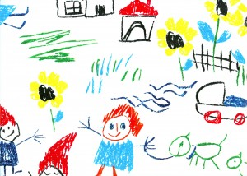

Partnerships and Networking

FOCUS has good relationship with other nongovernmental organizations, government institutions and other structures who work with/for children. They are partners, collaborators, facilitators in different activities and projects of the association.

Among those we can list:
- Multidisciplinary training center for child abuse
The focus of this center is to work with abused and neglected children. This NGO has a good tradition on training of professionals and influencing the public awareness for child abuse. This NGO collaborates with us for training, publications and services.
- National Center of Growth, Development, and Rehabilitation of children (NCGDRC)
The focus of this center is treatment of children with physical and mental handicap. Our association has a close relationship with this Center for implementation of different studies, projects and services.
- Counseling center for women and girls.
Some trainers and members of our association are included in different activities organized by this center. In some other cases our professionals are involved also in treatment of different cases of child abuse
- Every child
Focus center has offered technical assistance in the implementation of different project from Every child Albania.
- Save the children
“Focus” Center with her professional members had offered training sessions for multidisciplinary teams in different schools supported by Save the Children in: Tirana, Librazhd, Berat, Korcas, Pogradec, Durres, Elbasan.
- Handicap International
- Partners Albania
- Plan Albania
- CARITAS, Albania

Collaboration with government structures:
- Ministry of Health
- Ministry of Education
- Public Health Institutions
- Municipalities

Some of the members of our association, work in those government institutions and help a lot in facilitating projects and receiving data for families and children in need.

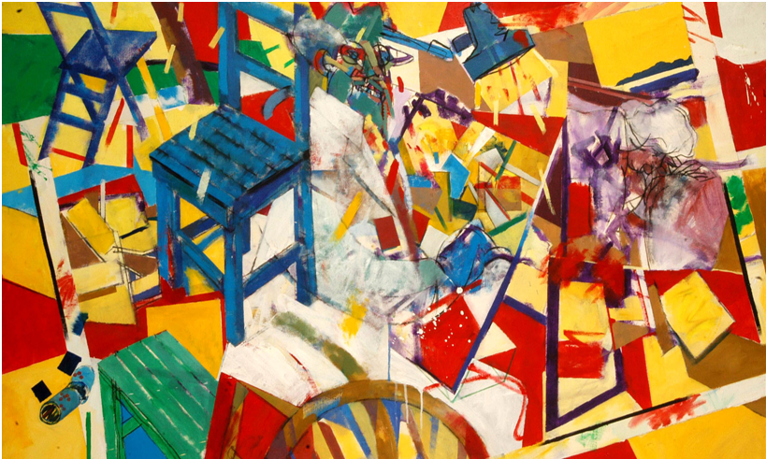

PUBLICATION INFORMATION
The 2018 Annual Report was published by FOCUS
Rruga Islam Alla - Tirana, AL, January 2019

