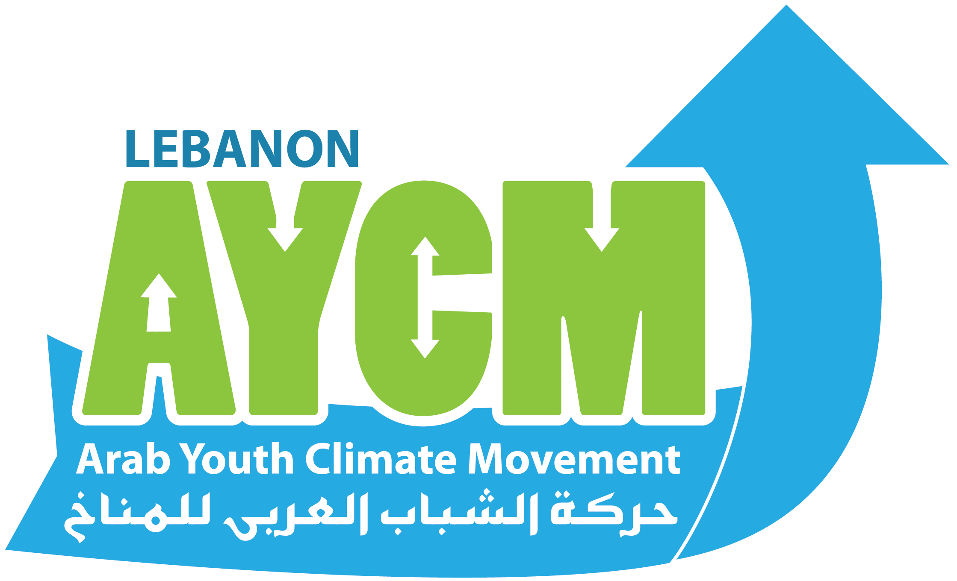

AYCM-Lebanon Report 2017

AYCM-Lebanon Twitter account: https://twitter.com/AycmLebanon
AYCM-Lebanon Facebook Account: https://www.facebook.com/AYCMLebanon
AYCM-Lebanon Instagram account: https://www.instagram.com/aycm_lebanon

This table summarize the events done in 2017:
Date | Event | Page | Comments
February, 1,2017 | Taking part in the Business Knowledge Platform training by Lebanon Climate Act | 3 | Organized by Lebanon Climate Act
March 25, 2017 | Earth Hour 2017 | 4 | Organized by G NGO while AYCM booth was organized by AYCM-Lebanon volunteers
March 27, 2017 | For Renewable energy in Curriculum Training | 5 | Organized by AYCM-Lebanon
July 10, 2017 | Annual launching of Business Knowledge platform within Lebanon Climate Act | 6 | Organized by Lebanon Climate Act
August 22, 2017 | Capacity Building workshop and Science-Policy Dialogue on Climate Change | 7 | Organized by AYCM-Lebanon
September 13, 2017 | Two Awareness Sessions at Collège Lycée of Agadir | 8 | Organized by AYCM-Lebanon

This tables shows the Networks Joined in 2017:

Date | Event | Page
September 15,2017 | Partnership in the Net Med Youth | 9
October 26, 2017 | We gained Organizational CIVICUS Membership for 2017 | 9
December 17,2017 | Waste Management Coalition | 10

Affiliations:

- CIVICUS
- 350.org
- Lebanon Climate Act
- Global Campaign for Climate Action
- Climate Action Network
- Waste Management Coalition (Lebanon)
- Net Med Youth
- YOUNGO

List of Events

Business Knowledge Platform
As Part of our partnership with Lebanon Climate Act, our team attended a training session on February 1st, 2017 at the Chamber of Commerce, Industry and Agriculture of Beirut to explore how to effectively partner with private companies in order to implement successful projects in the future. There was fruitful discussion on the collaboration between Private sector, municipalities and NGOs

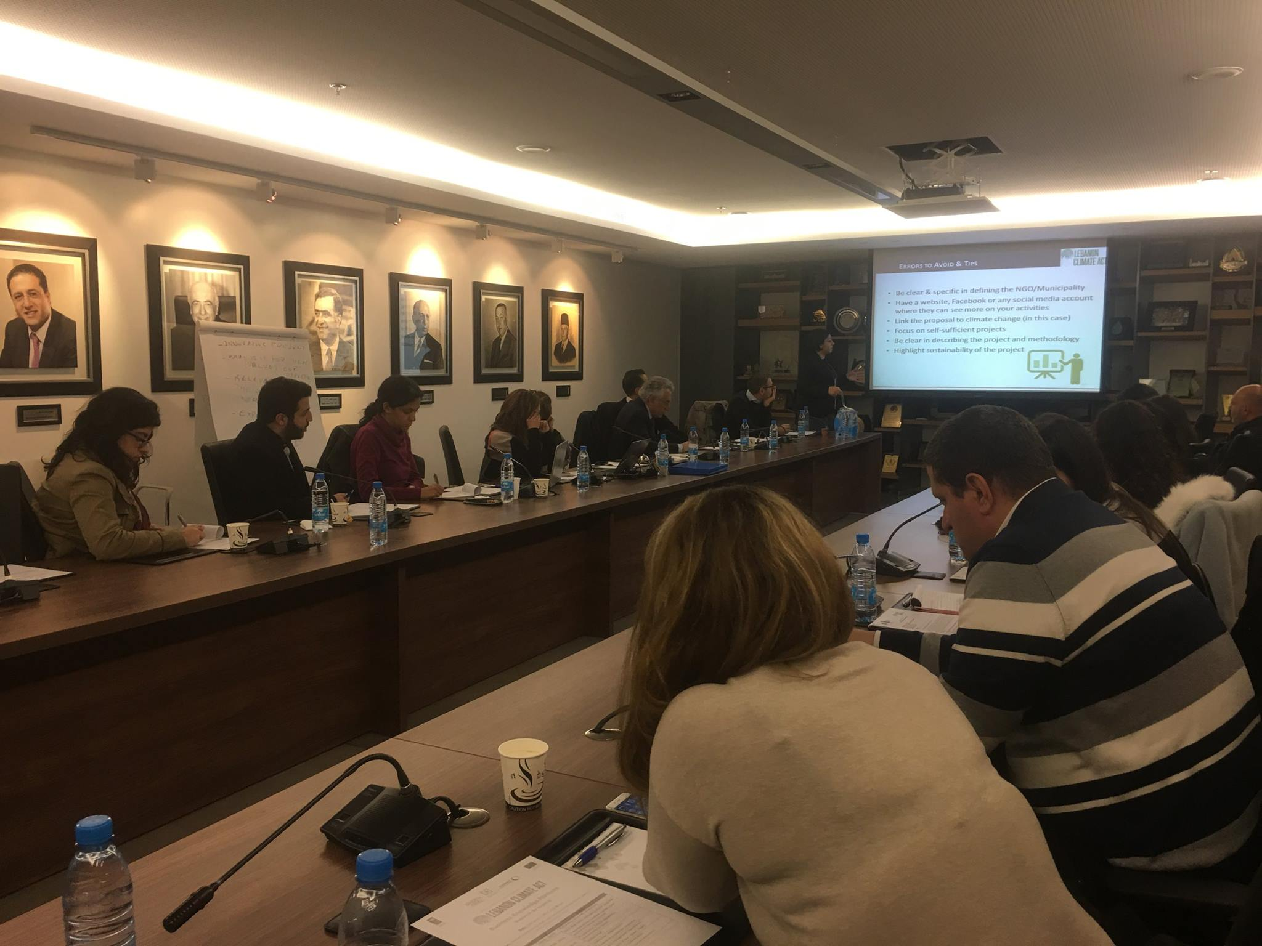

Earth Hour Campaign
It started by an online campaign during the month of March to end by a full day festival in Beil, Beirut on March 25, 2017. AYCM had a stand where there were volunteers raising awareness on climate change for kids, selling natural stuff and presenting electronic stuff for recycling.
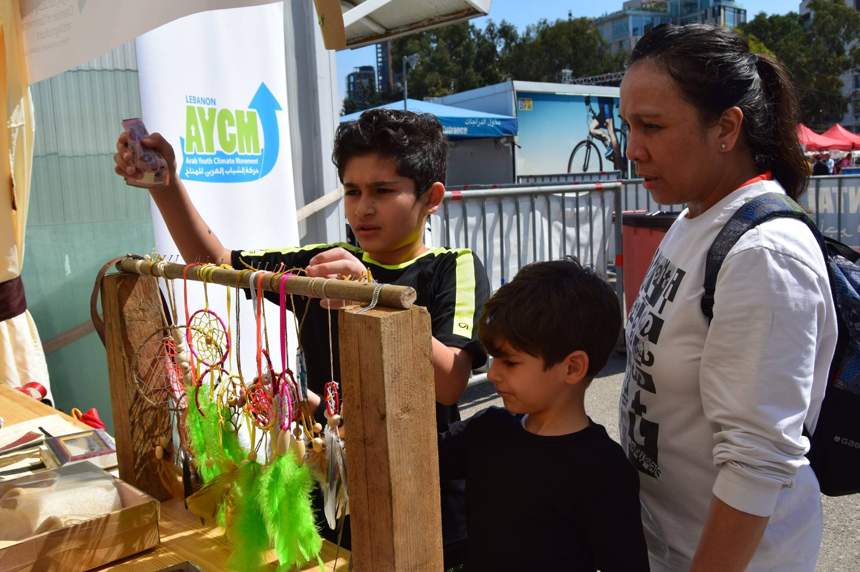

For Renewable energy in Curriculum Training
AYCM-Lebanon gave a lecture on how to introduce renewable energy into the curriculum for environmental coordinators in Al-Mabarrat schools. The coordinators of the 11 schools came from different Lebanese areas to attend the lecture in Beirut.

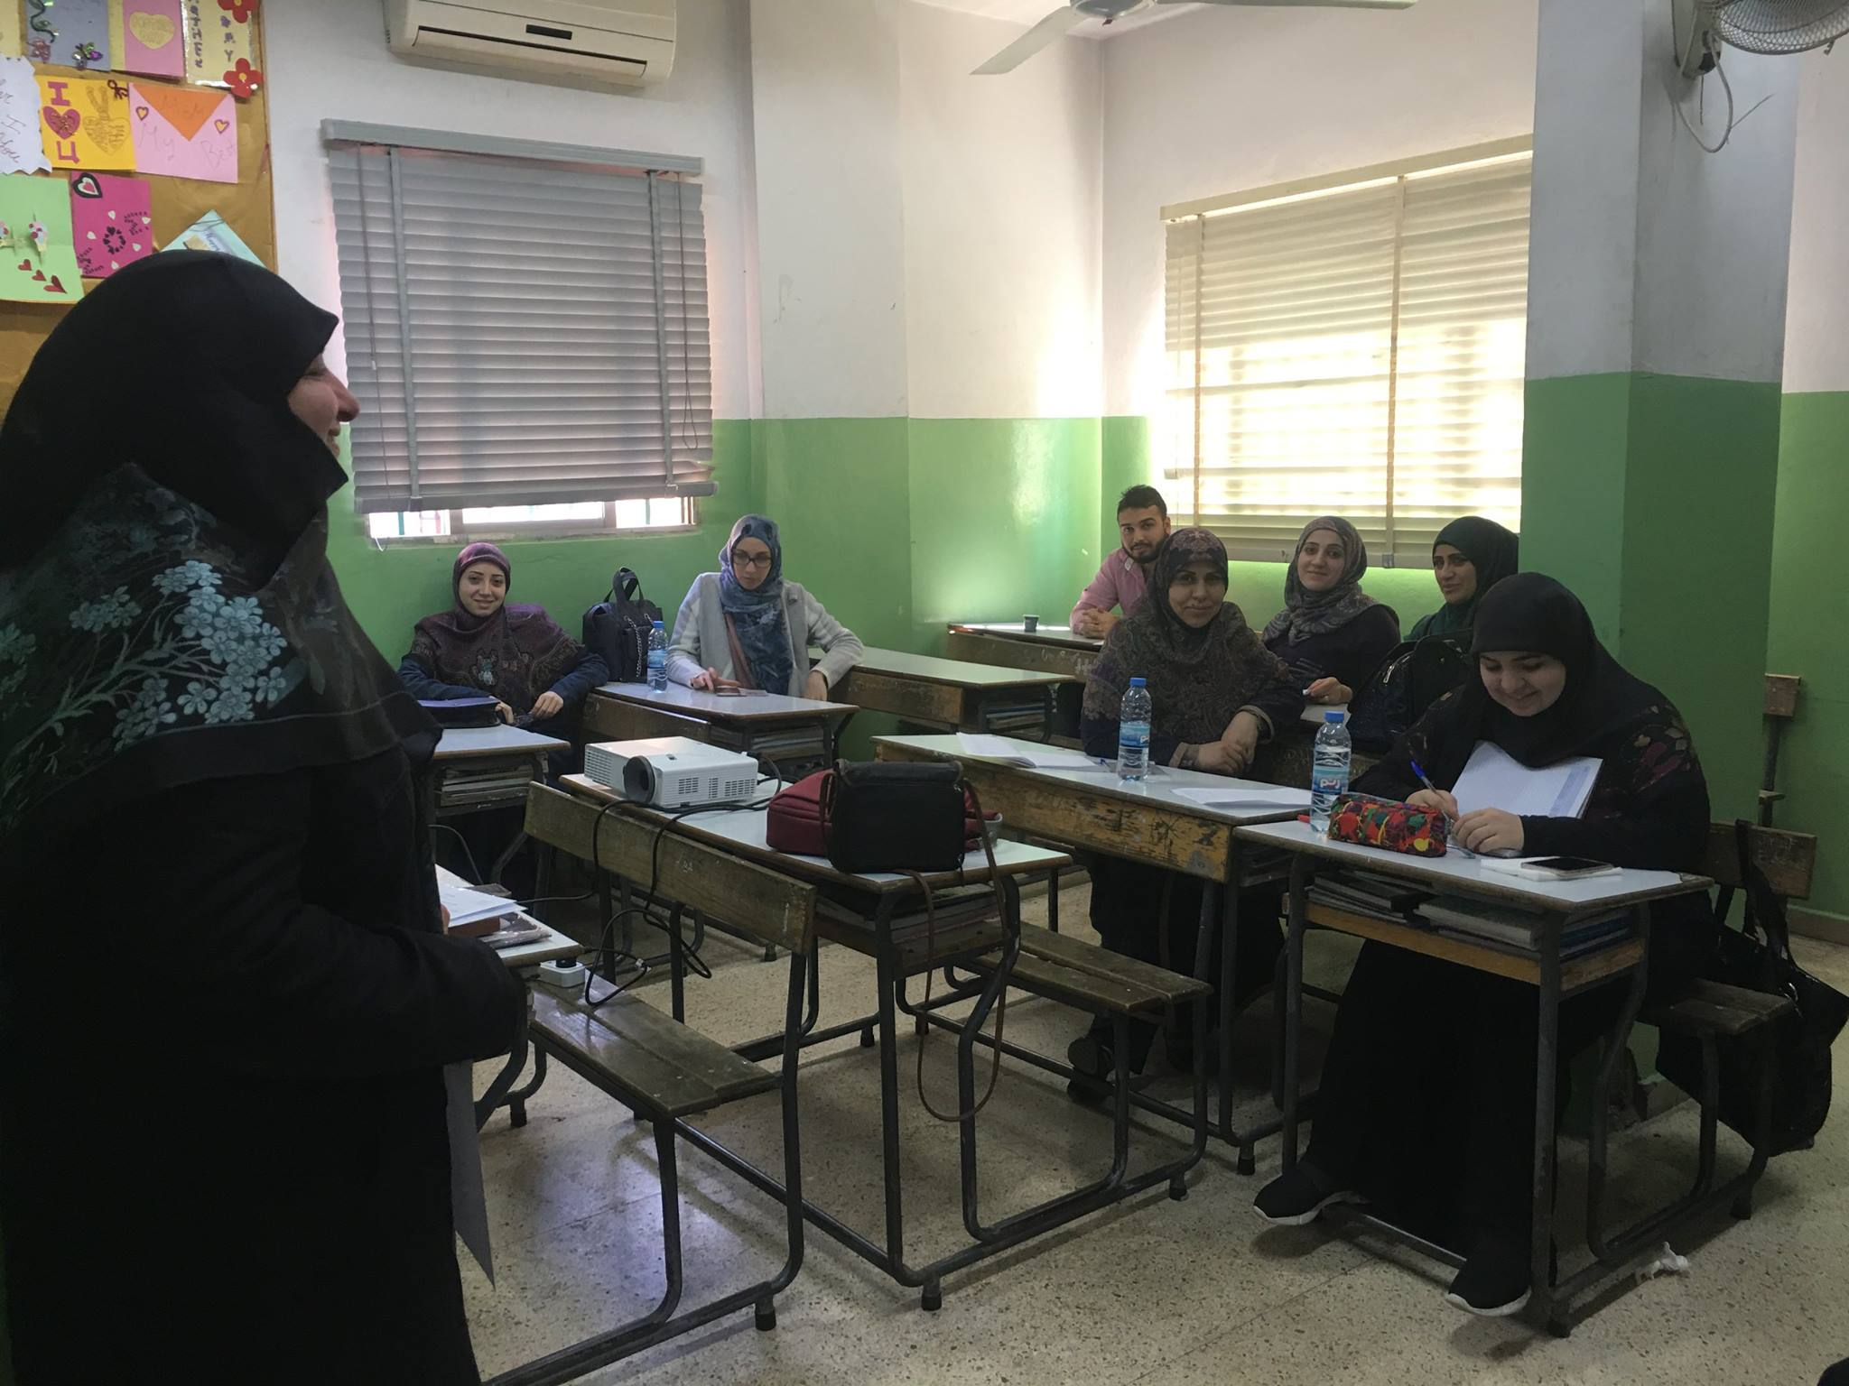

Annual Launch of the launching of Business Knowledge platform in Lebanon Climate Act
Members of the Arab Youth Movement for Climate-Lebanon attended as part of the movement's participation in the Lebanon Climate Act, the annual launch of the Business Knowledge Platform at the Saint Joseph University in Beirut, François Bassil Theater.

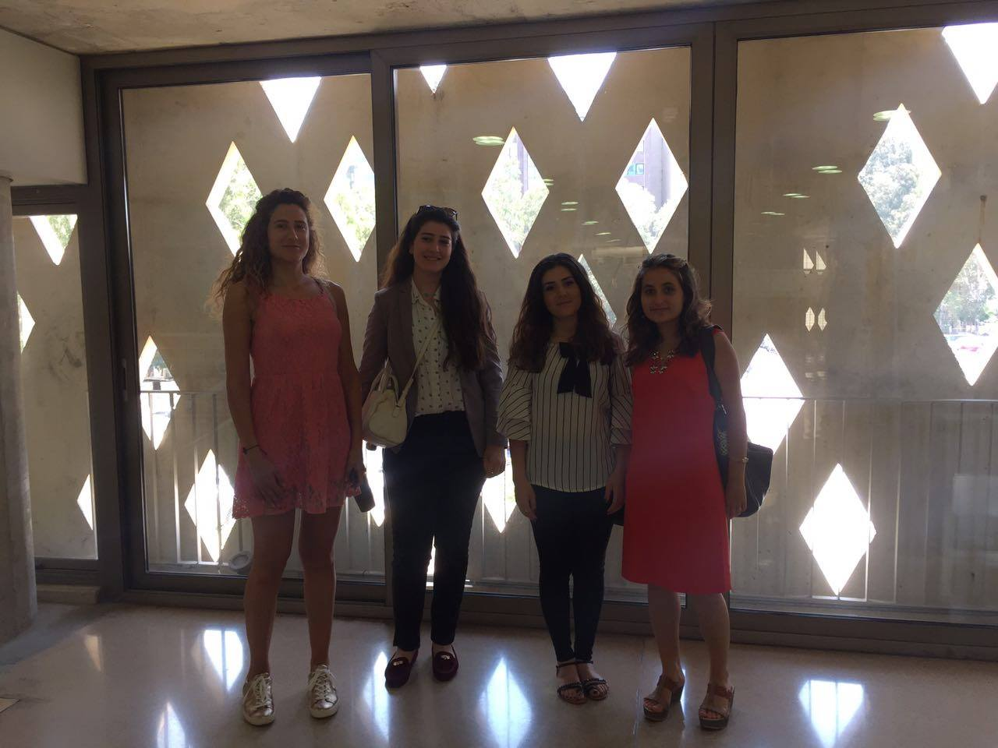

Capacity Building workshop and Science-Policy Dialogue on Climate Change

AYCM-Lebanon organize d a successful workshop on “CAPACITY BUILDING AND SCIENCE POLICY DIALOGUE ON CLIMATE CHANGE.” it was attended by 15 individuals and the session was conducted by Mrs. Lea Kai Aboujaoudé from the Ministry of Environment.

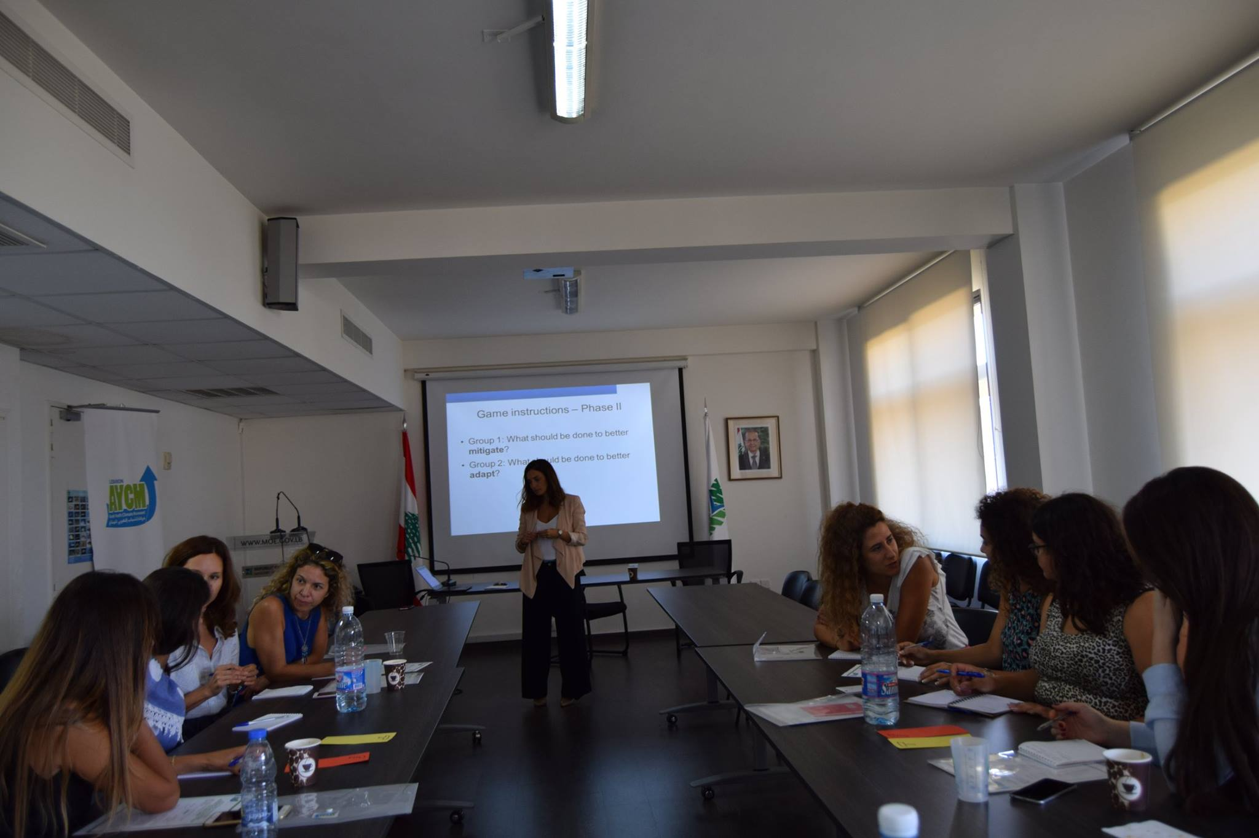

Two Awareness Sessions at Collège Lycée of Agadir

AYCM-Lebanon did on the occasion of Climate Chance 2017 - Agadir two sessions at the Collège Lycée of Agadir on the basics of climate change and how to engage as youth in climate action.

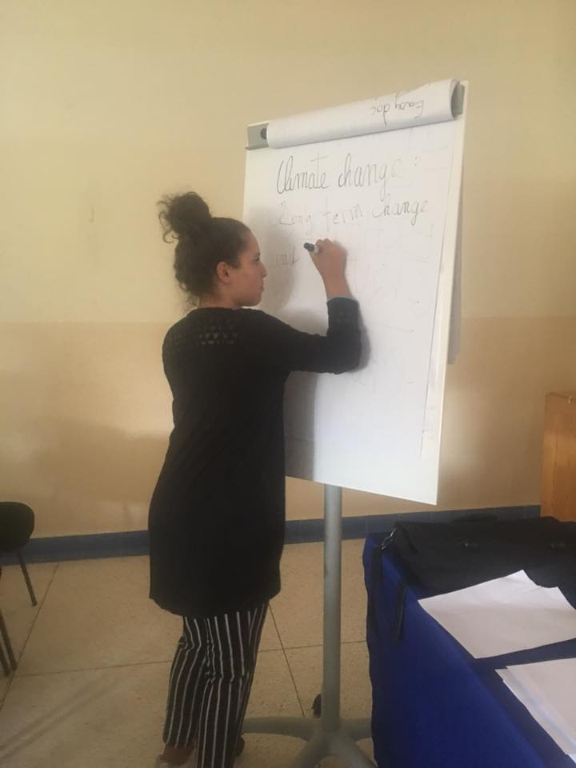

Networks Joined
Net med youth
AYCM-Lebanon is proud to announce its partnership in the Net Med Youth program on September 15,2017. 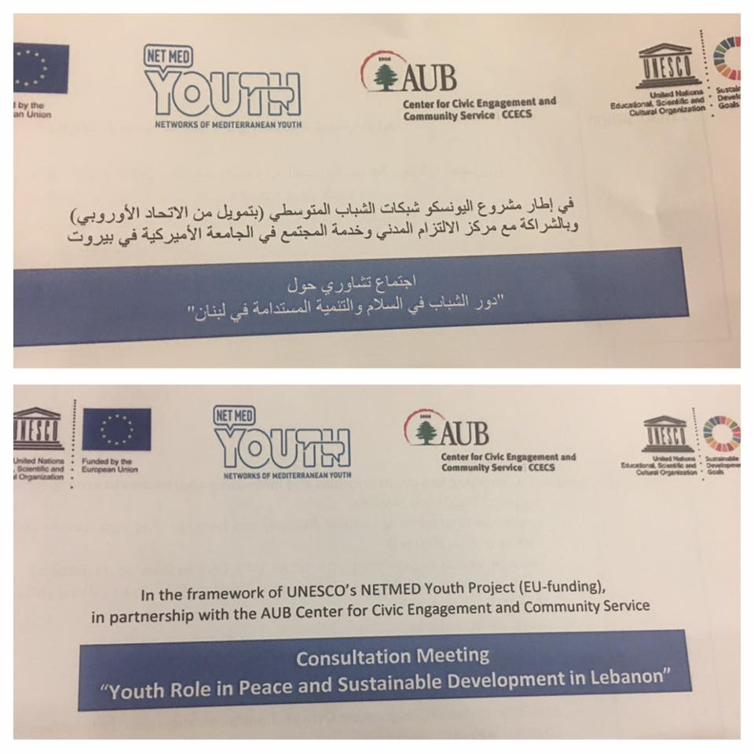

CIVICUS Membership
Our membership as a voting member in CIVICUS: World Alliance for Citizen Participation has been activated today.
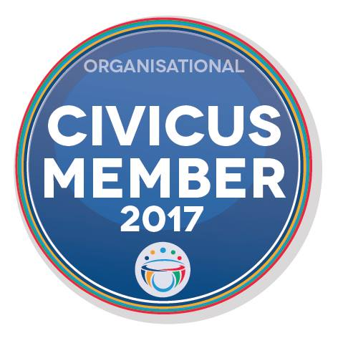

Waste Management Coalition

AYCM-Lebanon joined a new waste management coalition that has been announced in Lebanon in December2017 which aims to pressure the government to find sustainable solutions for the still unsolved trash problem.
